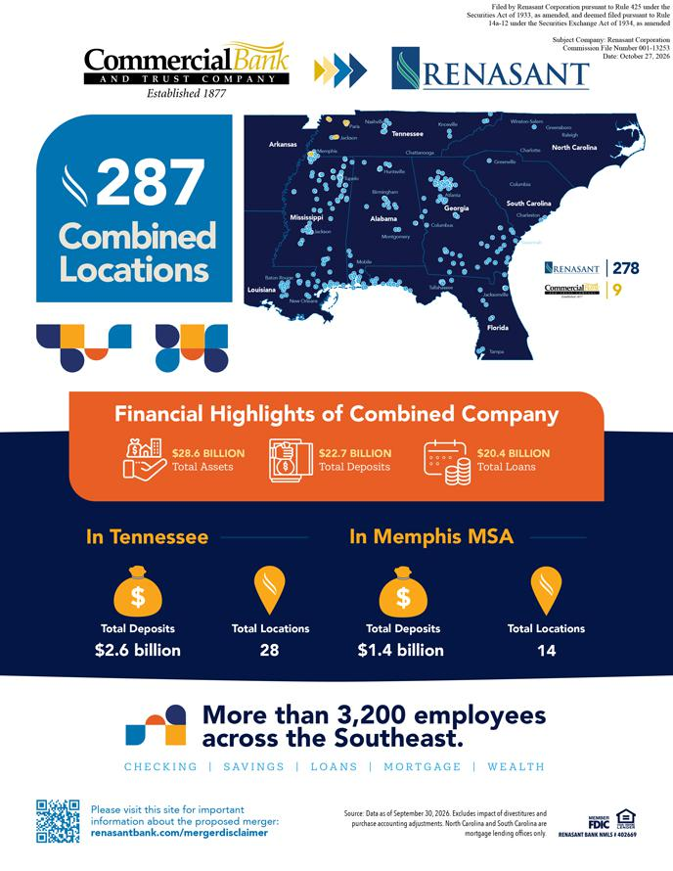

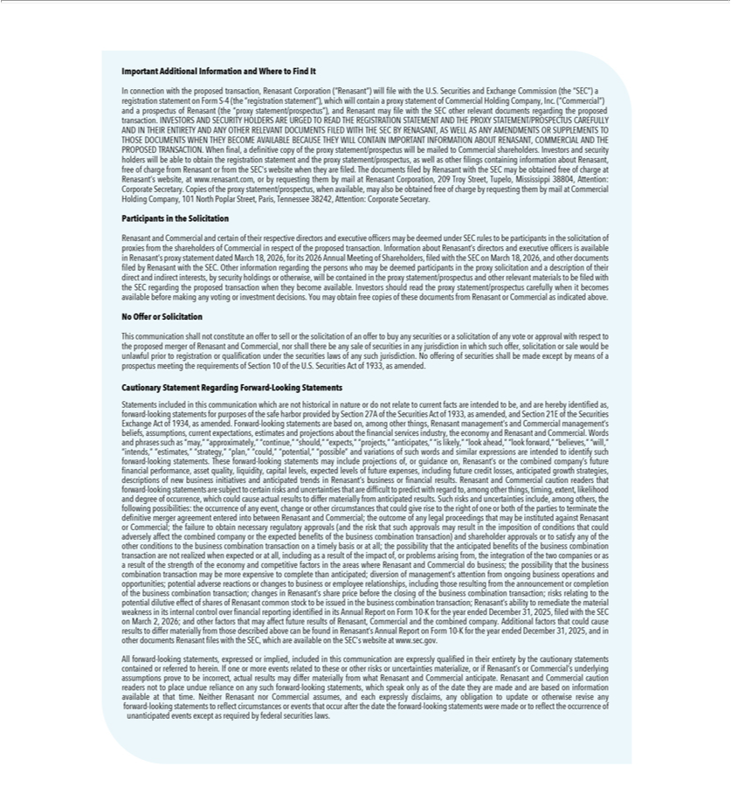

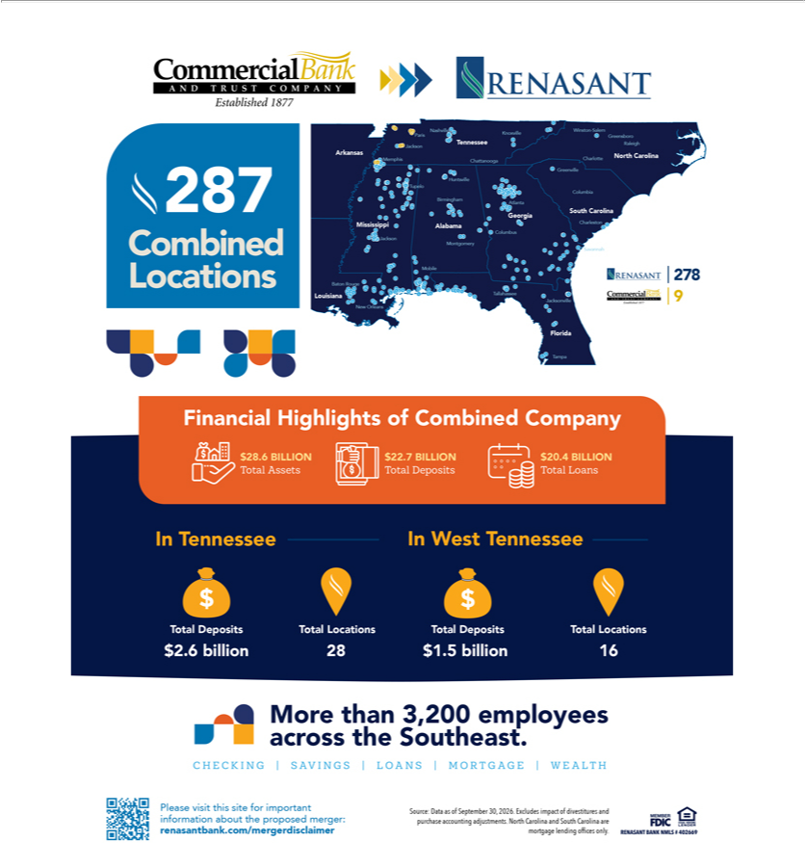

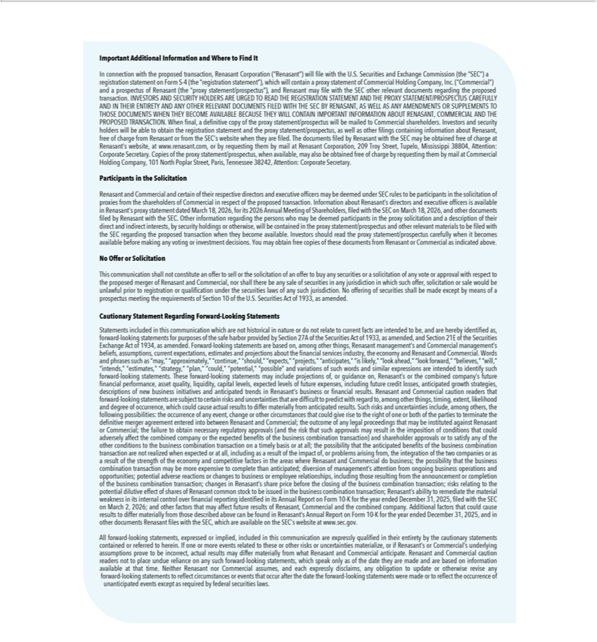

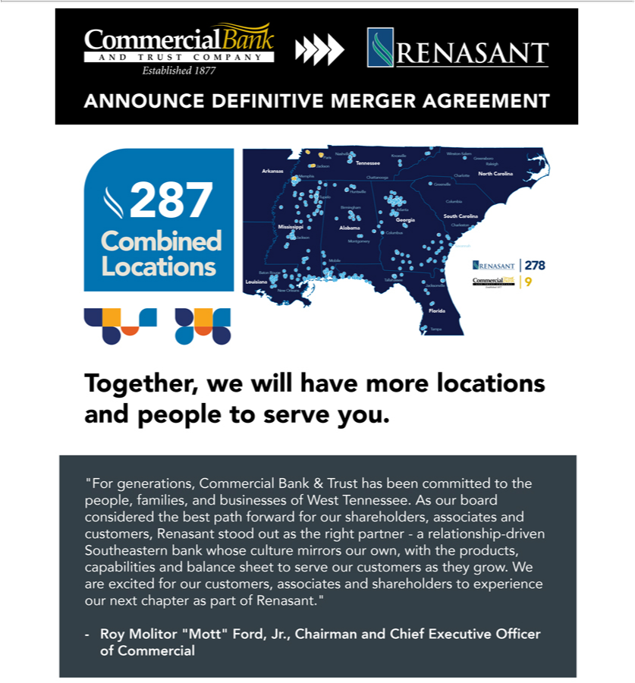

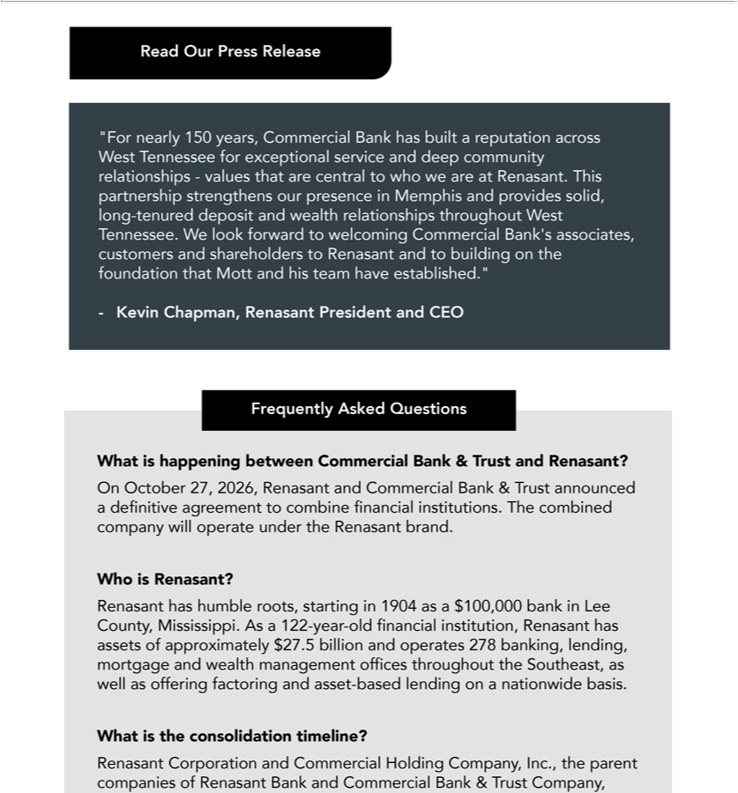

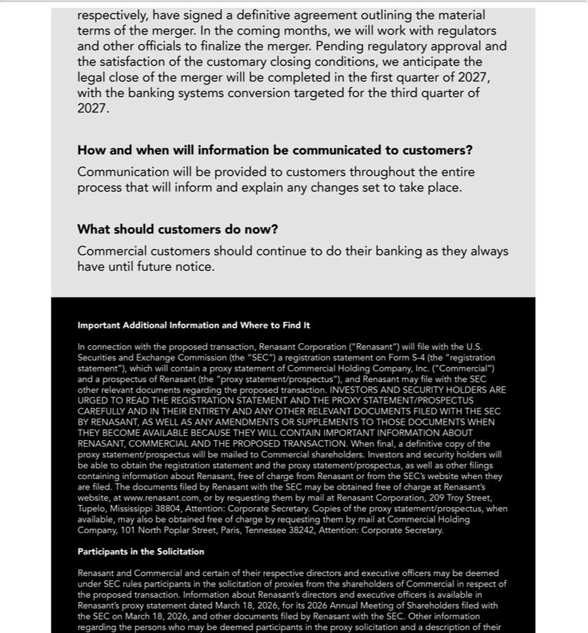

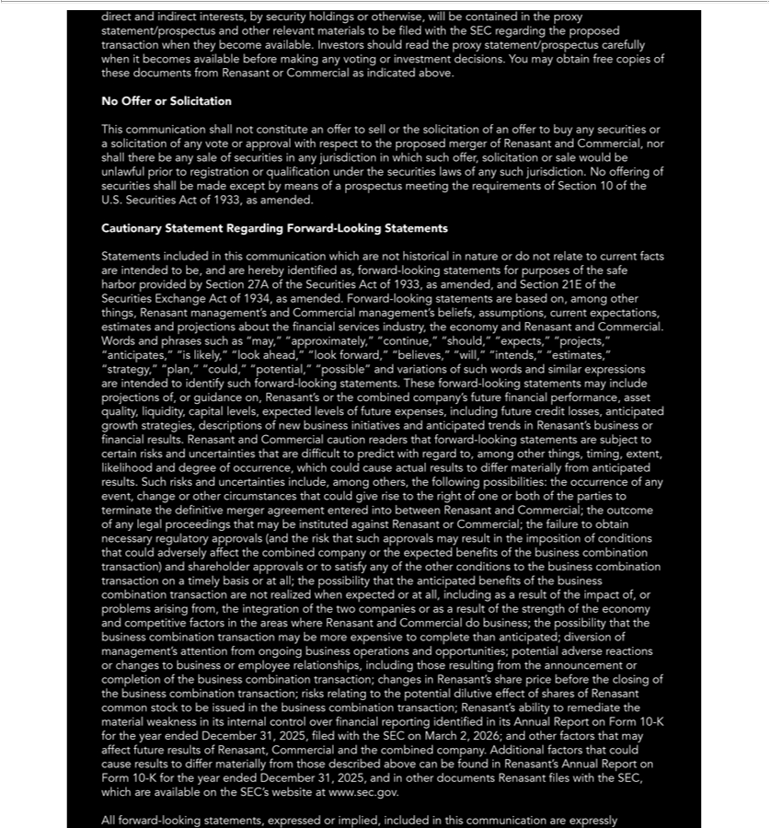

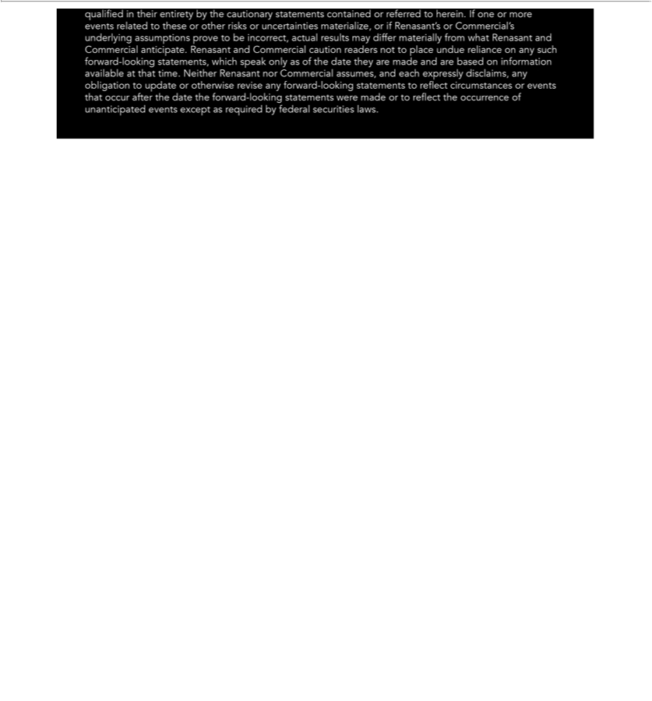

Important Additional Information and Where to Find It

In connection with the proposed transaction, Renasant Corporation (“Renasant”) will file with the U.S. Securities and Exchange Commission (the “SEC”) a registration statement on Form S-4 (the “registration statement”), which will contain a proxy statement of Commercial Holding Company, Inc. (”Commercial”) and a prospectus of Renasant (the “proxy statement/prospectus”), and Renasant may file with the SEC other relevant documents regarding the proposed transaction. INVESTORS AND SECURITY HOLDERS ARE URGED TO READ THE REGISTRATION STATEMENT AND THE PROXY STATEMENT/PROSPECTUS CAREFULLY AND IN THEIR ENTIRETY AND ANY OTHER RELEVANT DOCUMENTS FILED WITH THE SEC BY RENASANT, AS WELL AS ANY AMENDMENTS OR SUPPLEMENTS TO THOSE DOCUMENTS WHEN THEY BECOME AVAILABLE BECAUSE THEY WILL CONTAIN IMPORTANT INFORMATION ABOUT RENASANT, COMMERCIAL AND THE PROPOSED TRANSACTION. When final, a definitive copy of the proxy statement/prospectus will be mailed to Commercial shareholders. Investors and security holders will be able to obtain the registration statement and the proxy statement/prospectus, as well as other filings containing information about Renasant, free of charge from Renasant or from the SEC’s website when they are filed. The documents filed by Renasant with the SEC may be obtained free of charge at Renasant’s website, at www.renasant.com, or by requesting them by mail at Renasant Corporation, 209 Troy Street, Tupelo, Mississippi 38804, Attention: Corporate Secretary. Copies of the proxy statement/prospectus, when available, may also be obtained free of charge by requesting them by mail at Commercial Holding Company, 101 North Poplar Street, Paris, Tennessee 38242, Attention: Corporate Secretary.

Participants in the Solicitation

Renasant and Commercial and certain of their respective directors and executive officers may be deemed under SEC rules to be participants in the solicitation of proxies from the shareholders of Commercial in respect of the proposed transaction. Information about Renasant’s directors and executive officers is available in Renasant’s proxy statement dated March 18, 2026, for its 2026 Annual Meeting of Shareholders, filed with the SEC on March 18, 2026, and other documents filed by Renasant with the SEC. Other information regarding the persons who may be deemed participants in the proxy solicitation and a description of their direct and indirect interests, by security holdings or otherwise, will be contained in the proxy statement/prospectus and other relevant materials to be filed with the SEC regarding the proposed transaction when they become available. Investors should read the proxy statement/prospectus carefully when it becomes available before making any voting or investment decisions. You may obtain free copies of these documents from Renasant or Commercial as indicated above.

No Offer or Solicitation

This communication shall not constitute an offer to sell or the solicitation of an offer to buy any securities or a solicitation of any vote or approval with respect to the proposed merger of Renasant and Commercial, nor shall there be any sale of securities in any jurisdiction in which such offer, solicitation or sale would be unlawful prior to registration or qualification under the securities laws of any such jurisdiction. No offering of securities shall be made except by means of a prospectus meeting the requirements of Section 10 of the U.S. Securities Act of 1933, as amended.

Cautionary Statement Regarding Forward-Looking Statements

Statements included in this communication which are not historical in nature or do not relate to current facts are intended to be, and are hereby identified as, forward-looking statements for purposes of the safe harbor provided by Section 27A of the Securities Act of 1933, as amended, and Section 21E of the Securities Exchange Act of 1934, as amended. Forward-looking statements are based on, among other things, Renasant management’s and Commercial management’s beliefs, assumptions, current expectations, estimates and projections about the financial services industry, the economy and Renasant and Commercial. Words and phrases such as “may,” “approximately,” “continue,” “should,” “expects,” “projects,” “anticipates,” “is likely,” “look ahead,” “look forward,” “believes,” “will,” “intends,” “estimates,” “strategy,” “plan,” “could,” “potential,” “possible” and variations of such words and similar expressions are intended to identify such forward-looking statements. These forward-looking statements may include projections of, or guidance on, Renasant’s or the combined company’s future financial performance, asset quality, liquidity, capital levels, expected levels of future expenses, including future credit losses, anticipated growth strategies, descriptions of new business initiatives and anticipated trends in Renasant’s business or financial results. Renasant and Commercial caution readers that forward-looking statements are subject to certain risks and uncertainties that are difficult to predict with regard to, among other things, timing, extent, likelihood and degree of occurrence, which could cause actual results to differ materially from anticipated results. Such risks and uncertainties include, among others, the following possibilities: the occurrence of any event, change or other circumstances that could give rise to the right of one or both of the parties to terminate the definitive merger agreement entered into between Renasant and Commercial; the outcome of any legal proceedings that may be instituted against Renasant or Commercial; the failure to obtain necessary regulatory approvals (and the risk that such approvals may result in the imposition of conditions that could adversely affect the combined company or the expected benefits of the business combination transaction) and shareholder approvals or to satisfy any of the other conditions to the business combination transaction on a timely basis or at all; the possibility that the anticipated benefits of the business combination transaction are not realized when expected or at all, including as a result of the impact of, or problems arising from, the integration of the two companies or as a result of the strength of the economy and competitive factors in the areas where Renasant and Commercial do business; the possibility that the business combination transaction may be more expensive to complete than anticipated; diversion of management’s attention from ongoing business operations and opportunities; potential adverse reactions or changes to business or employee relationships, including those resulting from the announcement or completion of the business combination transaction; changes in Renasant’s share price before the closing of the business combination transaction; risks relating to the potential dilutive effect of shares of Renasant common stock to be issued in the business combination transaction; Renasant’s ability to remediate the material weakness in its internal control over financial reporting identified in its Annual Report on Form 10-K for the year ended December 31, 2025, filed with the SEC on March 2, 2026; and other factors that may affect future results of Renasant, Commercial and the combined company. Additional factors that could cause results to differ materially from those described above can be found in Renasant’s Annual Report on Form 10-K for the year ended December 31, 2025, and in other documents Renasant files with the SEC, which are available on the SEC’s website at www.sec.gov.

All forward-looking statements, expressed or implied, included in this communication are expressly qualified in their entirety by the cautionary statements contained or referred to herein. If one or more events related to these or other risks or uncertainties materialize, or if Renasant’s or Commercial’s underlying assumptions prove to be incorrect, actual results may differ materially from what Renasant and Commercial anticipate. Renasant and Commercial caution readers not to place undue reliance on any such forward-looking statements, which speak only as of the date they are made and are based on information available at that time. Neither Renasant nor Commercial assumes, and each expressly disclaims, any obligation to update or otherwise revise any forward-looking statements to reflect circumstances or events that occur after the date the forward-looking statements were made or to reflect the occurrence of unanticipated events except as required by federal securities laws.

