UNITED STATES
SECURITIES AND EXCHANGE COMMISSION
Washington, D.C. 20549

FORM 8-K
CURRENT REPORT
Pursuant to Section 13 OR 15(d) of the Securities Exchange Act of 1934

July 28, 2026
Date of report (Date of earliest event reported)

RENASANT CORPORATION
(Exact name of registrant as specified in its charter)
Mississippi |  |  | 001-13253 |  |  | 64-0676974
(State or other jurisdiction  of incorporation) |  |  | (Commission  File Number) |  |  | (I.R.S. Employer  Identification No.)

209 Troy Street, Tupelo, Mississippi 38804-4827
(Address of principal executive offices)(Zip Code)

Registrant’s telephone number, including area code: (662) 680-1001
Check the appropriate box below if the Form 8-K filing is intended to simultaneously satisfy the filing obligation of the registrant under any of the following provisions:
☐ |  |  | Written communications pursuant to Rule 425 under the Securities Act (17 CFR 230.425)
☐ |  |  | Soliciting material pursuant to Rule 14a-12 under the Exchange Act (17 CFR 240.14a-12)
☐ |  |  | Pre-commencement communications pursuant to Rule 14d-2(b) under the Exchange Act (17 CFR 240.14d-2(b))
☐ |  |  | Pre-commencement communications pursuant to Rule 13e-4(c) under the Exchange Act (17 CFR 240.13e-4(c))
Securities registered pursuant to Section 12(b) of the Act:
Title of each class |  |  | Trading Symbol(s) |  |  | Name of each exchange on which registered
Common stock, $5.00 par value per share |  |  | RNST |  |  | The New York Stock Exchange
Indicate by check mark whether the registrant is an emerging growth company as defined in Rule 405 of the Securities Act of 1933 (17 CFR §230.405) or Rule 12b-2 of the Securities Exchange Act of 1934 (17 CFR §240.12b-2). Emerging growth company ☐
If an emerging growth company, indicate by check mark if the registrant has elected not to use the extended transition period for complying with any new or revised financial accounting standards provided pursuant to Section 13(a) of the Exchange Act. ☐

Item 2.02. Results of Operations and Financial Condition.
On July 28, 2026, Renasant Corporation (the “Company”) issued a press release announcing earnings for the second quarter of 2026. The press release is furnished as Exhibit 99.1 to this Form 8-K.

Item 7.01. Regulation FD Disclosure
On July 28, 2026, the Company also made available presentation materials (the “Presentation”) prepared for use with its earnings conference call on July 29, 2026. The Presentation is attached hereto and incorporated herein as Exhibit 99.2.
In accordance with General Instruction B.2 of Form 8-K, the information in this Item 7.01, including Exhibit 99.2, is being furnished and shall not be deemed to be “filed” for purposes of Section 18 of the Securities Exchange Act of 1934, as amended, or otherwise subject to the liabilities of that section, and shall not be deemed incorporated by reference into any registration statement or other document filed pursuant to the Securities Act of 1933, as amended, or the Securities Exchange Act of 1934, as amended, except as shall be expressly set forth by specific reference in such filing.

CAUTIONARY NOTE REGARDING FORWARD-LOOKING STATEMENTS:

This press release may contain, or incorporate by reference, statements about Renasant Corporation that constitute “forward-looking statements” within the meaning of Section 27A of the Securities Act of 1933, as amended, and Section 21E of the Securities Exchange Act of 1934, as amended. Statements preceded by, followed by or that otherwise include the words “believes,” “expects,” “projects,” “anticipates,” “intends,” “estimates,” “plans,” “potential,” “focus,” “possible,” “may increase,” “may fluctuate,” “will likely result,” or similar expressions, or future or conditional verbs such as “will,” “should,” “would” and “could,” are generally forward-looking in nature and not historical facts. Forward-looking statements include information about the Company’s future financial performance, business strategy, projected plans and objectives and are based on the current beliefs and expectations of management. The Company’s management believes these forward-looking statements are reasonable, but they are all inherently subject to significant business, economic and competitive risks and uncertainties, many of which are beyond the Company’s control. In addition, these forward-looking statements are subject to assumptions with respect to future business strategies and decisions that are subject to change. Actual results may differ from those indicated or implied in the forward-looking statements, and such differences may be material. Prospective investors are cautioned that any forward-looking statements are not guarantees of future performance and involve risks and uncertainties and, accordingly, investors should not place undue reliance on these forward-looking statements, which speak only as of the date they are made.
Important factors currently known to management that could cause the Company’s actual results to differ materially from those in forward-looking statements include the following: (i) the Company’s ability to efficiently integrate acquisitions into its operations, retain the customers of these businesses, grow the acquired operations and realize the cost savings expected from an acquisition to the extent and in the timeframe anticipated by management (including the possibility that such cost savings will not be realized when expected, or at all, as a result of the impact of, or challenges arising from, the integration of the acquired assets and assumed liabilities into the Company, potential adverse reactions or changes to business or employee relationships, or as a result of other unexpected factors or events); (ii) potential exposure to unknown or contingent risks and liabilities the Company has acquired or may acquire; (iii) the effect of economic conditions and interest rates on a national, regional or international basis; (iv) timing and success of the implementation of changes in operations to achieve enhanced earnings or effect cost savings; (v) the Company’s ability to remediate the material weakness in the its internal control over financial reporting identified in the Company’s Annual Report on Form 10-K for the year ended December 31, 2025 filed with the Securities and Exchange Commission (the “SEC”) on March 2, 2026; (vi) competitive pressures in the consumer finance, commercial finance, financial services, asset management, retail banking, factoring and mortgage lending and auto lending industries; (vii) the financial resources of, and products available from, competitors; (viii) changes in laws and regulations as well as changes in accounting standards; (ix) changes in governmental and

regulatory policy, whether applicable specifically to financial institutions or impacting the United States generally (such as, for example, changes in trade policy); (x) changes in the securities and foreign exchange markets; (xi) the Company’s potential growth, including its entrance or expansion into new markets, and the need for sufficient capital to support that growth; (xii) changes in the quality or composition of the Company’s loan or investment portfolios, including adverse developments in borrower industries or in the repayment ability of individual borrowers or issuers of investment securities, or the impact of interest rates on the value of the Company’s investment securities portfolio; (xiii) an insufficient allowance for credit losses as a result of inaccurate assumptions; (xiv) changes in the sources and costs of the capital the Company uses to make loans and otherwise fund the Company’s operations, due to deposit outflows, changes in the mix of deposits and the cost and availability of borrowings; (xv) general economic, market or business conditions, including the impact of inflation; (xvi) changes in demand for loan and deposit products and other financial services; (xvii) concentrations of credit or deposit exposure; (xviii) changes or the lack of changes in interest rates, yield curves and interest rate spread relationships; (xix) losses resulting from fraudulent activity, including loan and deposit fraud and social engineering attacks targeting the Company’s customers, employees and third party vendors; (xx) increased cybersecurity risk, including potential network breaches, business disruptions or financial losses, including as a result of sophisticated attacks using artificial intelligence (“AI”) and similar tools; (xxi) civil unrest, natural disasters, epidemics and other catastrophic events in the Company’s geographic area; (xxii) geopolitical conditions, including acts or threats of terrorism and actions taken by the United States or other governments in response to acts or threats of terrorism and/or military conflicts, which could impact business and economic conditions in the United States and abroad; (xxiii) the impact, extent and timing of technological changes, including the rapid development of AI technologies; and (xxiv) other circumstances, many of which are beyond management’s control.
Management believes that the assumptions underlying Company’s forward-looking statements are reasonable, but any of the assumptions could prove to be inaccurate. Investors are urged to carefully consider the risks described in the Company’s filings with the SEC from time to time, including its most recent Annual Report on Form 10-K and subsequent Quarterly Reports on Form 10-Q, which are available at www.renasant.com and the SEC’s website at www.sec.gov.
The Company undertakes no obligation, and specifically disclaims any obligation, to update or revise forward-looking statements, whether as a result of new information or to reflect changed assumptions, the occurrence of unanticipated events or changes to future operating results over time, except as required by federal securities laws.

Item 9.01. Financial Statements and Exhibits.
(d) The following exhibits are furnished herewith:
Exhibit No. Description
99.1 Press release issued by Renasant Corporation announcing earnings for the second quarter of 2026
99.2 Presentation materials for Renasant Corporation Second Quarter 2026 Earnings Call
104 The cover page of Renasant Corporation's Form 8-K is formatted in Inline XBRL.

SIGNATURES
Pursuant to the requirements of the Securities Exchange Act of 1934, the registrant has duly caused this report to be signed on its behalf by the undersigned hereunto duly authorized.
 |  |  |  |  |  | RENASANT CORPORATION
Date: July 28, 2026 |  |  |  |  |  | By: |  |  | /s/ Kevin D. Chapman
 |  |  |  |  |  |  |  |  | Kevin D. Chapman
 |  |  |  |  |  |  |  |  | Chief Executive Officer


Contacts: |  |  | For Media: |  |  |  |  |  | For Financials:
 |  |  | John S. Oxford |  |  |  |  |  | James C. Mabry IV
 |  |  | Senior Vice President |  |  |  |  |  | Executive Vice President
 |  |  | Chief Marketing Officer |  |  |  |  |  | Chief Financial Officer
 |  |  | (662) 680-1219 |  |  |  |  |  | (662) 680-1281

RENASANT CORPORATION ANNOUNCES
EARNINGS FOR THE SECOND QUARTER OF 2026

TUPELO, MISSISSIPPI (July 28, 2026) - Renasant Corporation (NYSE: RNST) (the “Company”) today announced earnings results for the second quarter of 2026.

(Dollars in thousands, except earnings per share) |  |  | Three Months Ended |  |  |  |  |  |  |  |  |  |  |  | Six Months Ended
 |  |  | Jun 30, 2026 |  |  | Mar 31, 2026 |  |  | Jun 30, 2025 |  |  |  |  |  | Jun 30, 2026 |  |  | Jun 30, 2025
Net income and Earnings per share:
Net income |  |  | $87,091 |  |  | $88,228 |  |  | $1,018 |  |  |  |  |  | $175,319 |  |  | $42,536
Merger and conversion related expenses (net of tax) |  |  | — |  |  | — |  |  | (15,935) |  |  |  |  |  | — |  |  | (16,527)
Day 1 acquisition provision (net of tax) |  |  | — |  |  | — |  |  | (50,026) |  |  |  |  |  | — |  |  | (50,026)
Basic EPS |  |  | 0.95 |  |  | 0.94 |  |  | 0.01 |  |  |  |  |  | 1.89 |  |  | 0.54
Diluted EPS |  |  | 0.94 |  |  | 0.94 |  |  | 0.01 |  |  |  |  |  | 1.88 |  |  | 0.53
Adjusted diluted EPS (non-GAAP)(1) |  |  | 0.94 |  |  | 0.93 |  |  | 0.69 |  |  |  |  |  | 1.88 |  |  | 1.36
Impact to diluted EPS from merger and conversion related expenses (net of tax) |  |  | — |  |  | — |  |  | (0.17) |  |  |  |  |  | — |  |  | (0.21)
Impact to diluted EPS from Day 1 acquisition provision (net of tax) |  |  | — |  |  | — |  |  | (0.53) |  |  |  |  |  | — |  |  | (0.63)

“Second quarter results were strong, and together with the first quarter, we have six months of financial performance that is well ahead of last year’s levels. We believe our team is operating at a high level and has positioned us to continue producing strong profitability as we pursue opportunities for added growth throughout our footprint,” remarked Kevin D. Chapman, President and Chief Executive Officer of the Company.

Quarterly Highlights

Earnings
•Net income for the second quarter of 2026 was $87.1 million; both diluted EPS and adjusted diluted EPS (non-GAAP)(1) were $0.94
•Net interest income, on a fully tax equivalent basis, for the second quarter of 2026 was $227.7 million, down $0.8 million linked quarter
•Net interest margin, on fully tax equivalent basis, for the second quarter of 2026 was 3.83%, down 4 basis points linked quarter. Adjusted net interest margin (non-GAAP)(1) was flat at 3.61%
•Cost of total deposits was 1.96% for the second quarter of 2026, up 2 basis points linked quarter
1
•Noninterest income increased $0.9 million linked quarter
•Mortgage banking income decreased $0.3 million linked quarter. The mortgage division generated $611.6 million in interest rate lock volume in the second quarter of 2026, up $69.3 million linked quarter. Gain on sale margin was 1.57% for the second quarter of 2026, down 28 basis points linked quarter
•Noninterest expense increased $6.2 million linked quarter, driven primarily by deferred compensation accruals tied to market valuations, higher health insurance claims and annual merit increases

Balance Sheet
•Loans increased $220.9 million linked quarter, representing a 4.7% annualized net loan increase. Included in this increase is a $58.3 million loan portfolio that Renasant Bank’s subsidiary, Republic Business Credit, acquired during the quarter
•Securities increased $9.3 million linked quarter. The Company purchased $162.4 million in securities during the second quarter, which was offset by a negative fair market value adjustment in the Company’s available-for-sale portfolio of $9.2 million and cash flows related to principal payments, calls and maturities of $146.5 million
•Deposits at June 30, 2026 decreased $398.4 million linked quarter. Seasonal outflows in public fund deposits accounted for $367.7 million of the decrease. Noninterest bearing deposits decreased $145.4 million linked quarter and represented 23.2% of total deposits at June 30, 2026 as compared to 23.5% at March 31, 2026

Capital and Stock Repurchase Program
•Book value per share and tangible book value per share (non-GAAP)(1) increased 1.7% and 1.4%, respectively, linked quarter
•Effective April 28, 2026, the Company’s quarterly cash dividend was increased to $0.24 per share
•The Company has a $250.0 million stock repurchase program under which the Company is authorized to repurchase outstanding shares of its common stock either in open market purchases or privately negotiated transactions. The program will remain in effect until the earlier of October 2026 or the repurchase of the entire amount authorized under the plan. During the second quarter of 2026, the Company repurchased $60.0 million of common stock at a weighted average price of $39.54. As of June 30, 2026, $101.8 million in repurchase authorization remained available under the program
•On May 7, 2026, the Company completed a subordinated debt offering, issuing $300.0 million aggregate principal amount of 6.25% Fixed-to-Floating Rate Subordinated Notes due 2036

Credit Quality
•The Company recorded a provision for credit losses on loans and unfunded commitments of $1.2 million and $2.6 million, respectively, for the second quarter of 2026, representing a decrease of $3.1 million and $1.2 million, respectively, linked quarter
•The ratio of the allowance for credit losses on loans to total loans was 1.54% at June 30, 2026, down 2 basis points linked quarter
•The coverage ratio, or the allowance for credit losses on loans to nonperforming loans, was 158.73% at June 30, 2026, compared to 147.71% at March 31, 2026
•Net loan charge-offs for the second quarter of 2026 were $2.8 million, or 0.06% annualized
•Nonperforming loans to total loans decreased to 0.97% at June 30, 2026 compared to 1.06% at March 31, 2026 , and criticized loans (which include classified and Special Mention loans) to total loans decreased to 2.66% at June 30, 2026, compared to 2.77% at March 31, 2026

(1) This is a non-GAAP financial measure. A reconciliation of all non-GAAP financial measures disclosed in this release from GAAP to non-GAAP is included in the tables at the end of this release. The information below under the heading “Non-GAAP Financial Measures” explains why the Company believes the non-GAAP financial measures in this release provide useful information and describes the other purposes for which the Company uses non-GAAP financial measures.

2
Income Statement
(Dollars in thousands, except per share data) |  |  | Three Months Ended |  |  |  |  |  |  |  |  |  |  |  |  |  |  |  |  |  | Six Months Ended
 |  |  | Jun 30, 2026 |  |  | Mar 31, 2026 |  |  | Dec 31, 2025 |  |  | Sep 30, 2025 |  |  | Jun 30, 2025 |  |  |  |  |  | Jun 30, 2026 |  |  | Jun 30, 2025
Interest income
Loans held for investment |  |  | $ | 296,346 |  | $ | 295,397 |  | $ | 305,604 |  | $ | 308,110 |  | $ | 301,794 |  |  |  |  | $ | 591,743 |  | $ | 498,360
Loans held for sale |  |  | 3,329 |  |  | 2,876 |  |  | 3,617 |  |  | 4,675 |  |  | 4,639 |  |  |  |  |  | 6,205 |  |  | 7,647
Securities |  |  | 35,660 |  |  | 32,266 |  |  | 30,232 |  |  | 30,217 |  |  | 28,408 |  |  |  |  |  | 67,926 |  |  | 40,525
Other |  |  | 5,105 |  |  | 7,581 |  |  | 7,480 |  |  | 8,096 |  |  | 9,057 |  |  |  |  |  | 12,686 |  |  | 17,696
Total interest income |  |  | 340,440 |  |  | 338,120 |  |  | 346,933 |  |  | 351,098 |  |  | 343,898 |  |  |  |  |  | 678,560 |  |  | 564,228
Interest expense
Deposits |  |  | 106,398 |  |  | 103,860 |  |  | 105,673 |  |  | 115,573 |  |  | 111,921 |  |  |  |  |  | 210,258 |  |  | 191,307
Borrowings |  |  | 11,288 |  |  | 10,701 |  |  | 13,867 |  |  | 12,005 |  |  | 13,118 |  |  |  |  |  | 21,989 |  |  | 19,865
Total interest expense |  |  | 117,686 |  |  | 114,561 |  |  | 119,540 |  |  | 127,578 |  |  | 125,039 |  |  |  |  |  | 232,247 |  |  | 211,172
Net interest income |  |  | 222,754 |  |  | 223,559 |  |  | 227,393 |  |  | 223,520 |  |  | 218,859 |  |  |  |  |  | 446,313 |  |  | 353,056
Provision for credit losses
Provision for loan losses |  |  | 1,166 |  |  | 4,224 |  |  | 5,473 |  |  | 9,650 |  |  | 75,400 |  |  |  |  |  | 5,390 |  |  | 77,450
Provision for unfunded commitments |  |  | 2,633 |  |  | 3,856 |  |  | 5,462 |  |  | 800 |  |  | 5,922 |  |  |  |  |  | 6,489 |  |  | 8,622
Total provision for credit losses |  |  | 3,799 |  |  | 8,080 |  |  | 10,935 |  |  | 10,450 |  |  | 81,322 |  |  |  |  |  | 11,879 |  |  | 86,072
Net interest income after provision for credit losses |  |  | 218,955 |  |  | 215,479 |  |  | 216,458 |  |  | 213,070 |  |  | 137,537 |  |  |  |  |  | 434,434 |  |  | 266,984
Noninterest income |  |  | 51,190 |  |  | 50,272 |  |  | 51,125 |  |  | 46,026 |  |  | 48,334 |  |  |  |  |  | 101,462 |  |  | 84,729
Noninterest expense |  |  | 161,501 |  |  | 155,328 |  |  | 170,750 |  |  | 183,830 |  |  | 183,204 |  |  |  |  |  | 316,829 |  |  | 297,080
Income before income taxes |  |  | 108,644 |  |  | 110,423 |  |  | 96,833 |  |  | 75,266 |  |  | 2,667 |  |  |  |  |  | 219,067 |  |  | 54,633
Income taxes |  |  | 21,553 |  |  | 22,195 |  |  | 17,885 |  |  | 15,478 |  |  | 1,649 |  |  |  |  |  | 43,748 |  |  | 12,097
Net income |  |  | $ | 87,091 |  | $ | 88,228 |  | $ | 78,948 |  | $ | 59,788 |  | $ | 1,018 |  |  |  |  | $ | 175,319 |  | $ | 42,536
Adjusted net income (non-GAAP)(1) |  |  | $ | 87,091 |  | $ | 88,071 |  | $ | 86,879 |  | $ | 72,917 |  | $ | 65,877 |  |  |  |  | $ | 175,162 |  | $ | 107,987
Adjusted pre-provision net revenue (“PPNR”) (non-GAAP)(1) |  |  | $ | 112,443 |  | $ | 118,294 |  | $ | 118,335 |  | $ | 103,210 |  | $ | 103,001 |  |  |  |  | $ | 230,737 |  | $ | 160,508
Basic earnings per share |  |  | $ | 0.95 |  | $ | 0.94 |  | $ | 0.84 |  | $ | 0.63 |  | $ | 0.01 |  |  |  |  | $ | 1.89 |  | $ | 0.54
Diluted earnings per share |  |  | 0.94 |  |  | 0.94 |  |  | 0.83 |  |  | 0.63 |  |  | 0.01 |  |  |  |  |  | 1.88 |  |  | 0.53
Adjusted diluted earnings per share (non-GAAP)(1) |  |  | 0.94 |  |  | 0.93 |  |  | 0.91 |  |  | 0.77 |  |  | 0.69 |  |  |  |  |  | 1.88 |  |  | 1.36
Average basic shares outstanding |  |  | 91,650,415 |  |  | 93,693,615 |  |  | 94,469,544 |  |  | 94,623,551 |  |  | 94,580,927 |  |  |  |  |  | 92,666,370 |  |  | 79,209,073
Average diluted shares outstanding |  |  | 92,220,282 |  |  | 94,228,343 |  |  | 95,172,380 |  |  | 95,284,603 |  |  | 95,136,160 |  |  |  |  |  | 93,219,350 |  |  | 79,671,775
Cash dividends per common share |  |  | $ | 0.24 |  | $ | 0.23 |  | $ | 0.23 |  | $ | 0.22 |  | $ | 0.22 |  |  |  |  | $ | 0.47 |  | $ | 0.44
(1) This is a non-GAAP financial measure. A reconciliation of all non-GAAP financial measures disclosed in this release from GAAP to non-GAAP is included in the tables at the end of this release. The information below under the heading “Non-GAAP Financial Measures” explains why the Company believes the non-GAAP financial measures in this release provide useful information and describes the other purposes for which the Company uses non-GAAP financial measures.
3
Performance Ratios
 |  |  | Three Months Ended |  |  |  |  |  |  |  |  |  |  |  |  |  |  |  |  |  | Six Months Ended
 |  |  | Jun 30, 2026 |  |  | Mar 31, 2026 |  |  | Dec 31, 2025 |  |  | Sep 30, 2025 |  |  | Jun 30, 2025 |  |  |  |  |  | Jun 30, 2026 |  |  | Jun 30, 2025
Return on average assets |  |  | 1.30 |  | % | 1.33 |  | % | 1.17 |  | % | 0.90 |  | % | 0.02 |  | % |  |  |  | 1.32 |  | % | 0.39 |  | %
Adjusted return on average assets (non-GAAP)(1) |  |  | 1.30 |  |  | 1.33 |  |  | 1.29 |  |  | 1.09 |  |  | 1.01 |  |  |  |  |  | 1.32 |  |  | 0.98
Return on average tangible assets (non-GAAP)(1) |  |  | 1.48 |  |  | 1.51 |  |  | 1.35 |  |  | 1.06 |  |  | 0.13 |  |  |  |  |  | 1.50 |  |  | 0.48
Adjusted return on average tangible assets (non-GAAP)(1) |  |  | 1.48 |  |  | 1.51 |  |  | 1.47 |  |  | 1.27 |  |  | 1.18 |  |  |  |  |  | 1.50 |  |  | 1.12
Return on average equity |  |  | 9.07 |  |  | 9.20 |  |  | 8.14 |  |  | 6.25 |  |  | 0.11 |  |  |  |  |  | 9.14 |  |  | 2.66
Adjusted return on average equity (non-GAAP)(1) |  |  | 9.07 |  |  | 9.19 |  |  | 8.95 |  |  | 7.62 |  |  | 7.06 |  |  |  |  |  | 9.13 |  |  | 6.76
Return on average tangible equity (non-GAAP)(1) |  |  | 16.25 |  |  | 16.36 |  |  | 14.80 |  |  | 11.87 |  |  | 1.43 |  |  |  |  |  | 16.30 |  |  | 5.24
Adjusted return on average tangible equity (non-GAAP)(1) |  |  | 16.25 |  |  | 16.33 |  |  | 16.18 |  |  | 14.22 |  |  | 13.50 |  |  |  |  |  | 16.29 |  |  | 12.10
Efficiency ratio (fully taxable equivalent) |  |  | 57.92 |  |  | 55.73 |  |  | 60.23 |  |  | 67.05 |  |  | 67.59 |  |  |  |  |  | 56.83 |  |  | 66.78
Adjusted efficiency ratio (non-GAAP)(1) |  |  | 54.92 |  |  | 52.82 |  |  | 53.52 |  |  | 57.51 |  |  | 57.07 |  |  |  |  |  | 53.87 |  |  | 59.95
Dividend payout ratio |  |  | 25.26 |  |  | 24.47 |  |  | 27.38 |  |  | 34.92 |  |  | 2200.00 |  |  |  |  |  | 24.87 |  |  | 81.48

Capital and Balance Sheet Ratios
 |  |  | As of
 |  |  | Jun 30, 2026 |  |  | Mar 31, 2026 |  |  | Dec 31, 2025 |  |  | Sep 30, 2025 |  |  | Jun 30, 2025
Shares outstanding |  |  | 91,403,230 |  |  | 92,881,329 |  |  | 94,636,207 |  |  | 95,020,881 |  |  | 95,019,311
Market value per share |  |  | $ | 42.54 |  | $ | 36.13 |  | $ | 35.22 |  | $ | 36.89 |  | $ | 35.93
Book value per share |  |  | 42.35 |  |  | 41.63 |  |  | 41.05 |  |  | 40.26 |  |  | 39.77
Tangible book value per share (non-GAAP)(1) |  |  | 25.34 |  |  | 25.00 |  |  | 24.65 |  |  | 23.77 |  |  | 23.10
Shareholders’ equity to assets |  |  | 14.34 |  | % | 14.27 |  | % | 14.52 |  | % | 14.31 |  | % | 14.19 |  | %
Tangible common equity ratio (non-GAAP)(1) |  |  | 9.10 |  |  | 9.08 |  |  | 9.26 |  |  | 8.98 |  |  | 8.77
Leverage ratio(2) |  |  | 9.55 |  |  | 9.54 |  |  | 9.61 |  |  | 9.46 |  |  | 9.36
Common equity tier 1 capital ratio(2) |  |  | 11.06 |  |  | 11.22 |  |  | 11.24 |  |  | 11.04 |  |  | 11.08
Tier 1 risk-based capital ratio(2) |  |  | 11.06 |  |  | 11.22 |  |  | 11.24 |  |  | 11.04 |  |  | 11.08
Total risk-based capital ratio(2) |  |  | 15.94 |  |  | 14.77 |  |  | 14.78 |  |  | 14.88 |  |  | 14.97

(1) This is a non-GAAP financial measure. A reconciliation of all non-GAAP financial measures disclosed in this release from GAAP to non-GAAP is included in the tables at the end of this release. The information below under the heading “Non-GAAP Financial Measures” explains why the Company believes the non-GAAP financial measures in this release provide useful information and describes the other purposes for which the Company uses non-GAAP financial measures.

(2) Preliminary

4
Noninterest Income and Noninterest Expense
(Dollars in thousands) |  |  | Three Months Ended |  |  |  |  |  |  |  |  |  |  |  |  |  |  |  |  |  | Six Months Ended
 |  |  | Jun 30, 2026 |  |  | Mar 31, 2026 |  |  | Dec 31, 2025 |  |  | Sep 30, 2025 |  |  | Jun 30, 2025 |  |  |  |  |  | Jun 30, 2026 |  |  | Jun 30, 2025
Noninterest income
Service charges on deposit accounts |  |  | $ | 14,516 |  | $ | 14,740 |  | $ | 14,535 |  | $ | 13,416 |  | $ | 13,618 |  |  |  |  | $ | 29,256 |  | $ | 23,982
Fees and commissions |  |  | 5,471 |  |  | 4,654 |  |  | 5,192 |  |  | 4,167 |  |  | 6,650 |  |  |  |  |  | 10,125 |  |  | 10,437
Wealth management revenue |  |  | 9,073 |  |  | 8,678 |  |  | 8,572 |  |  | 8,217 |  |  | 7,345 |  |  |  |  |  | 17,751 |  |  | 14,412
Mortgage banking income |  |  | 9,178 |  |  | 9,435 |  |  | 8,924 |  |  | 9,017 |  |  | 11,263 |  |  |  |  |  | 18,613 |  |  | 19,410
BOLI income |  |  | 4,608 |  |  | 3,689 |  |  | 3,697 |  |  | 4,235 |  |  | 3,383 |  |  |  |  |  | 8,297 |  |  | 6,312
Other |  |  | 8,344 |  |  | 9,076 |  |  | 10,205 |  |  | 6,974 |  |  | 6,075 |  |  |  |  |  | 17,420 |  |  | 10,176
Total noninterest income |  |  | $ | 51,190 |  | $ | 50,272 |  | $ | 51,125 |  | $ | 46,026 |  | $ | 48,334 |  |  |  |  | $ | 101,462 |  | $ | 84,729
Noninterest expense
Salaries and employee benefits |  |  | $ | 96,228 |  | $ | 91,749 |  | $ | 98,082 |  | $ | 98,982 |  | $ | 99,542 |  |  |  |  | $ | 187,977 |  | $ | 171,499
Data processing |  |  | 5,037 |  |  | 5,221 |  |  | 5,636 |  |  | 5,541 |  |  | 5,438 |  |  |  |  |  | 10,258 |  |  | 9,527
Net occupancy and equipment |  |  | 18,018 |  |  | 18,031 |  |  | 16,123 |  |  | 18,415 |  |  | 17,359 |  |  |  |  |  | 36,049 |  |  | 29,113
Other real estate owned |  |  | 453 |  |  | 1,399 |  |  | 481 |  |  | 328 |  |  | 157 |  |  |  |  |  | 1,852 |  |  | 842
Professional fees |  |  | 4,518 |  |  | 4,402 |  |  | 4,327 |  |  | 3,435 |  |  | 4,223 |  |  |  |  |  | 8,920 |  |  | 7,107
Advertising and public relations |  |  | 4,677 |  |  | 4,599 |  |  | 4,314 |  |  | 5,254 |  |  | 4,490 |  |  |  |  |  | 9,276 |  |  | 8,787
Intangible amortization |  |  | 8,370 |  |  | 8,220 |  |  | 8,465 |  |  | 8,674 |  |  | 8,884 |  |  |  |  |  | 16,590 |  |  | 9,964
Communications |  |  | 3,566 |  |  | 4,009 |  |  | 4,493 |  |  | 3,955 |  |  | 3,184 |  |  |  |  |  | 7,575 |  |  | 5,217
Merger and conversion related expenses |  |  | — |  |  | — |  |  | 10,567 |  |  | 17,494 |  |  | 20,479 |  |  |  |  |  | — |  |  | 21,270
Other |  |  | 20,634 |  |  | 17,698 |  |  | 18,262 |  |  | 21,752 |  |  | 19,448 |  |  |  |  |  | 38,332 |  |  | 33,754
Total noninterest expense |  |  | $ | 161,501 |  | $ | 155,328 |  | $ | 170,750 |  | $ | 183,830 |  | $ | 183,204 |  |  |  |  | $ | 316,829 |  | $ | 297,080

Mortgage Banking Income
(Dollars in thousands) |  |  | Three Months Ended |  |  |  |  |  |  |  |  |  |  |  |  |  |  |  |  |  | Six Months Ended
 |  |  | Jun 30, 2026 |  |  | Mar 31, 2026 |  |  | Dec 31, 2025 |  |  | Sep 30, 2025 |  |  | Jun 30, 2025 |  |  |  |  |  | Jun 30, 2026 |  |  | Jun 30, 2025
Gain on sales of loans, net(1) |  |  | $ | 4,760 |  | $ | 5,305 |  | $ | 5,243 |  | $ | 5,270 |  | $ | 5,316 |  |  |  |  | $ | 10,065 |  | $ | 9,816
Fees, net |  |  | 3,470 |  |  | 2,842 |  |  | 2,970 |  |  | 3,050 |  |  | 3,740 |  |  |  |  |  | 6,312 |  |  | 6,057
Mortgage servicing income, net |  |  | 948 |  |  | 1,288 |  |  | 711 |  |  | 697 |  |  | 2,207 |  |  |  |  |  | 2,236 |  |  | 3,537
Total mortgage banking income |  |  | $ | 9,178 |  | $ | 9,435 |  | $ | 8,924 |  | $ | 9,017 |  | $ | 11,263 |  |  |  |  | $ | 18,613 |  | $ | 19,410
(1) Gain on sales of loans, net includes pipeline fair value adjustments

5

Balance Sheet
(Dollars in thousands) |  |  | As of
 |  |  | Jun 30, 2026 |  |  | Mar 31, 2026 |  |  | Dec 31, 2025 |  |  | Sep 30, 2025 |  |  | Jun 30, 2025
Assets
Cash and cash equivalents |  |  | $ | 881,203 |  | $ | 1,216,980 |  | $ | 1,070,718 |  | $ | 1,083,785 |  | $ | 1,378,612
Securities held to maturity, at amortized cost |  |  | 983,032 |  |  | 1,006,511 |  |  | 1,030,073 |  |  | 1,051,884 |  |  | 1,076,817
Securities available for sale, at fair value |  |  | 2,842,424 |  |  | 2,809,647 |  |  | 2,560,818 |  |  | 2,512,650 |  |  | 2,471,487
Loans held for sale, at fair value |  |  | 241,588 |  |  | 230,980 |  |  | 265,959 |  |  | 286,779 |  |  | 356,791
Loans held for investment |  |  | 19,196,172 |  |  | 18,975,248 |  |  | 19,047,039 |  |  | 19,025,521 |  |  | 18,563,447
Allowance for credit losses on loans |  |  | (296,008) |  |  | (295,862) |  |  | (293,955) |  |  | (297,591) |  |  | (290,770)
Loans, net |  |  | 18,900,164 |  |  | 18,679,386 |  |  | 18,753,084 |  |  | 18,727,930 |  |  | 18,272,677
Premises and equipment, net |  |  | 464,020 |  |  | 463,723 |  |  | 465,141 |  |  | 471,213 |  |  | 465,100
Other real estate owned |  |  | 15,571 |  |  | 12,954 |  |  | 15,191 |  |  | 10,578 |  |  | 11,750
Goodwill |  |  | 1,417,538 |  |  | 1,406,667 |  |  | 1,405,840 |  |  | 1,411,711 |  |  | 1,419,782
Other intangibles |  |  | 138,022 |  |  | 138,392 |  |  | 146,612 |  |  | 155,077 |  |  | 163,751
Bank-owned life insurance |  |  | 495,235 |  |  | 494,874 |  |  | 492,541 |  |  | 488,920 |  |  | 486,613
Mortgage servicing rights |  |  | 65,816 |  |  | 64,850 |  |  | 65,271 |  |  | 65,466 |  |  | 64,539
Other assets |  |  | 560,386 |  |  | 582,310 |  |  | 480,178 |  |  | 460,172 |  |  | 457,056
Total assets |  |  | $ | 27,004,999 |  | $ | 27,107,274 |  | $ | 26,751,426 |  | $ | 26,726,165 |  | $ | 26,624,975
Liabilities and Shareholders’ Equity
Liabilities
Deposits:
Noninterest-bearing |  |  | $ | 5,038,070 |  | $ | 5,183,426 |  | $ | 5,043,960 |  | $ | 5,238,431 |  | $ | 5,356,153
Interest-bearing |  |  | 16,662,982 |  |  | 16,916,058 |  |  | 16,429,110 |  |  | 16,186,124 |  |  | 16,226,484
Total deposits |  |  | 21,701,052 |  |  | 22,099,484 |  |  | 21,473,070 |  |  | 21,424,555 |  |  | 21,582,637
Short-term borrowings |  |  | 315,225 |  |  | 305,863 |  |  | 555,774 |  |  | 606,063 |  |  | 405,349
Long-term debt |  |  | 796,469 |  |  | 500,342 |  |  | 499,756 |  |  | 558,878 |  |  | 556,976
Other liabilities |  |  | 320,875 |  |  | 334,667 |  |  | 337,921 |  |  | 310,891 |  |  | 301,159
Total liabilities |  |  | $ | 23,133,621 |  | $ | 23,240,356 |  | $ | 22,866,521 |  | $ | 22,900,387 |  | $ | 22,846,121
Shareholders’ equity:
Common stock |  |  | 488,612 |  |  | 488,612 |  |  | 488,612 |  |  | 488,612 |  |  | 488,612
Treasury stock |  |  | (232,402) |  |  | (173,835) |  |  | (103,494) |  |  | (90,297) |  |  | (90,248)
Additional paid-in capital |  |  | 2,390,839 |  |  | 2,388,649 |  |  | 2,392,997 |  |  | 2,389,033 |  |  | 2,393,566
Retained earnings |  |  | 1,327,997 |  |  | 1,263,116 |  |  | 1,196,522 |  |  | 1,139,600 |  |  | 1,100,965
Accumulated other comprehensive loss |  |  | (103,668) |  |  | (99,624) |  |  | (89,732) |  |  | (101,170) |  |  | (114,041)
Total shareholders’ equity |  |  | 3,871,378 |  |  | 3,866,918 |  |  | 3,884,905 |  |  | 3,825,778 |  |  | 3,778,854
Total liabilities and shareholders’ equity |  |  | $ | 27,004,999 |  | $ | 27,107,274 |  | $ | 26,751,426 |  | $ | 26,726,165 |  | $ | 26,624,975

6
Net Interest Income and Net Interest Margin

(Dollars in thousands) |  |  | Three Months Ended
 |  |  | June 30, 2026 |  |  |  |  |  |  |  |  | March 31, 2026 |  |  |  |  |  |  |  |  | June 30, 2025
 |  |  | Average  Balance |  |  | Interest  Income/  Expense(1) |  |  | Yield/  Rate(1) |  |  | Average  Balance |  |  | Interest  Income/  Expense(1) |  |  | Yield/  Rate(1) |  |  | Average  Balance |  |  | Interest  Income/  Expense(1) |  |  | Yield/  Rate(1)
Interest-earning assets:
Loans held for investment |  |  | $ | 19,060,083 |  | $ | 300,112 |  | 6.31 |  | % | $ | 19,035,115 |  | $ | 299,125 |  | 6.37 |  | % | $ | 18,448,000 |  | $ | 304,834 |  | 6.63 |  | %
Loans held for sale |  |  | 223,489 |  |  | 3,329 |  |  | 5.96 |  | % | 211,507 |  |  | 2,876 |  |  | 5.44 |  | % | 287,855 |  |  | 4,639 |  |  | 6.45 |  | %
Taxable securities |  |  | 3,472,422 |  |  | 29,691 |  |  | 3.42 |  | % | 3,380,880 |  |  | 28,861 |  |  | 3.41 |  | % | 3,106,565 |  |  | 24,917 |  |  | 3.21 |  | %
Tax-exempt securities |  |  | 445,249 |  |  | 7,106 |  |  | 6.38 |  | % | 432,789 |  |  | 4,542 |  |  | 4.20 |  | % | 462,732 |  |  | 4,309 |  |  | 3.72 |  | %
Total securities |  |  | 3,917,671 |  |  | 36,797 |  |  | 3.76 |  | % | 3,813,669 |  |  | 33,403 |  |  | 3.50 |  | % | 3,569,297 |  |  | 29,226 |  |  | 3.28 |  | %
Interest-bearing balances with banks |  |  | 600,075 |  |  | 5,105 |  |  | 3.41 |  | % | 823,706 |  |  | 7,581 |  |  | 3.73 |  | % | 901,803 |  |  | 9,057 |  |  | 4.03 |  | %
Total interest-earning assets |  |  | 23,801,318 |  |  | 345,343 |  |  | 5.82 |  | % | 23,883,997 |  |  | 342,985 |  |  | 5.81 |  | % | 23,206,955 |  |  | 347,756 |  |  | 6.01 |  | %
Cash and due from banks |  |  | 264,246 |  |  |  |  |  |  |  |  | 290,611 |  |  |  |  |  |  |  |  | 357,338
Intangible assets |  |  | 1,546,924 |  |  |  |  |  |  |  |  | 1,548,244 |  |  |  |  |  |  |  |  | 1,589,490
Other assets |  |  | 1,187,805 |  |  |  |  |  |  |  |  | 1,132,508 |  |  |  |  |  |  |  |  | 1,029,082
Total assets |  |  | $ | 26,800,293 |  |  |  |  |  |  |  | $ | 26,855,360 |  |  |  |  |  |  |  | $ | 26,182,865
Interest-bearing liabilities:
Interest-bearing demand(2) |  |  | $ | 11,647,640 |  | $ | 72,261 |  | 2.49 |  | % | $ | 11,741,333 |  | $ | 72,025 |  | 2.49 |  | % | $ | 11,191,443 |  | $ | 76,542 |  | 2.74 |  | %
Savings deposits |  |  | 1,307,314 |  |  | 944 |  |  | 0.29 |  | % | 1,289,327 |  |  | 876 |  |  | 0.28 |  | % | 1,322,007 |  |  | 1,032 |  |  | 0.31 |  | %
Time deposits |  |  | 3,760,192 |  |  | 33,193 |  |  | 3.54 |  | % | 3,583,946 |  |  | 30,959 |  |  | 3.50 |  | % | 3,404,482 |  |  | 34,347 |  |  | 4.05 |  | %
Total interest-bearing deposits |  |  | 16,715,146 |  |  | 106,398 |  |  | 2.55 |  | % | 16,614,606 |  |  | 103,860 |  |  | 2.54 |  | % | 15,917,932 |  |  | 111,921 |  |  | 2.82 |  | %
Borrowed funds |  |  | 891,081 |  |  | 11,288 |  |  | 5.07 |  | % | 973,114 |  |  | 10,701 |  |  | 4.44 |  | % | 1,036,045 |  |  | 13,118 |  |  | 5.07 |  | %
Total interest-bearing liabilities |  |  | 17,606,227 |  |  | 117,686 |  |  | 2.68 |  | % | 17,587,720 |  |  | 114,561 |  |  | 2.64 |  | % | 16,953,977 |  |  | 125,039 |  |  | 2.96 |  | %
Noninterest-bearing deposits |  |  | 5,038,879 |  |  |  |  |  |  |  |  | 5,088,817 |  |  |  |  |  |  |  |  | 5,233,976
Other liabilities |  |  | 303,586 |  |  |  |  |  |  |  |  | 290,242 |  |  |  |  |  |  |  |  | 249,861
Shareholders’ equity |  |  | 3,851,601 |  |  |  |  |  |  |  |  | 3,888,581 |  |  |  |  |  |  |  |  | 3,745,051
Total liabilities and shareholders’ equity |  |  | $ | 26,800,293 |  |  |  |  |  |  |  | $ | 26,855,360 |  |  |  |  |  |  |  | $ | 26,182,865
Net interest income/ net interest margin (FTE) |  |  |  |  |  | $ | 227,657 |  | 3.83 |  | % |  |  |  | $ | 228,424 |  | 3.87 |  | % |  |  |  | $ | 222,717 |  | 3.85 |  | %
Cost of funding |  |  |  |  |  |  |  |  | 2.08 |  | % |  |  |  |  |  |  | 2.05 |  | % |  |  |  |  |  |  | 2.26 |  | %
Cost of total deposits |  |  |  |  |  |  |  |  | 1.96 |  | % |  |  |  |  |  |  | 1.94 |  | % |  |  |  |  |  |  | 2.12 |  | %
(1) Interest income and weighted average yields on tax-exempt loans and securities have been computed on a fully tax equivalent basis assuming a federal tax rate of 21%.
(2) Interest-bearing demand deposits include interest-bearing transactional accounts and money market deposits.

7
Net Interest Income and Net Interest Margin, continued
(Dollars in thousands) |  |  | Six Months Ended
 |  |  | June 30, 2026 |  |  |  |  |  |  |  |  | June 30, 2025
 |  |  | Average  Balance |  |  | Interest  Income/  Expense(1) |  |  | Yield/  Rate(1) |  |  | Average  Balance |  |  | Interest  Income/  Expense(1) |  |  | Yield/  Rate(1)
Interest-earning assets:
Loans held for investment |  |  | $ | 19,047,668 |  | $ | 599,237 |  | 6.34% |  |  | $ | 15,722,576 |  | $ | 504,338 |  | 6.47%
Loans held for sale |  |  | 217,531 |  |  | 6,205 |  |  | 5.71% |  |  | 244,626 |  |  | 7,647 |  |  | 6.25%
Taxable securities |  |  | 3,426,904 |  |  | 58,552 |  |  | 3.42% |  |  | 2,498,428 |  |  | 35,888 |  |  | 2.87%
Tax-exempt securities |  |  | 439,053 |  |  | 11,648 |  |  | 5.31% |  |  | 361,827 |  |  | 5,752 |  |  | 3.18%
Total securities |  |  | 3,865,957 |  |  | 70,200 |  |  | 3.63% |  |  | 2,860,255 |  |  | 41,640 |  |  | 2.91%
Interest-bearing balances with banks |  |  | 711,273 |  |  | 12,686 |  |  | 3.60% |  |  | 863,486 |  |  | 17,696 |  |  | 4.13%
Total interest-earning assets |  |  | 23,842,429 |  |  | 688,328 |  |  | 5.81% |  |  | 19,690,943 |  |  | 571,321 |  |  | 5.84%
Cash and due from banks |  |  | 277,356 |  |  |  |  |  |  |  |  | 270,088
Intangible assets |  |  | 1,547,581 |  |  |  |  |  |  |  |  | 1,297,622
Other assets |  |  | 1,160,309 |  |  |  |  |  |  |  |  | 850,231
Total assets |  |  | $ | 26,827,675 |  |  |  |  |  |  |  | $ | 22,108,884
Interest-bearing liabilities:
Interest-bearing demand(2) |  |  | $ | 11,694,228 |  | $ | 144,286 |  | 2.49% |  |  | $ | 9,522,800 |  | $ | 131,252 |  | 2.78%
Savings deposits |  |  | 1,298,370 |  |  | 1,820 |  |  | 0.28% |  |  | 1,069,134 |  |  | 1,743 |  |  | 0.33%
Time deposits |  |  | 3,672,555 |  |  | 64,152 |  |  | 3.52% |  |  | 2,941,920 |  |  | 58,312 |  |  | 3.99%
Total interest-bearing deposits |  |  | 16,665,153 |  |  | 210,258 |  |  | 2.54% |  |  | 13,533,854 |  |  | 191,307 |  |  | 2.85%
Borrowed funds |  |  | 931,871 |  |  | 21,989 |  |  | 4.74% |  |  | 797,714 |  |  | 19,865 |  |  | 5.00%
Total interest-bearing liabilities |  |  | 17,597,024 |  |  | 232,247 |  |  | 2.66% |  |  | 14,331,568 |  |  | 211,172 |  |  | 2.97%
Noninterest-bearing deposits |  |  | 5,063,710 |  |  |  |  |  |  |  |  | 4,326,445
Other liabilities |  |  | 296,952 |  |  |  |  |  |  |  |  | 229,098
Shareholders’ equity |  |  | 3,869,989 |  |  |  |  |  |  |  |  | 3,221,773
Total liabilities and shareholders’ equity |  |  | $ | 26,827,675 |  |  |  |  |  |  |  | $ | 22,108,884
Net interest income/ net interest margin (FTE) |  |  |  |  |  | $ | 456,081 |  | 3.85% |  |  |  |  |  | $ | 360,149 |  | 3.68%
Cost of funding |  |  |  |  |  |  |  |  | 2.07% |  |  |  |  |  |  |  |  | 2.28%
Cost of total deposits |  |  |  |  |  |  |  |  | 1.95% |  |  |  |  |  |  |  |  | 2.16%
(1) Interest income and weighted average yields on tax-exempt loans and securities have been computed on a fully tax equivalent basis assuming a federal tax rate of 21%.
(2) Interest-bearing demand deposits include interest-bearing transactional accounts and money market deposits.

8
Loan Portfolio
(Dollars in thousands) |  |  | As of
 |  |  | Jun 30, 2026 |  |  | Mar 31, 2026 |  |  | Dec 31, 2025 |  |  | Sep 30, 2025 |  |  | Jun 30, 2025
Loan Portfolio:
Real estate - 1-4 family mortgage |  |  | $ | 4,568,039 |  | $ | 4,584,118 |  | $ | 4,635,033 |  | $ | 4,642,657 |  | $ | 4,648,443
Construction and Land Development |  |  | 2,009,664 |  |  | 1,898,629 |  |  | 1,905,636 |  |  | 1,990,657 |  |  | 1,795,197
Commercial Real Estate - Non-Owner Occupied |  |  | 6,123,500 |  |  | 6,135,543 |  |  | 6,245,480 |  |  | 6,120,677 |  |  | 5,953,135
Commercial Real Estate - Owner Occupied |  |  | 3,332,728 |  |  | 3,357,965 |  |  | 3,334,664 |  |  | 3,321,186 |  |  | 3,288,005
Commercial and Industrial |  |  | 3,063,069 |  |  | 2,895,477 |  |  | 2,818,326 |  |  | 2,834,669 |  |  | 2,756,491
Consumer |  |  | 99,172 |  |  | 103,516 |  |  | 107,900 |  |  | 115,675 |  |  | 122,176
Total loans |  |  | $ | 19,196,172 |  | $ | 18,975,248 |  | $ | 19,047,039 |  | $ | 19,025,521 |  | $ | 18,563,447

Credit Quality and Allowance for Credit Losses on Loans
(Dollars in thousands) |  |  | As of
 |  |  | Jun 30, 2026 |  |  | Mar 31, 2026 |  |  | Dec 31, 2025 |  |  | Sep 30, 2025 |  |  | Jun 30, 2025
Nonperforming Assets:
Nonaccruing loans |  |  | $ | 186,432 |  | $ | 197,515 |  | $ | 175,730 |  | $ | 170,756 |  | $ | 137,999
Loans 90 days or more past due |  |  | 51 |  |  | 2,779 |  |  | 288 |  |  | 792 |  |  | 3,860
Total nonperforming loans |  |  | 186,483 |  |  | 200,294 |  |  | 176,018 |  |  | 171,548 |  |  | 141,859
Other real estate owned |  |  | 15,571 |  |  | 12,954 |  |  | 15,191 |  |  | 10,578 |  |  | 11,750
Total nonperforming assets |  |  | $ | 202,054 |  | $ | 213,248 |  | $ | 191,209 |  | $ | 182,126 |  | $ | 153,609
Criticized Loans
Classified loans |  |  | $ | 336,816 |  | $ | 349,068 |  | $ | 359,235 |  | $ | 392,721 |  | $ | 333,626
Special Mention loans |  |  | 173,401 |  |  | 176,345 |  |  | 201,428 |  |  | 219,792 |  |  | 159,931
Criticized loans |  |  | $ | 510,217 |  | $ | 525,413 |  | $ | 560,663 |  | $ | 612,513 |  | $ | 493,557
Allowance for credit losses on loans |  |  | $ | 296,008 |  | $ | 295,862 |  | $ | 293,955 |  | $ | 297,591 |  | $ | 290,770
Net loan charge-offs |  |  | $ | 2,770 |  | $ | 2,317 |  | $ | 9,109 |  | $ | 4,339 |  | $ | 12,054
Annualized net loan charge-offs / average loans |  |  | 0.06 |  | % | 0.05 |  | % | 0.19 |  | % | 0.09 |  | % | 0.26 |  | %
Nonperforming loans / total loans |  |  | 0.97 |  |  | 1.06 |  |  | 0.92 |  |  | 0.90 |  |  | 0.76
Nonperforming assets / total assets |  |  | 0.75 |  |  | 0.79 |  |  | 0.71 |  |  | 0.68 |  |  | 0.58
Allowance for credit losses on loans / total loans |  |  | 1.54 |  |  | 1.56 |  |  | 1.54 |  |  | 1.56 |  |  | 1.57
Allowance for credit losses on loans / nonperforming loans |  |  | 158.73 |  |  | 147.71 |  |  | 167.00 |  |  | 173.47 |  |  | 204.97
Criticized loans / total loans |  |  | 2.66 |  |  | 2.77 |  |  | 2.94 |  |  | 3.22 |  |  | 2.66

9
CONFERENCE CALL INFORMATION:
A live audio webcast of a conference call with analysts will be available beginning at 10:00 AM Eastern Time (9:00 AM Central Time) on Wednesday, July 29, 2026.

The webcast is accessible through Renasant’s investor relations website at www.renasant.com or https://event.choruscall.com/mediaframe/webcast.html?webcastid=ATOn3Pcb. To access the conference via telephone, dial 1-877-513-1143 in the United States and request the Renasant Corporation 2026 Second Quarter Earnings Webcast and Conference Call. International participants should dial 1-412-902-4145 to access the conference call.

The webcast will be archived on www.renasant.com after the call and will remain accessible for one year. A replay can be accessed via telephone by dialing 1-855-669-9658 in the United States and entering conference number 8054019 or by dialing 1-412-317-0088 internationally and entering the same conference number. Telephone replay access is available until August 12, 2026.

ABOUT RENASANT CORPORATION:
Renasant Corporation is the parent of Renasant Bank, a 122-year-old financial services institution. Renasant has assets of approximately $27.0 billion and operates 279 banking, lending, mortgage and wealth management offices throughout the Southeast and also offers factoring and asset-based lending on a nationwide basis.

CAUTIONARY NOTE REGARDING FORWARD-LOOKING STATEMENTS:
This press release may contain, or incorporate by reference, statements about Renasant Corporation that constitute “forward-looking statements” within the meaning of Section 27A of the Securities Act of 1933, as amended, and Section 21E of the Securities Exchange Act of 1934, as amended. Statements preceded by, followed by or that otherwise include the words “believes,” “expects,” “projects,” “anticipates,” “intends,” “estimates,” “plans,” “potential,” “focus,” “possible,” “may increase,” “may fluctuate,” “will likely result,” or similar expressions, or future or conditional verbs such as “will,” “should,” “would” and “could,” are generally forward-looking in nature and not historical facts. Forward-looking statements include information about the Company’s future financial performance, business strategy, projected plans and objectives and are based on the current beliefs and expectations of management. The Company’s management believes these forward-looking statements are reasonable, but they are all inherently subject to significant business, economic and competitive risks and uncertainties, many of which are beyond the Company’s control. In addition, these forward-looking statements are subject to assumptions with respect to future business strategies and decisions that are subject to change. Actual results may differ from those indicated or implied in the forward-looking statements, and such differences may be material. Prospective investors are cautioned that any forward-looking statements are not guarantees of future performance and involve risks and uncertainties and, accordingly, investors should not place undue reliance on these forward-looking statements, which speak only as of the date they are made.

Important factors currently known to management that could cause the Company’s actual results to differ materially from those in forward-looking statements include the following: (i) the Company’s ability to efficiently integrate acquisitions into its operations, retain the customers of these businesses, grow the acquired operations and realize the cost savings expected from an acquisition to the extent and in the timeframe anticipated by management (including the possibility that such cost savings will not be realized when expected, or at all, as a result of the impact of, or challenges arising from, the integration of the acquired assets and assumed liabilities into the Company, potential adverse reactions or changes to business or employee relationships, or as a result of other unexpected factors or events); (ii) potential exposure to unknown or contingent risks and liabilities the Company has acquired or may acquire; (iii) the effect of economic conditions and interest rates on a national, regional or international basis; (iv) timing and success of the implementation of changes in operations to achieve enhanced earnings or effect cost savings; (v) the Company’s ability to remediate the material weakness in its internal control over financial reporting identified in the Company’s Annual Report on Form 10-K for the year ended December 31, 2025 filed with the Securities and Exchange Commission (the “SEC”) on March 2, 2026; (vi) competitive pressures in the consumer finance, commercial finance, financial services, asset management, retail banking, factoring and mortgage lending and auto lending industries; (vii) the financial resources of, and products available from, competitors; (viii) changes in laws and regulations as well as changes in accounting standards; (ix) changes in governmental and regulatory policy, whether applicable specifically to financial institutions or impacting the United States generally (such as, for example, changes in trade policy); (x) changes in the securities and foreign exchange markets; (xi) the Company’s potential growth, including its entrance or expansion into new markets, and the need for sufficient capital to support that growth; (xii) changes in the quality or composition of the Company’s loan or investment portfolios, including adverse developments in borrower industries or in the repayment ability of individual borrowers or issuers of investment securities, or the impact of interest rates on the value of the Company’s investment securities portfolio;
10
(xiii) an insufficient allowance for credit losses as a result of inaccurate assumptions; (xiv) changes in the sources and costs of the capital the Company uses to make loans and otherwise fund the Company’s operations, due to deposit outflows, changes in the mix of deposits and the cost and availability of borrowings; (xv) general economic, market or business conditions, including the impact of inflation; (xvi) changes in demand for loan and deposit products and other financial services; (xvii) concentrations of credit or deposit exposure; (xviii) changes or the lack of changes in interest rates, yield curves and interest rate spread relationships; (xix) losses resulting from fraudulent activity, including loan and deposit fraud and social engineering attacks targeting the Company’s customers, employees and third party vendors; (xx) increased cybersecurity risk, including potential network breaches, business disruptions or financial losses, including as a result of sophisticated attacks using artificial intelligence (“AI”) and similar tools; (xxi) civil unrest, natural disasters, epidemics and other catastrophic events in the Company’s geographic area; (xxii) geopolitical conditions, including acts or threats of terrorism and actions taken by the United States or other governments in response to acts or threats of terrorism and/or military conflicts, which could impact business and economic conditions in the United States and abroad; (xxiii) the impact, extent and timing of technological changes, including the rapid development of AI technologies; and (xxiv) other circumstances, many of which are beyond management’s control.

Management believes that the assumptions underlying the Company’s forward-looking statements are reasonable, but any of the assumptions could prove to be inaccurate. Investors are urged to carefully consider the risks described in the Company’s filings with the SEC from time to time, including its most recent Annual Report on Form 10-K and subsequent Quarterly Reports on Form 10-Q, which are available at www.renasant.com and the SEC’s website at www.sec.gov.

The Company undertakes no obligation, and specifically disclaims any obligation, to update or revise forward-looking statements, whether as a result of new information or to reflect changed assumptions, the occurrence of unanticipated events or changes to future operating results over time, except as required by federal securities laws.

NON-GAAP FINANCIAL MEASURES:
In addition to results presented in accordance with generally accepted accounting principles in the United States of America (“GAAP”), this press release and the presentation slides furnished to the SEC on the same Form 8-K as this release contain non-GAAP financial measures, namely, (i) adjusted loan yield, (ii) adjusted net interest income and margin, (iii) pre-provision net revenue (including on an as-adjusted basis), (iv) adjusted net revenue and net income, (v) adjusted diluted earnings per share, (vi) tangible book value per share, (vii) the tangible common equity ratio, (viii) the adjusted return on average assets and on average equity and certain other performance ratios (namely, the ratio of pre-provision net revenue to average assets and the return on average tangible assets and on average tangible common equity (including each of the foregoing on an as-adjusted basis)), (ix) adjusted noninterest expense, and (x) the adjusted efficiency ratio.
These non-GAAP financial measures adjust GAAP financial measures to exclude intangible assets, including related amortization, and/or certain gains or charges, with respect to which the Company is unable to accurately predict when these charges will be incurred or, when incurred, the amount thereof. Management uses these non-GAAP financial measures when evaluating capital utilization and adequacy. In addition, the Company believes that these non-GAAP financial measures facilitate the making of period-to-period comparisons and are meaningful indicators of its operating performance, particularly because these measures are widely used by industry analysts for companies with merger and acquisition activities. Also, because intangible assets such as goodwill and the core deposit intangible can vary extensively from company to company and, as to intangible assets, are excluded from the calculation of a financial institution’s regulatory capital, the Company believes that the presentation of this non-GAAP financial information allows readers to more easily compare the Company’s results to information provided in other regulatory reports and the results of other companies. Reconciliations of these non-GAAP financial measures to the most directly comparable GAAP financial measures are included in the tables below.
None of the non-GAAP financial information that the Company has included in this release or the accompanying presentation slides are intended to be considered in isolation or as a substitute for any measure prepared in accordance with GAAP. Investors should note that, because there are no standardized definitions for the calculations as well as the results, the Company’s calculations may not be comparable to similarly titled measures presented by other companies. Also, there may be limits in the usefulness of these measures to investors. As a result, the Company encourages readers to consider its consolidated financial statements in their entirety and not to rely on any single financial measure.

11
Non-GAAP Reconciliations

(Dollars in thousands, except per share data) |  |  | Three Months Ended |  |  |  |  |  |  |  |  |  |  |  |  |  |  |  |  |  | Six Months Ended
 |  |  | Jun 30, 2026 |  |  | Mar 31, 2026 |  |  | Dec 31, 2025 |  |  | Sep 30, 2025 |  |  | Jun 30, 2025 |  |  |  |  |  | Jun 30, 2026 |  |  | Jun 30, 2025
Adjusted Pre-Provision Net Revenue (“PPNR”)
Net income (GAAP) |  |  | $ | 87,091 |  | $ | 88,228 |  | $ | 78,948 |  | $ | 59,788 |  | $ | 1,018 |  |  |  |  | $ | 175,319 |  | $ | 42,536
Income taxes |  |  | 21,553 |  |  | 22,195 |  |  | 17,885 |  |  | 15,478 |  |  | 1,649 |  |  |  |  |  | 43,748 |  |  | 12,097
Provision for credit losses (including unfunded commitments) |  |  | 3,799 |  |  | 8,080 |  |  | 10,935 |  |  | 10,450 |  |  | 81,322 |  |  |  |  |  | 11,879 |  |  | 86,072
Pre-provision net revenue (non-GAAP) |  |  | $ | 112,443 |  | $ | 118,503 |  | $ | 107,768 |  | $ | 85,716 |  | $ | 83,989 |  |  |  |  | $ | 230,946 |  | $ | 140,705
Merger and conversion related expenses |  |  | — |  |  | — |  |  | 10,567 |  |  | 17,494 |  |  | 20,479 |  |  |  |  |  | — |  |  | 21,270
Gain on sales of MSR |  |  | — |  |  | (209) |  |  | — |  |  | — |  |  | (1,467) |  |  |  |  |  | (209) |  |  | (1,467)
Adjusted pre-provision net revenue (non-GAAP) |  |  | $ | 112,443 |  | $ | 118,294 |  | $ | 118,335 |  | $ | 103,210 |  | $ | 103,001 |  |  |  |  | $ | 230,737 |  | $ | 160,508
Adjusted Net Income and Adjusted Tangible Net Income
Net income (GAAP) |  |  | $ | 87,091 |  | $ | 88,228 |  | $ | 78,948 |  | $ | 59,788 |  | $ | 1,018 |  |  |  |  | $ | 175,319 |  | $ | 42,536
Amortization of intangibles |  |  | 8,370 |  |  | 8,220 |  |  | 8,465 |  |  | 8,674 |  |  | 8,884 |  |  |  |  |  | 16,590 |  |  | 9,964
Tax effect of adjustments noted above(1) |  |  | (2,084) |  |  | (2,047) |  |  | (2,112) |  |  | (2,164) |  |  | (2,212) |  |  |  |  |  | (4,131) |  |  | (2,481)
Tangible net income (non-GAAP) |  |  | $ | 93,377 |  | $ | 94,401 |  | $ | 85,301 |  | $ | 66,298 |  | $ | 7,690 |  |  |  |  | $ | 187,778 |  | $ | 50,019
Net income (GAAP) |  |  | $ | 87,091 |  | $ | 88,228 |  | $ | 78,948 |  | $ | 59,788 |  | $ | 1,018 |  |  |  |  | $ | 175,319 |  | $ | 42,536
Merger and conversion related expenses |  |  | — |  |  | — |  |  | 10,567 |  |  | 17,494 |  |  | 20,479 |  |  |  |  |  | — |  |  | 21,270
Day 1 acquisition provision for loan losses |  |  | — |  |  | — |  |  | — |  |  | — |  |  | 62,190 |  |  |  |  |  | — |  |  | 62,190
Day 1 acquisition provision for unfunded commitments |  |  | — |  |  | — |  |  | — |  |  | — |  |  | 4,422 |  |  |  |  |  | — |  |  | 4,422
Gain on sales of MSR |  |  | — |  |  | (209) |  |  | — |  |  | — |  |  | (1,467) |  |  |  |  |  | (209) |  |  | (1,467)
Tax effect of adjustments noted above(1) |  |  | — |  |  | 52 |  |  | (2,636) |  |  | (4,365) |  |  | (20,765) |  |  |  |  |  | 52 |  |  | (20,964)
Adjusted net income (non-GAAP) |  |  | $ | 87,091 |  | $ | 88,071 |  | $ | 86,879 |  | $ | 72,917 |  | $ | 65,877 |  |  |  |  | $ | 175,162 |  | $ | 107,987
Amortization of intangibles |  |  | 8,370 |  |  | 8,220 |  |  | 8,465 |  |  | 8,674 |  |  | 8,884 |  |  |  |  |  | 16,590 |  |  | 9,964
Tax effect of adjustments noted above(1) |  |  | (2,084) |  |  | (2,047) |  |  | (2,112) |  |  | (2,164) |  |  | (2,212) |  |  |  |  |  | (4,131) |  |  | (2,481)
Adjusted tangible net income (non-GAAP) |  |  | $ | 93,377 |  | $ | 94,244 |  | $ | 93,232 |  | $ | 79,427 |  | $ | 72,549 |  |  |  |  | $ | 187,621 |  | $ | 115,470
Tangible Assets and Tangible Shareholders’ Equity
Average shareholders’ equity (GAAP) |  |  | $ | 3,851,601 |  | $ | 3,888,581 |  | $ | 3,849,791 |  | $ | 3,794,996 |  | $ | 3,745,051 |  |  |  |  | $ | 3,869,989 |  | $ | 3,221,773
Average intangible assets |  |  | (1,546,924) |  |  | (1,548,244) |  |  | (1,563,189) |  |  | (1,578,846) |  |  | (1,589,490) |  |  |  |  |  | (1,547,581) |  |  | (1,297,622)
Average tangible shareholders’ equity (non-GAAP) |  |  | $ | 2,304,677 |  | $ | 2,340,337 |  | $ | 2,286,602 |  | $ | 2,216,150 |  | $ | 2,155,561 |  |  |  |  | $ | 2,322,408 |  | $ | 1,924,151
Average assets (GAAP) |  |  | $ | 26,800,293 |  | $ | 26,855,360 |  | $ | 26,693,539 |  | $ | 26,456,596 |  | $ | 26,182,865 |  |  |  |  | $ | 26,827,675 |  | $ | 22,108,884
Average intangible assets |  |  | (1,546,924) |  |  | (1,548,244) |  |  | (1,563,189) |  |  | (1,578,846) |  |  | (1,589,490) |  |  |  |  |  | (1,547,581) |  |  | (1,297,622)
Average tangible assets (non-GAAP) |  |  | $ | 25,253,369 |  | $ | 25,307,116 |  | $ | 25,130,350 |  | $ | 24,877,750 |  | $ | 24,593,375 |  |  |  |  | $ | 25,280,094 |  | $ | 20,811,262
Shareholders’ equity (GAAP) |  |  | $ | 3,871,378 |  | $ | 3,866,918 |  | $ | 3,884,905 |  | $ | 3,825,778 |  | $ | 3,778,854 |  |  |  |  | $ | 3,871,378 |  | $ | 3,778,854
Intangible assets |  |  | (1,555,560) |  |  | (1,545,059) |  |  | (1,552,452) |  |  | (1,566,788) |  |  | (1,583,533) |  |  |  |  |  | (1,555,560) |  |  | (1,583,533)
Tangible shareholders’ equity (non-GAAP) |  |  | $ | 2,315,818 |  | $ | 2,321,859 |  | $ | 2,332,453 |  | $ | 2,258,990 |  | $ | 2,195,321 |  |  |  |  | $ | 2,315,818 |  | $ | 2,195,321
Total assets (GAAP) |  |  | $ | 27,004,999 |  | $ | 27,107,274 |  | $ | 26,751,426 |  | $ | 26,726,165 |  | $ | 26,624,975 |  |  |  |  | $ | 27,004,999 |  | $ | 26,624,975
Intangible assets |  |  | (1,555,560) |  |  | (1,545,059) |  |  | (1,552,452) |  |  | (1,566,788) |  |  | (1,583,533) |  |  |  |  |  | (1,555,560) |  |  | (1,583,533)
Total tangible assets (non-GAAP) |  |  | $ | 25,449,439 |  | $ | 25,562,215 |  | $ | 25,198,974 |  | $ | 25,159,377 |  | $ | 25,041,442 |  |  |  |  | $ | 25,449,439 |  | $ | 25,041,442
12
Adjusted Performance Ratios
Return on average assets (GAAP) |  |  | 1.30 |  | % | 1.33 |  | % | 1.17 |  | % | 0.90 |  | % | 0.02 |  | % |  |  |  | 1.32 |  | % | 0.39 |  | %
Adjusted return on average assets (non-GAAP) |  |  | 1.30 |  |  | 1.33 |  |  | 1.29 |  |  | 1.09 |  |  | 1.01 |  |  |  |  |  | 1.32 |  |  | 0.98
Return on average tangible assets (non-GAAP) |  |  | 1.48 |  |  | 1.51 |  |  | 1.35 |  |  | 1.06 |  |  | 0.13 |  |  |  |  |  | 1.50 |  |  | 0.48
Pre-provision net revenue to average assets (non-GAAP) |  |  | 1.68 |  |  | 1.79 |  |  | 1.60 |  |  | 1.29 |  |  | 1.29 |  |  |  |  |  | 1.74 |  |  | 1.28
Adjusted pre-provision net revenue to average assets (non-GAAP) |  |  | 1.68 |  |  | 1.79 |  |  | 1.76 |  |  | 1.55 |  |  | 1.58 |  |  |  |  |  | 1.73 |  |  | 1.46
Adjusted return on average tangible assets (non-GAAP) |  |  | 1.48 |  |  | 1.51 |  |  | 1.47 |  |  | 1.27 |  |  | 1.18 |  |  |  |  |  | 1.50 |  |  | 1.12
Return on average equity (GAAP) |  |  | 9.07 |  |  | 9.20 |  |  | 8.14 |  |  | 6.25 |  |  | 0.11 |  |  |  |  |  | 9.14 |  |  | 2.66
Adjusted return on average equity (non-GAAP) |  |  | 9.07 |  |  | 9.19 |  |  | 8.95 |  |  | 7.62 |  |  | 7.06 |  |  |  |  |  | 9.13 |  |  | 6.76
Return on average tangible equity (non-GAAP) |  |  | 16.25 |  |  | 16.36 |  |  | 14.80 |  |  | 11.87 |  |  | 1.43 |  |  |  |  |  | 16.30 |  |  | 5.24
Adjusted return on average tangible equity (non-GAAP) |  |  | 16.25 |  |  | 16.33 |  |  | 16.18 |  |  | 14.22 |  |  | 13.50 |  |  |  |  |  | 16.29 |  |  | 12.10
Adjusted Diluted Earnings Per Share
Average diluted shares outstanding |  |  | 92,220,282 |  |  | 94,228,343 |  |  | 95,172,380 |  |  | 95,284,603 |  |  | 95,136,160 |  |  |  |  |  | 93,219,350 |  |  | 79,671,775
Diluted earnings per share (GAAP) |  |  | $ | 0.94 |  | $ | 0.94 |  | $ | 0.83 |  | $ | 0.63 |  | $ | 0.01 |  |  |  |  | $ | 1.88 |  | $ | 0.53
Adjusted diluted earnings per share (non-GAAP) |  |  | $ | 0.94 |  | $ | 0.93 |  | $ | 0.91 |  | $ | 0.77 |  | $ | 0.69 |  |  |  |  | $ | 1.88 |  | $ | 1.36
Tangible Book Value Per Share
Shares outstanding |  |  | 91,403,230 |  |  | 92,881,329 |  |  | 94,636,207 |  |  | 95,020,881 |  |  | 95,019,311 |  |  |  |  |  | 91,403,230 |  |  | 95,019,311
Book value per share (GAAP) |  |  | $ | 42.35 |  | $ | 41.63 |  | $ | 41.05 |  | $ | 40.26 |  | $ | 39.77 |  |  |  |  | $ | 42.35 |  | $ | 39.77
Tangible book value per share (non-GAAP) |  |  | $ | 25.34 |  | $ | 25.00 |  | $ | 24.65 |  | $ | 23.77 |  | $ | 23.10 |  |  |  |  | $ | 25.34 |  | $ | 23.10
Tangible Common Equity Ratio
Shareholders’ equity to assets (GAAP) |  |  | 14.34 |  | % | 14.27 |  | % | 14.52 |  | % | 14.31 |  | % | 14.19 |  | % |  |  |  | 14.34 |  | % | 14.19 |  | %
Tangible common equity ratio (non-GAAP) |  |  | 9.10 |  | % | 9.08 |  | % | 9.26 |  | % | 8.98 |  | % | 8.77 |  | % |  |  |  | 9.10 |  | % | 8.77 |  | %
Adjusted Efficiency Ratio
Net interest income (FTE) (GAAP) |  |  | $ | 227,657 |  | $ | 228,424 |  | $ | 232,361 |  | $ | 228,131 |  | $ | 222,717 |  |  |  |  | $ | 456,081 |  | $ | 360,149
Total noninterest income (GAAP) |  |  | $ | 51,190 |  | $ | 50,272 |  | $ | 51,125 |  | $ | 46,026 |  | $ | 48,334 |  |  |  |  | $ | 101,462 |  | $ | 84,729
Gain on sales of MSR |  |  | — |  |  | (209) |  |  | — |  |  | — |  |  | (1,467) |  |  |  |  |  | (209) |  |  | (1,467)
Total adjusted noninterest income (non-GAAP) |  |  | $ | 51,190 |  | $ | 50,063 |  | $ | 51,125 |  | $ | 46,026 |  | $ | 46,867 |  |  |  |  | $ | 101,253 |  | $ | 83,262
Noninterest expense (GAAP) |  |  | $ | 161,501 |  | $ | 155,328 |  | $ | 170,750 |  | $ | 183,830 |  | $ | 183,204 |  |  |  |  | $ | 316,829 |  | $ | 297,080
Amortization of intangibles |  |  | (8,370) |  |  | (8,220) |  |  | (8,465) |  |  | (8,674) |  |  | (8,884) |  |  | — |  |  | (16,590) |  |  | (9,964)
Merger and conversion expense |  |  | — |  |  | — |  |  | (10,567) |  |  | (17,494) |  |  | (20,479) |  |  |  |  |  | — |  |  | (21,270)
Total adjusted noninterest expense (non-GAAP) |  |  | $ | 153,131 |  | $ | 147,108 |  | $ | 151,718 |  | $ | 157,662 |  | $ | 153,841 |  |  |  |  | $ | 300,239 |  | $ | 265,846
Efficiency ratio (GAAP) |  |  | 57.92 |  | % | 55.73 |  | % | 60.23 |  | % | 67.05 |  | % | 67.59 |  | % |  |  |  | 56.83 |  | % | 66.78 |  | %
Adjusted efficiency ratio (non-GAAP) |  |  | 54.92 |  | % | 52.82 |  | % | 53.52 |  | % | 57.51 |  | % | 57.07 |  | % |  |  |  | 53.87 |  | % | 59.95 |  | %
13
Adjusted Net Interest Income and Adjusted Net Interest Margin
Net interest income (FTE) (GAAP) |  |  | $ | 227,657 |  | $ | 228,424 |  | $ | 232,361 |  | $ | 228,131 |  | $ | 222,717 |  |  |  |  | $ | 456,081 |  | $ | 360,149
Net interest income collected on problem loans |  |  | (1,166) |  |  | (210) |  |  | (2,767) |  |  | (664) |  |  | (2,779) |  |  |  |  |  | (1,376) |  |  | (3,805)
Accretion recognized on purchased loans |  |  | (12,327) |  |  | (15,248) |  |  | (13,632) |  |  | (16,862) |  |  | (17,834) |  |  |  |  |  | (27,575) |  |  | (18,392)
Amortization recognized on purchased time deposits |  |  | — |  |  | — |  |  | — |  |  | 2,995 |  |  | 4,396 |  |  |  |  |  | — |  |  | 4,396
Amortization recognized on purchased long term borrowings |  |  | 336 |  |  | 336 |  |  | 335 |  |  | 837 |  |  | 1,072 |  |  |  |  |  | 672 |  |  | 1,072
Adjustments to net interest income |  |  | $ | (13,157) |  | $ | (15,122) |  | $ | (16,064) |  | $ | (13,694) |  | $ | (15,145) |  |  |  |  | $ | (28,279) |  | $ | (16,729)
Adjusted net interest income (FTE) (non-GAAP) |  |  | $ | 214,500 |  | $ | 213,302 |  | $ | 216,297 |  | $ | 214,437 |  | $ | 207,572 |  |  |  |  | $ | 427,802 |  | $ | 343,420
Net interest margin (FTE) (GAAP) |  |  | 3.83 |  | % | 3.87 |  | % | 3.89 |  | % | 3.85 |  | % | 3.85 |  | % |  |  |  | 3.85 |  | % | 3.68 |  | %
Adjusted net interest margin (FTE) (non-GAAP) |  |  | 3.61 |  | % | 3.61 |  | % | 3.62 |  | % | 3.62 |  | % | 3.58 |  | % |  |  |  | 3.61 |  | % | 3.51 |  | %
Adjusted Loan Yield
Loan interest income (FTE) (GAAP) |  |  | $ | 300,112 |  | $ | 299,125 |  | $ | 309,667 |  | $ | 311,903 |  | $ | 304,834 |  |  |  |  | $ | 599,237 |  | $ | 504,338
Net interest income collected on problem loans |  |  | (1,166) |  |  | (210) |  |  | (2,767) |  |  | (664) |  |  | (2,779) |  |  |  |  |  | (1,376) |  |  | (3,805)
Accretion recognized on purchased loans |  |  | (12,327) |  |  | (15,248) |  |  | (13,632) |  |  | (16,862) |  |  | (17,834) |  |  |  |  |  | (27,575) |  |  | (18,392)
Adjusted loan interest income (FTE) (non-GAAP) |  |  | $ | 286,619 |  | $ | 283,667 |  | $ | 293,268 |  | $ | 294,377 |  | $ | 284,221 |  |  |  |  | $ | 570,286 |  | $ | 482,141
Loan yield (GAAP) |  |  | 6.31 |  | % | 6.37 |  | % | 6.45 |  | % | 6.60 |  | % | 6.63 |  | % |  |  |  | 6.34 |  | % | 6.47 |  | %
Adjusted loan yield (non-GAAP) |  |  | 6.03 |  | % | 6.04 |  | % | 6.11 |  | % | 6.23 |  | % | 6.18 |  | % |  |  |  | 6.04 |  | % | 6.18 |  | %
(1) Tax effect is calculated based on the respective legal entity’s appropriate federal and state tax rates (as applicable) for the period, and includes the estimated impact of both current and deferred tax expense.

###

14
Second Quarter 2026 Earnings Call


Forward-Looking Statements This presentation may contain various statements about Renasant Corporation (“Renasant,” the “Company,” “we,” “our,” or “us”) that constitute “forward-looking statements” within the meaning of Section 27A of the Securities Act of 1933, as amended, and Section 21E of the Securities Exchange Act of 1934, as amended. Statements preceded by, followed by or that otherwise include the words “believes,” “expects,” “projects,” “anticipates,” “intends,” “estimates,” “plans,” “potential,” “focus,” “possible,” “may increase,” “may fluctuate,” “will likely result,” or similar expressions, or future or conditional verbs such as “will,” “should,” “would” and “could,” are generally forward-looking in nature and not historical facts. Forward-looking statements include information about our future financial performance, business strategy, projected plans and objectives and are based on the current beliefs and expectations of management. We believe these forward-looking statements are reasonable, but they are all inherently subject to significant business, economic and competitive risks and uncertainties, many of which are beyond our control. In addition, these forward-looking statements are subject to assumptions about future business strategies and decisions that are subject to change. Actual results may differ from those indicated or implied in the forward-looking statements; such differences may be material. Prospective investors are cautioned that any forward-looking statements are not guarantees of future performance and involve risks and uncertainties. Investors should not place undue reliance on these forward-looking statements, which speak only as of the date they are made. Important factors currently known to management that could cause the Company’s actual results to differ materially from those in forward-looking statements include the following: (i) the Company’s ability to efficiently integrate acquisitions into its operations, retain the customers of these businesses, grow the acquired operations and realize the cost savings expected from an acquisition to the extent and in the timeframe anticipated by management (including the possibility that such cost savings will not be realized when expected, or at all, as a result of the impact of, or challenges arising from, the integration of the acquired assets and assumed liabilities into the Company, potential adverse reactions or changes to business or employee relationships, or as a result of other unexpected factors or events); (ii) potential exposure to unknown or contingent risks and liabilities the Company has acquired or may acquire; (iii) the effect of economic conditions and interest rates on a national, regional or international basis; (iv) timing and success of the implementation of changes in operations to achieve enhanced earnings or effect cost savings; (v) our ability to remediate the material weakness in the Company’s internal control over financial reporting identified in the Company’s Annual Report on Form 10-K for the year ended December 1, 2025 filed with the Securities and Exchange Commission (the “SEC”) on March 2, 2026; (vi) competitive pressures in the consumer finance, commercial finance, financial services, asset management, retail banking, factoring and mortgage lending and auto lending industries; (vii) the financial resources of, and products available from, competitors; (viii) changes in laws and regulations as well as changes in accounting standards; (ix) changes in governmental and regulatory policy, whether applicable specifically to financial institutions or impacting the United States generally (such as, for example, changes in trade policy); (x) changes in the securities and foreign exchange markets; (xi) the Company’s potential growth, including its entrance or expansion into new markets, and the need for sufficient capital to support that growth; (xii) changes in the quality or composition of the Company’s loan or investment portfolios, including adverse developments in borrower industries or in the repayment ability of individual borrowers or issuers of investment securities, or the impact of interest rates on the value of the Company’s investment securities portfolio; (xiii) an insufficient allowance for credit losses as a result of inaccurate assumptions; (xiv) changes in the sources and costs of the capital the Company uses to make loans and otherwise fund the Company’s operations, due to deposit outflows, changes in the mix of deposits and the cost and availability of borrowings; (xv) general economic, market or business conditions, including the impact of inflation; (xvi) changes in demand for loan and deposit products and other financial services; (xvii) concentrations of credit or deposit exposure; (xviii) changes or the lack of changes in interest rates, yield curves and interest rate spread relationships; (xix) losses resulting from fraudulent activity, including loan and deposit fraud and social engineering attacks targeting our customers, employees and third party vendors; (xx) increased cybersecurity risk, including potential network breaches, business disruptions or financial losses, including as a result of sophisticated attacks using artificial intelligence (“AI”) and similar tools; (xxi) civil unrest, natural disasters, epidemics and other catastrophic events in the Company’s geographic area; (xxii) geopolitical conditions, including acts or threats of terrorism and actions taken by the United States or other governments in response to acts or threats of terrorism and/or military conflicts, which could impact business and economic conditions in the United States and abroad; (xxiii) the impact, extent and timing of technological changes, including the rapid development of AI technologies; and (xxiv) other circumstances, many of which are beyond management’s control. Management believes that the assumptions underlying our forward-looking statements are reasonable, but any of the assumptions could prove to be inaccurate. Investors are urged to carefully consider the risks described in Renasant’s filings with the SEC from time to time, including its most recent Annual Report on Form 10-K and subsequent Quarterly Reports on Form 10-Q, which are available at www.renasant.com and the SEC’s website at www.sec.gov. We undertake no obligation, and specifically disclaim any obligation, to update or revise our forward-looking statements, whether as a result of new information or to reflect changed assumptions, the occurrence of unanticipated events or changes to future operating results over time, except as required by federal securities laws. 2

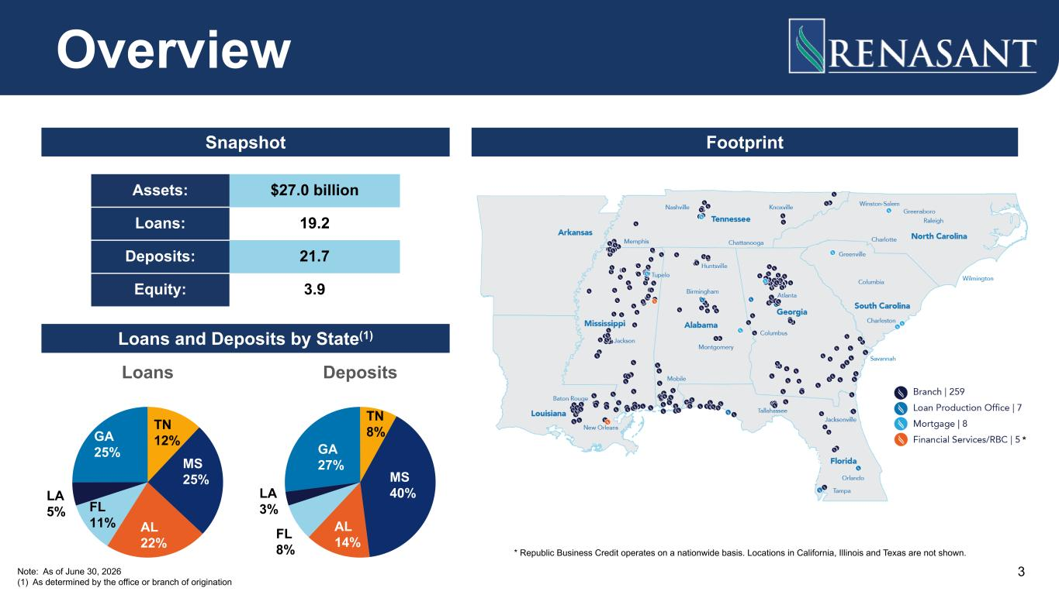
Loans TN 12% MS 25% AL 22% FL 11% LA 5% GA 25% Deposits TN 8% MS 40% AL 14%FL 8% LA 3% GA 27% * Overview * Republic Business Credit operates on a nationwide basis. Locations in California, Illinois and Texas are not shown. Snapshot Footprint Loans and Deposits by State(1) Note: As of June 30, 2026 (1) As determined by the office or branch of origination 3 Assets: $27.0 billion Loans: 19.2 Deposits: 21.7 Equity: 3.9

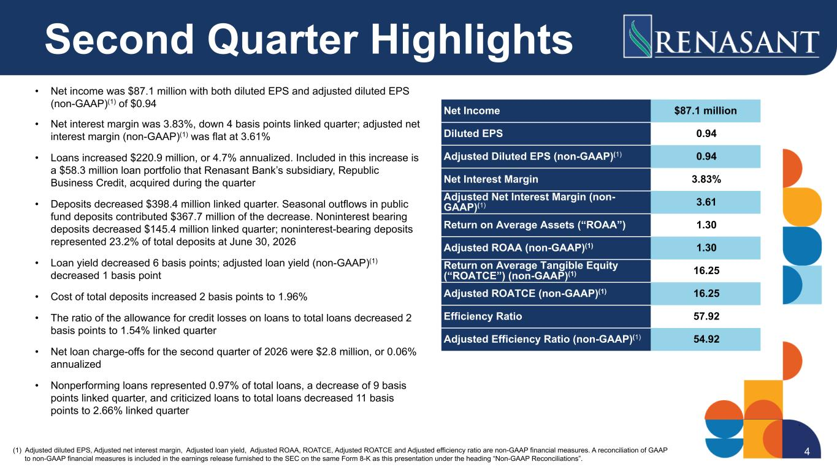
Second Quarter Highlights • Net income was $87.1 million with both diluted EPS and adjusted diluted EPS (non-GAAP)(1) of $0.94 • Net interest margin was 3.83%, down 4 basis points linked quarter; adjusted net interest margin (non-GAAP)(1) was flat at 3.61% • Loans increased $220.9 million, or 4.7% annualized. Included in this increase is a $58.3 million loan portfolio that Renasant Bank’s subsidiary, Republic Business Credit, acquired during the quarter • Deposits decreased $398.4 million linked quarter. Seasonal outflows in public fund deposits contributed $367.7 million of the decrease. Noninterest bearing deposits decreased $145.4 million linked quarter; noninterest-bearing deposits represented 23.2% of total deposits at June 30, 2026 • Loan yield decreased 6 basis points; adjusted loan yield (non-GAAP)(1) decreased 1 basis point • Cost of total deposits increased 2 basis points to 1.96% • The ratio of the allowance for credit losses on loans to total loans decreased 2 basis points to 1.54% linked quarter • Net loan charge-offs for the second quarter of 2026 were $2.8 million, or 0.06% annualized • Nonperforming loans represented 0.97% of total loans, a decrease of 9 basis points linked quarter, and criticized loans to total loans decreased 11 basis points to 2.66% linked quarter (1) Adjusted diluted EPS, Adjusted net interest margin, Adjusted loan yield, Adjusted ROAA, ROATCE, Adjusted ROATCE and Adjusted efficiency ratio are non-GAAP financial measures. A reconciliation of GAAP to non-GAAP financial measures is included in the earnings release furnished to the SEC on the same Form 8-K as this presentation under the heading “Non-GAAP Reconciliations”. 4 Net Income $87.1 million Diluted EPS 0.94 Adjusted Diluted EPS (non-GAAP)(1) 0.94 Net Interest Margin 3.83% Adjusted Net Interest Margin (non- GAAP)(1) 3.61 Return on Average Assets (“ROAA”) 1.30 Adjusted ROAA (non-GAAP)(1) 1.30 Return on Average Tangible Equity (“ROATCE”) (non-GAAP)(1) 16.25 Adjusted ROATCE (non-GAAP)(1) 16.25 Efficiency Ratio 57.92 Adjusted Efficiency Ratio (non-GAAP)(1) 54.92

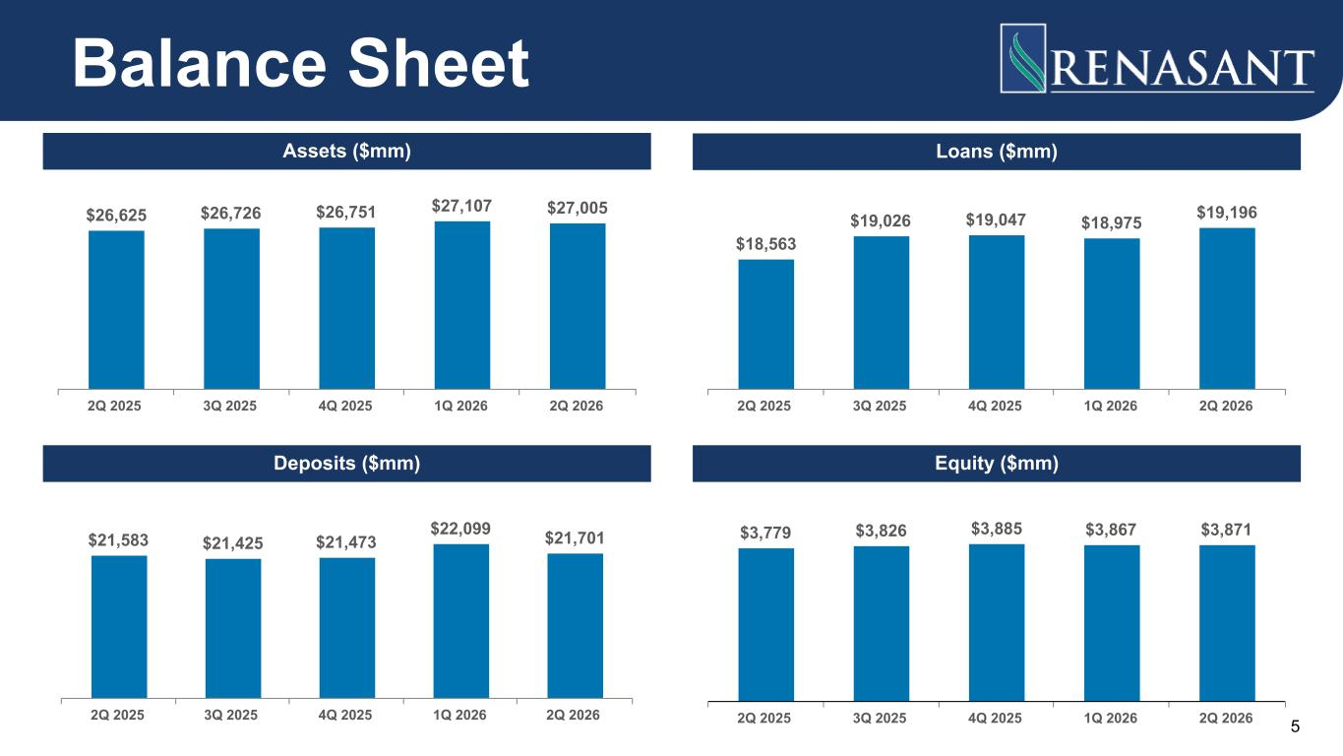
$26,625 $26,726 $26,751 $27,107 $27,005 2Q 2025 3Q 2025 4Q 2025 1Q 2026 2Q 2026 $18,563 $19,026 $19,047 $18,975 $19,196 2Q 2025 3Q 2025 4Q 2025 1Q 2026 2Q 2026 $21,583 $21,425 $21,473 $22,099 $21,701 2Q 2025 3Q 2025 4Q 2025 1Q 2026 2Q 2026 $3,779 $3,826 $3,885 $3,867 $3,871 2Q 2025 3Q 2025 4Q 2025 1Q 2026 2Q 2026 Balance Sheet Assets ($mm) Loans ($mm) Deposits ($mm) Equity ($mm) 5

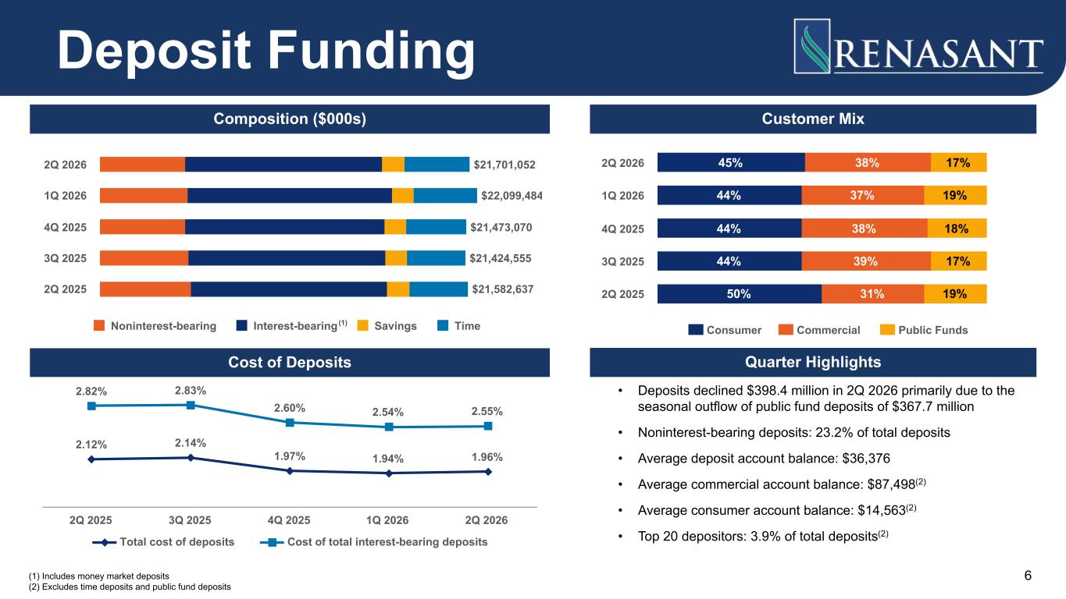
(1) Includes money market deposits (2) Excludes time deposits and public fund deposits Composition ($000s) Quarter Highlights $21,701,052 $22,099,484 $21,473,070 $21,424,555 $21,582,637 Noninterest-bearing Interest-bearing Savings Time 2Q 2026 1Q 2026 4Q 2025 3Q 2025 2Q 2025 Deposit Funding • Deposits declined $398.4 million in 2Q 2026 primarily due to the seasonal outflow of public fund deposits of $367.7 million • Noninterest-bearing deposits: 23.2% of total deposits • Average deposit account balance: $36,376 • Average commercial account balance: $87,498(2) • Average consumer account balance: $14,563(2) • Top 20 depositors: 3.9% of total deposits(2) Customer Mix 45% 44% 44% 44% 50% 38% 37% 38% 39% 31% 17% 19% 18% 17% 19% Consumer Commercial Public Funds 2Q 2026 1Q 2026 4Q 2025 3Q 2025 2Q 2025 2.12% 2.14% 1.97% 1.94% 1.96% 2.82% 2.83% 2.60% 2.54% 2.55% Total cost of deposits Cost of total interest-bearing deposits 2Q 2025 3Q 2025 4Q 2025 1Q 2026 2Q 2026 Cost of Deposits 6 (1)

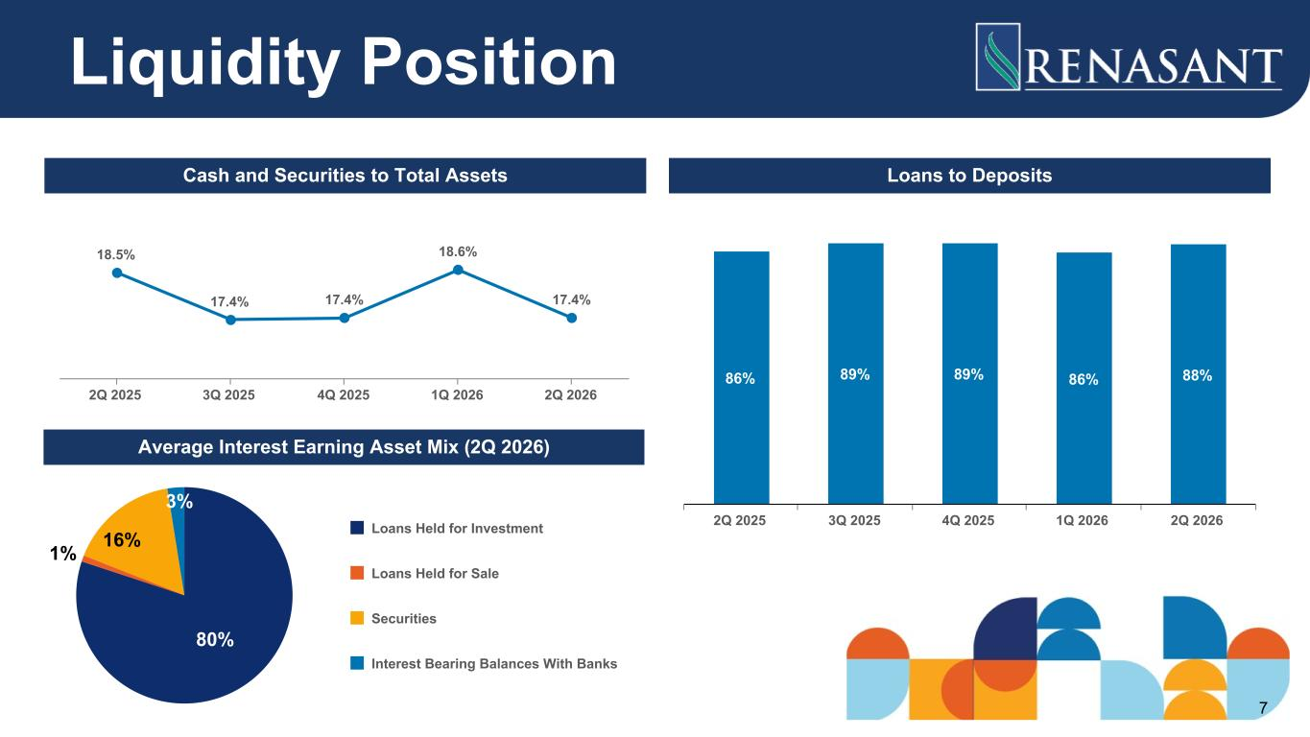
Cash and Securities to Total Assets Loans to Deposits Average Interest Earning Asset Mix (2Q 2026) 18.5% 17.4% 17.4% 18.6% 17.4% 2Q 2025 3Q 2025 4Q 2025 1Q 2026 2Q 2026 86% 89% 89% 86% 88% 2Q 2025 3Q 2025 4Q 2025 1Q 2026 2Q 2026 80% 1% 16% 3% Loans Held for Investment Loans Held for Sale Securities Interest Bearing Balances With Banks Liquidity Position 7

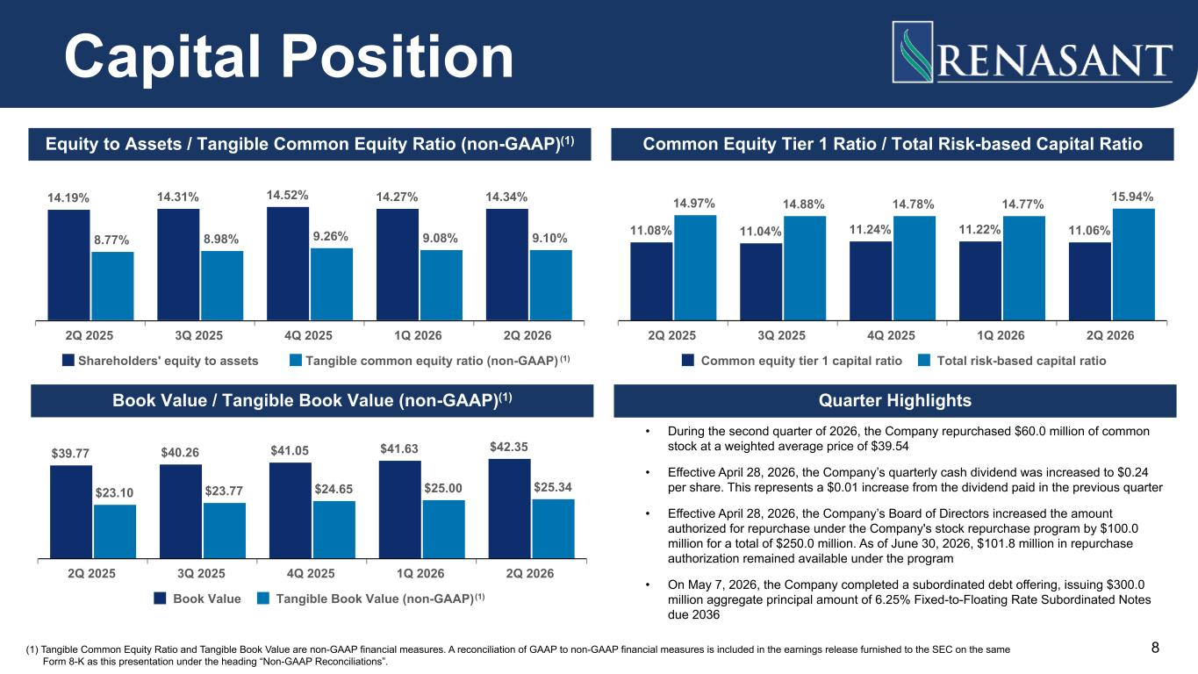
14.19% 14.31% 14.52% 14.27% 14.34% 8.77% 8.98% 9.26% 9.08% 9.10% Shareholders' equity to assets Tangible common equity ratio (non-GAAP) 2Q 2025 3Q 2025 4Q 2025 1Q 2026 2Q 2026 11.08% 11.04% 11.24% 11.22% 11.06% 14.97% 14.88% 14.78% 14.77% 15.94% Common equity tier 1 capital ratio Total risk-based capital ratio 2Q 2025 3Q 2025 4Q 2025 1Q 2026 2Q 2026 Quarter Highlights • During the second quarter of 2026, the Company repurchased $60.0 million of common stock at a weighted average price of $39.54 • Effective April 28, 2026, the Company’s quarterly cash dividend was increased to $0.24 per share. This represents a $0.01 increase from the dividend paid in the previous quarter • Effective April 28, 2026, the Company’s Board of Directors increased the amount authorized for repurchase under the Company's stock repurchase program by $100.0 million for a total of $250.0 million. As of June 30, 2026, $101.8 million in repurchase authorization remained available under the program • On May 7, 2026, the Company completed a subordinated debt offering, issuing $300.0 million aggregate principal amount of 6.25% Fixed-to-Floating Rate Subordinated Notes due 2036 (1) Tangible Common Equity Ratio and Tangible Book Value are non-GAAP financial measures. A reconciliation of GAAP to non-GAAP financial measures is included in the earnings release furnished to the SEC on the same Form 8-K as this presentation under the heading “Non-GAAP Reconciliations”. $39.77 $40.26 $41.05 $41.63 $42.35 $23.10 $23.77 $24.65 $25.00 $25.34 Book Value Tangible Book Value (non-GAAP) 2Q 2025 3Q 2025 4Q 2025 1Q 2026 2Q 2026 Capital Position Equity to Assets / Tangible Common Equity Ratio (non-GAAP)(1) Common Equity Tier 1 Ratio / Total Risk-based Capital Ratio Book Value / Tangible Book Value (non-GAAP)(1) 8 (1) (1)

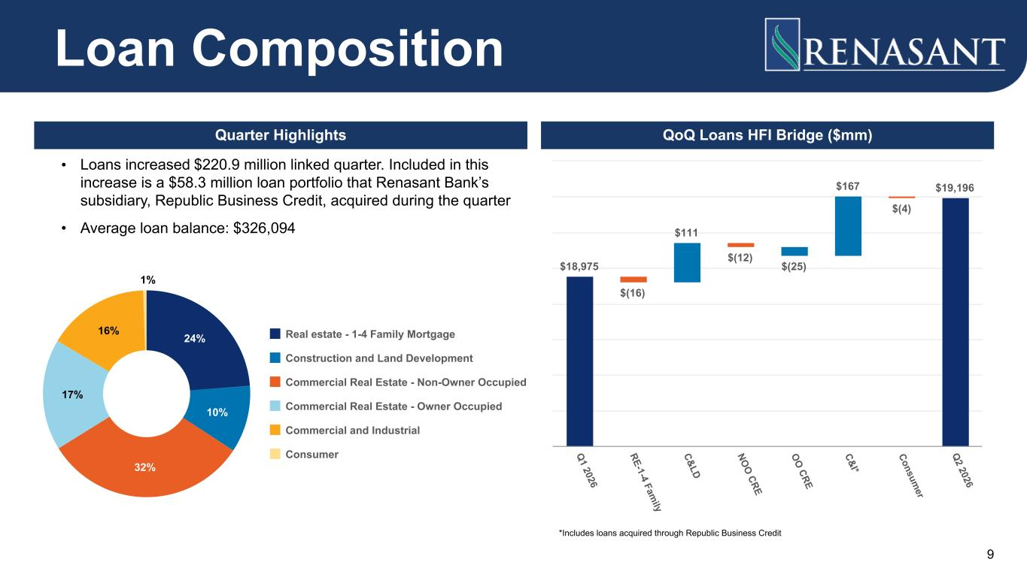
QoQ Loans HFI Bridge ($mm) $18,975 $(16) $111 $(12) $(25) $167 $(4) $19,196 Q 1 2026 RE-1-4 Fam ily C&LD NO O CRE O O CRE C&I* Consum er Q 2 2026 Quarter Highlights • Loans increased $220.9 million linked quarter. Included in this increase is a $58.3 million loan portfolio that Renasant Bank’s subsidiary, Republic Business Credit, acquired during the quarter • Average loan balance: $326,094 24% 10% 32% 17% 16% 1% Real estate - 1-4 Family Mortgage Construction and Land Development Commercial Real Estate - Non-Owner Occupied Commercial Real Estate - Owner Occupied Commercial and Industrial Consumer Loan Composition 9 *Includes loans acquired through Republic Business Credit

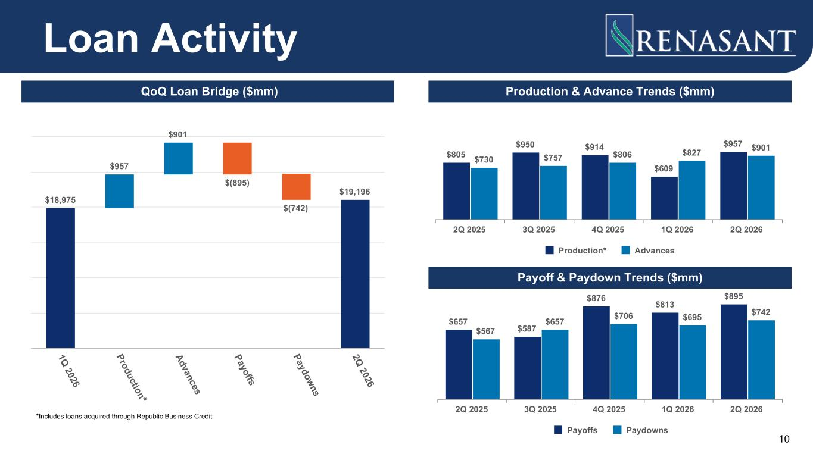
$805 $950 $914 $609 $957 $730 $757 $806 $827 $901 Production* Advances 2Q 2025 3Q 2025 4Q 2025 1Q 2026 2Q 2026 $657 $587 $876 $813 $895 $567 $657 $706 $695 $742 Payoffs Paydowns 2Q 2025 3Q 2025 4Q 2025 1Q 2026 2Q 2026 $18,975 $957 $901 $(895) $(742) $19,196 1Q 2026 Production* Advances Payoffs Paydowns 2Q 2026 Loan Activity QoQ Loan Bridge ($mm) Production & Advance Trends ($mm) Payoff & Paydown Trends ($mm) 10 *Includes loans acquired through Republic Business Credit

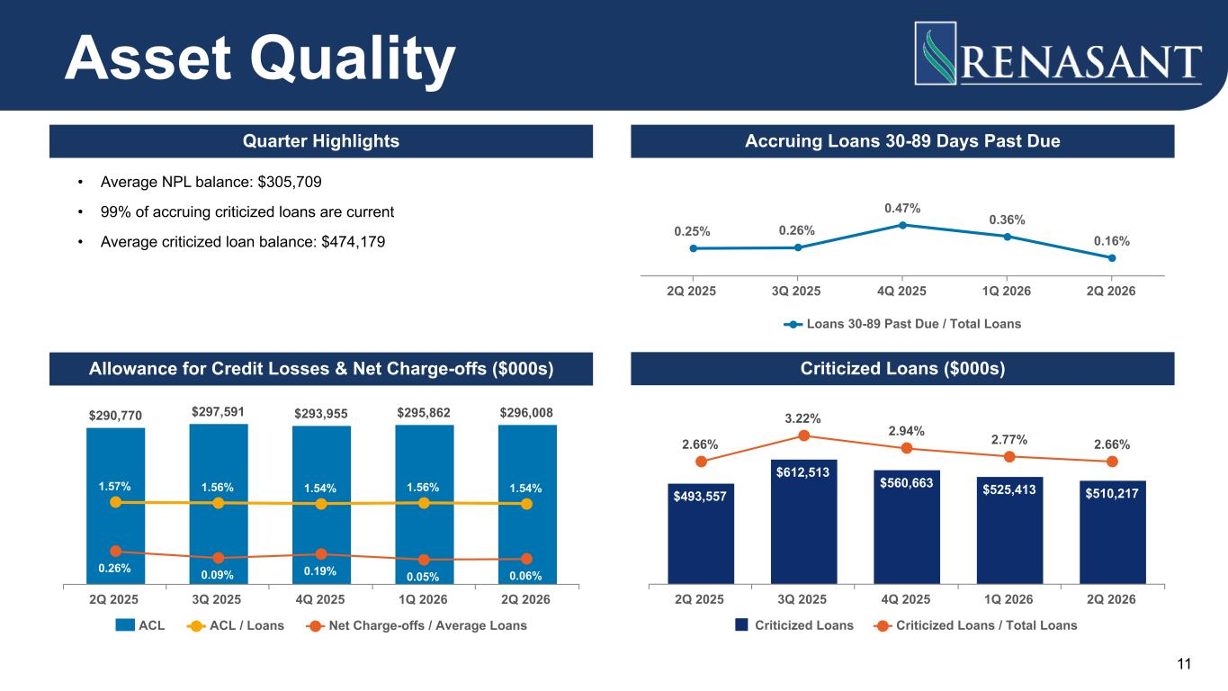
$290,770 $297,591 $293,955 $295,862 $296,008 1.57% 1.56% 1.54% 1.56% 1.54% 0.26% 0.09% 0.19% 0.05% 0.06% ACL ACL / Loans Net Charge-offs / Average Loans 2Q 2025 3Q 2025 4Q 2025 1Q 2026 2Q 2026 $493,557 $612,513 $560,663 $525,413 $510,217 2.66% 3.22% 2.94% 2.77% 2.66% Criticized Loans Criticized Loans / Total Loans 2Q 2025 3Q 2025 4Q 2025 1Q 2026 2Q 2026 Asset Quality Criticized Loans ($000s)Allowance for Credit Losses & Net Charge-offs ($000s) 0.25% 0.26% 0.47% 0.36% 0.16% Loans 30-89 Past Due / Total Loans 2Q 2025 3Q 2025 4Q 2025 1Q 2026 2Q 2026 Accruing Loans 30-89 Days Past DueQuarter Highlights • Average NPL balance: $305,709 • 99% of accruing criticized loans are current • Average criticized loan balance: $474,179 11

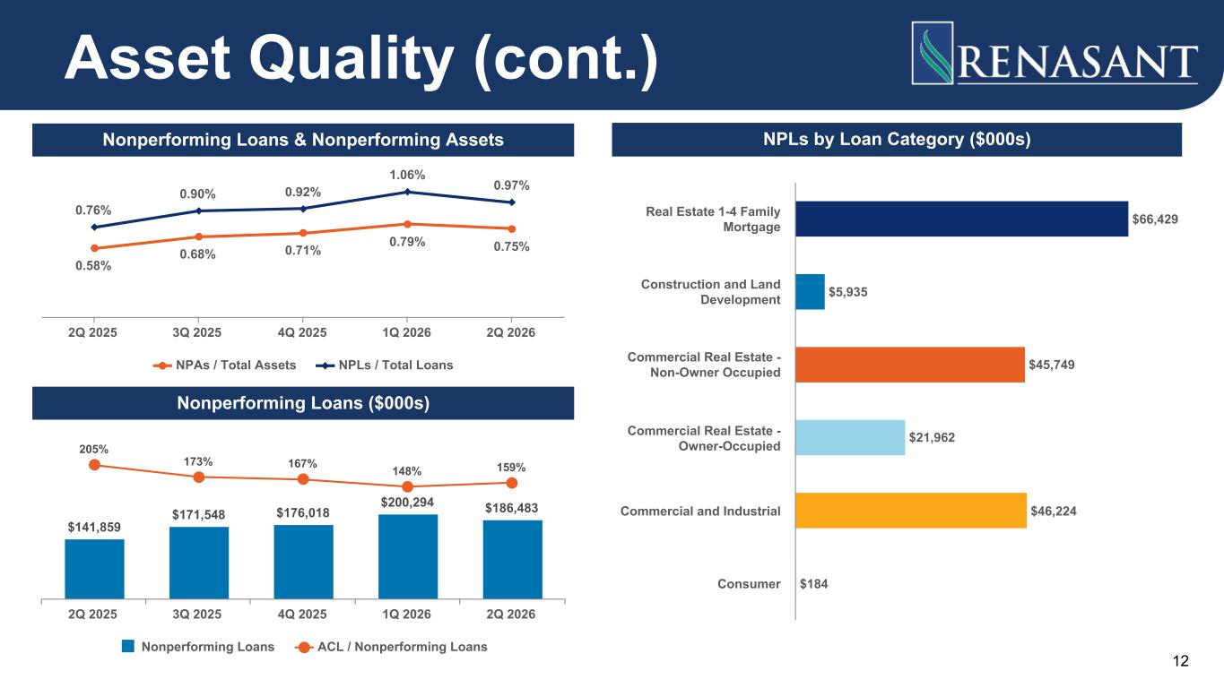
0.58% 0.68% 0.71% 0.79% 0.75% 0.76% 0.90% 0.92% 1.06% 0.97% NPAs / Total Assets NPLs / Total Loans 2Q 2025 3Q 2025 4Q 2025 1Q 2026 2Q 2026 $66,429 $5,935 $45,749 $21,962 $46,224 $184 Real Estate 1-4 Family Mortgage Construction and Land Development Commercial Real Estate - Non-Owner Occupied Commercial Real Estate - Owner-Occupied Commercial and Industrial Consumer NPLs by Loan Category ($000s) Asset Quality (cont.) Nonperforming Loans & Nonperforming Assets $141,859 $171,548 $176,018 $200,294 $186,483 205% 173% 167% 148% 159% Nonperforming Loans ACL / Nonperforming Loans 2Q 2025 3Q 2025 4Q 2025 1Q 2026 2Q 2026 Nonperforming Loans ($000s) 12

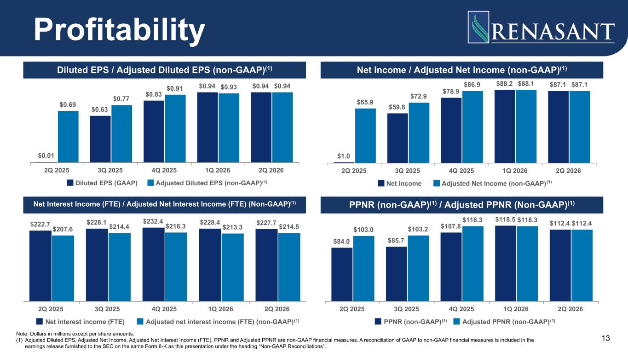
$0.01 $0.63 $0.83 $0.94 $0.94 $0.69 $0.77 $0.91 $0.93 $0.94 Diluted EPS (GAAP) Adjusted Diluted EPS (non-GAAP) 2Q 2025 3Q 2025 4Q 2025 1Q 2026 2Q 2026 $222.7 $228.1 $232.4 $228.4 $227.7 $207.6 $214.4 $216.3 $213.3 $214.5 Net interest income (FTE) Adjusted net interest income (FTE) (non-GAAP) 2Q 2025 3Q 2025 4Q 2025 1Q 2026 2Q 2026 Note: Dollars in millions except per share amounts. (1) Adjusted Diluted EPS, Adjusted Net Income, Adjusted Net Interest Income (FTE), PPNR and Adjusted PPNR are non-GAAP financial measures. A reconciliation of GAAP to non-GAAP financial measures is included in the earnings release furnished to the SEC on the same Form 8-K as this presentation under the heading “Non-GAAP Reconciliations”. $84.0 $85.7 $107.8 $118.5 $112.4 $103.0 $103.2 $118.3 $118.3 $112.4 PPNR (non-GAAP) Adjusted PPNR (non-GAAP) 2Q 2025 3Q 2025 4Q 2025 1Q 2026 2Q 2026 $1.0 $59.8 $78.9 $88.2 $87.1 $65.9 $72.9 $86.9 $88.1 $87.1 Net Income Adjusted Net Income (non-GAAP) 2Q 2025 3Q 2025 4Q 2025 1Q 2026 2Q 2026 Profitability Diluted EPS / Adjusted Diluted EPS (non-GAAP)(1) Net Income / Adjusted Net Income (non-GAAP)(1) PPNR (non-GAAP)(1) / Adjusted PPNR (Non-GAAP)(1)Net Interest Income (FTE) / Adjusted Net Interest Income (FTE) (Non-GAAP)(1) 13 (1) (1) (1) (1) (1)

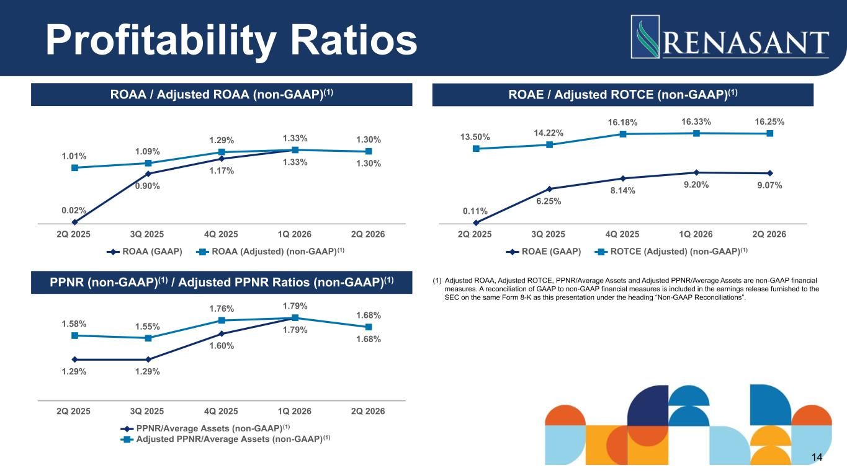
(1) Adjusted ROAA, Adjusted ROTCE, PPNR/Average Assets and Adjusted PPNR/Average Assets are non-GAAP financial measures. A reconciliation of GAAP to non-GAAP financial measures is included in the earnings release furnished to the SEC on the same Form 8-K as this presentation under the heading “Non-GAAP Reconciliations”. 0.02% 0.90% 1.17% 1.33% 1.30% 1.01% 1.09% 1.29% 1.33% 1.30% ROAA (GAAP) ROAA (Adjusted) (non-GAAP) 2Q 2025 3Q 2025 4Q 2025 1Q 2026 2Q 2026 0.11% 6.25% 8.14% 9.20% 9.07% 13.50% 14.22% 16.18% 16.33% 16.25% ROAE (GAAP) ROTCE (Adjusted) (non-GAAP) 2Q 2025 3Q 2025 4Q 2025 1Q 2026 2Q 2026 1.29% 1.29% 1.60% 1.79% 1.68% 1.58% 1.55% 1.76% 1.79% 1.68% PPNR/Average Assets (non-GAAP) Adjusted PPNR/Average Assets (non-GAAP) 2Q 2025 3Q 2025 4Q 2025 1Q 2026 2Q 2026 Profitability Ratios ROAA / Adjusted ROAA (non-GAAP)(1) ROAE / Adjusted ROTCE (non-GAAP)(1) PPNR (non-GAAP)(1) / Adjusted PPNR Ratios (non-GAAP)(1) 14 (1) (1) (1) (1)

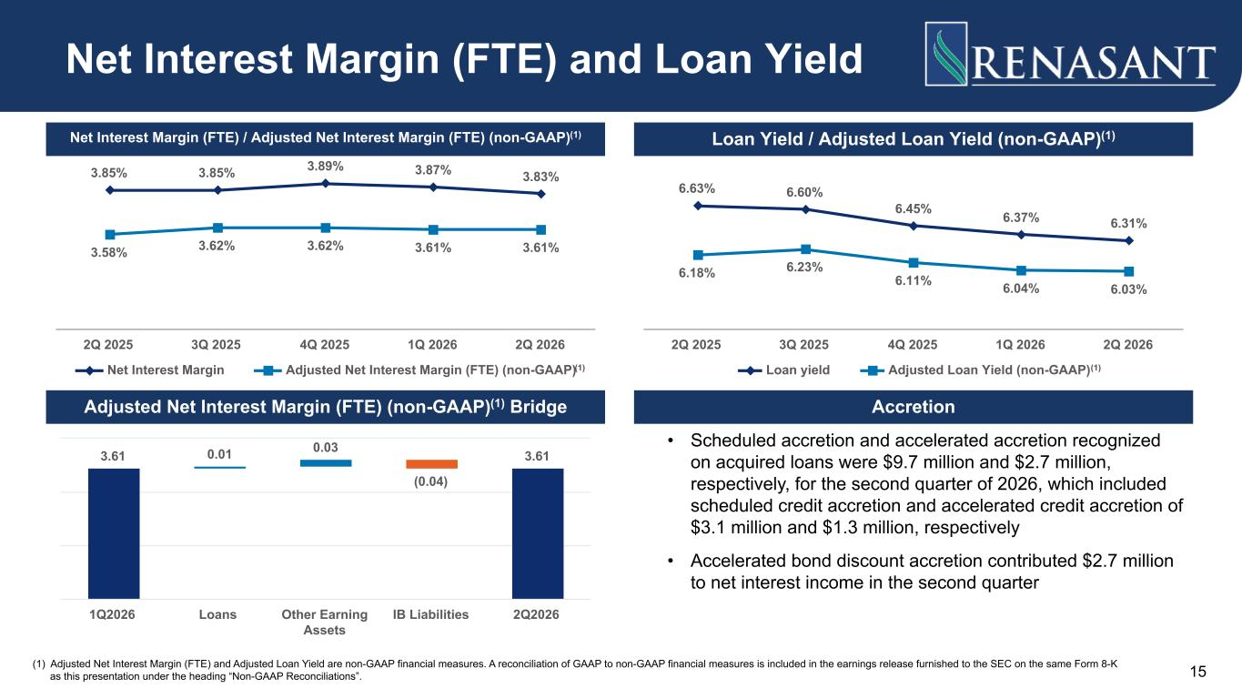
3.85% 3.85% 3.89% 3.87% 3.83% 3.58% 3.62% 3.62% 3.61% 3.61% Net Interest Margin Adjusted Net Interest Margin (FTE) (non-GAAP) 2Q 2025 3Q 2025 4Q 2025 1Q 2026 2Q 2026 (1) Adjusted Net Interest Margin (FTE) and Adjusted Loan Yield are non-GAAP financial measures. A reconciliation of GAAP to non-GAAP financial measures is included in the earnings release furnished to the SEC on the same Form 8-K as this presentation under the heading “Non-GAAP Reconciliations”. 6.63% 6.60% 6.45% 6.37% 6.31% 6.18% 6.23% 6.11% 6.04% 6.03% Loan yield Adjusted Loan Yield (non-GAAP) 2Q 2025 3Q 2025 4Q 2025 1Q 2026 2Q 2026 • Scheduled accretion and accelerated accretion recognized on acquired loans were $9.7 million and $2.7 million, respectively, for the second quarter of 2026, which included scheduled credit accretion and accelerated credit accretion of $3.1 million and $1.3 million, respectively • Accelerated bond discount accretion contributed $2.7 million to net interest income in the second quarter Net Interest Margin (FTE) and Loan Yield Net Interest Margin (FTE) / Adjusted Net Interest Margin (FTE) (non-GAAP)(1) Loan Yield / Adjusted Loan Yield (non-GAAP)(1) Adjusted Net Interest Margin (FTE) (non-GAAP)(1) Bridge Accretion 3.61 0.01 0.03 (0.04) 3.61 1Q2026 Loans Other Earning Assets IB Liabilities 2Q2026 15 (1) (1)

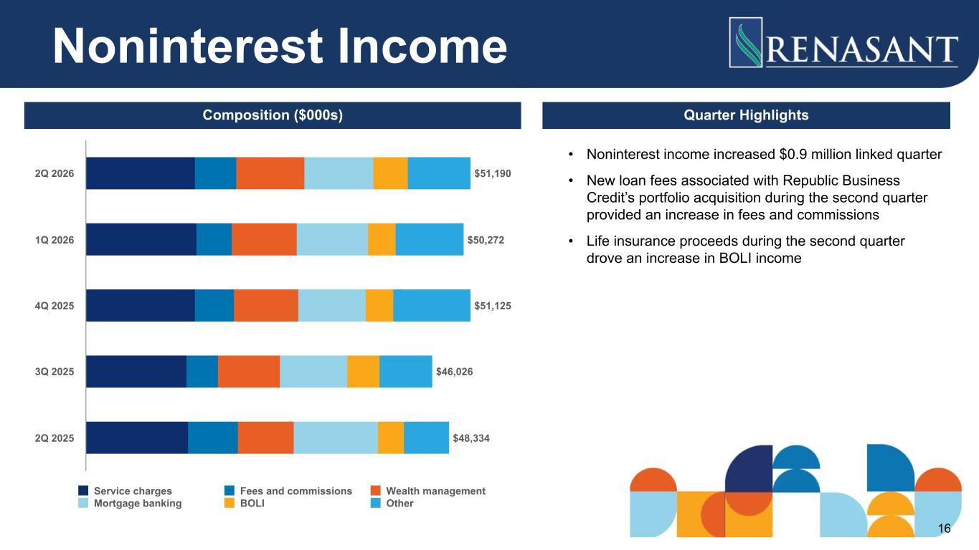
• Noninterest income increased $0.9 million linked quarter • New loan fees associated with Republic Business Credit’s portfolio acquisition during the second quarter provided an increase in fees and commissions • Life insurance proceeds during the second quarter drove an increase in BOLI income $51,190 $50,272 $51,125 $46,026 $48,334 Service charges Fees and commissions Wealth management Mortgage banking BOLI Other 2Q 2026 1Q 2026 4Q 2025 3Q 2025 2Q 2025 Noninterest Income Composition ($000s) Quarter Highlights 16

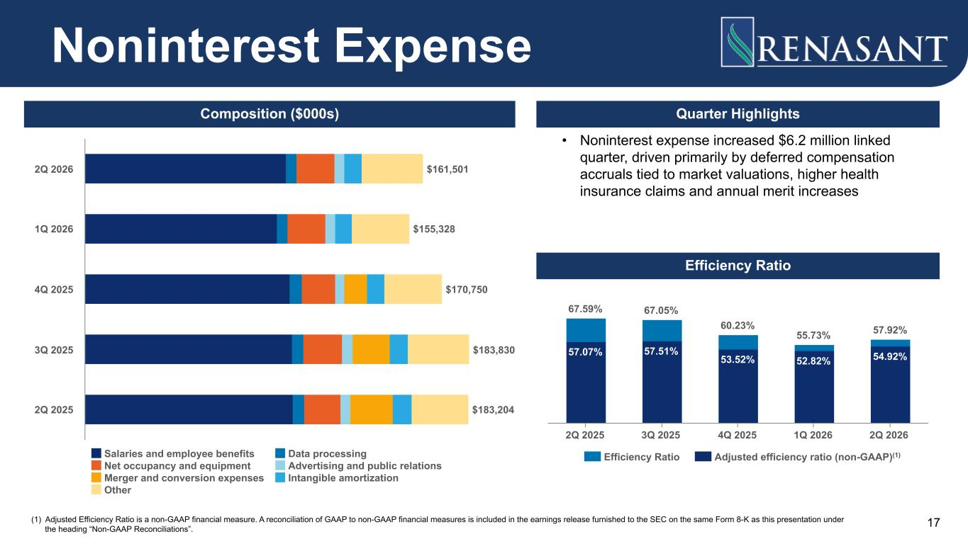
• Noninterest expense increased $6.2 million linked quarter, driven primarily by deferred compensation accruals tied to market valuations, higher health insurance claims and annual merit increases Quarter Highlights 57.07% 57.51% 53.52% 52.82% 54.92% 67.59% 67.05% 60.23% 55.73% 57.92% Efficiency Ratio Adjusted efficiency ratio (non-GAAP) 2Q 2025 3Q 2025 4Q 2025 1Q 2026 2Q 2026 $161,501 $155,328 $170,750 $183,830 $183,204 Salaries and employee benefits Data processing Net occupancy and equipment Advertising and public relations Merger and conversion expenses Intangible amortization Other 2Q 2026 1Q 2026 4Q 2025 3Q 2025 2Q 2025 Noninterest Expense Efficiency Ratio Composition ($000s) (1) Adjusted Efficiency Ratio is a non-GAAP financial measure. A reconciliation of GAAP to non-GAAP financial measures is included in the earnings release furnished to the SEC on the same Form 8-K as this presentation under the heading “Non-GAAP Reconciliations”. 17 (1)


Appendix

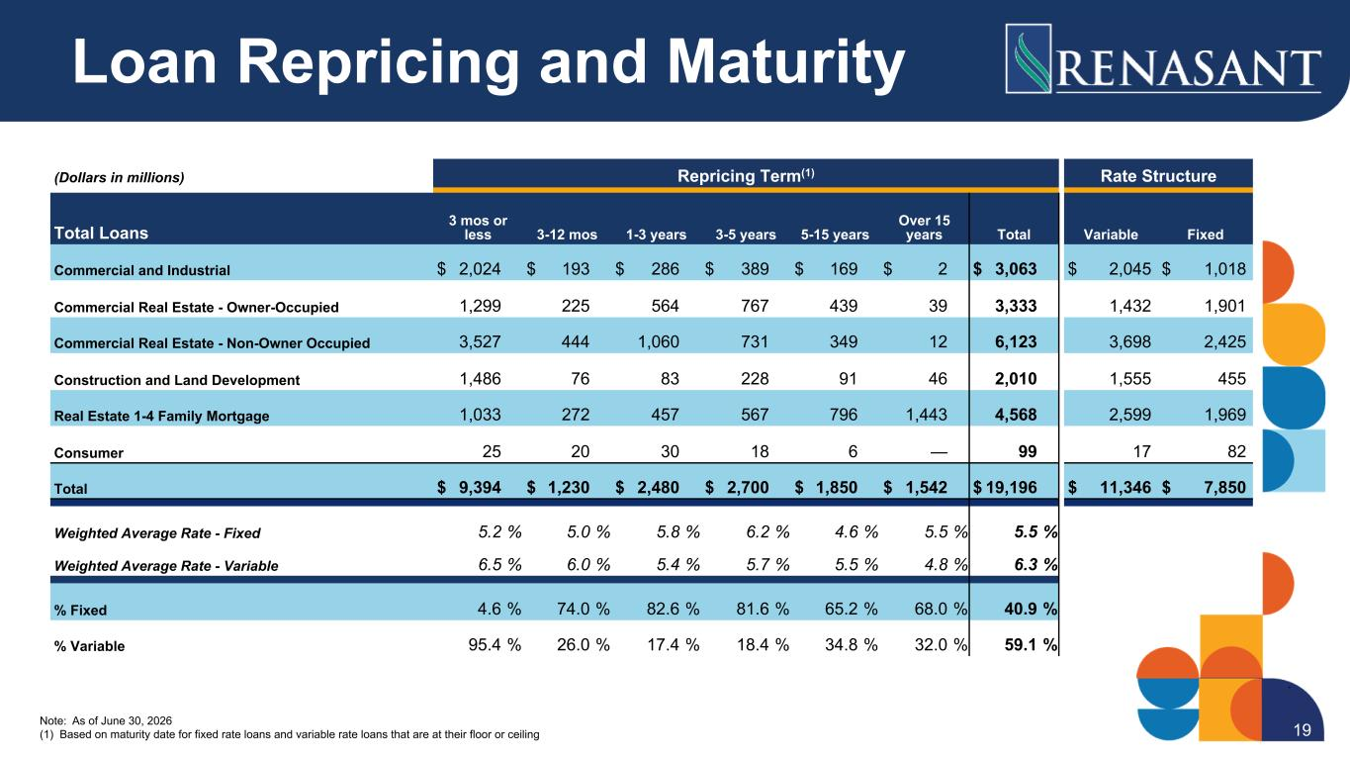
(Dollars in millions) Repricing Term(1) Rate Structure Total Loans 3 mos or less 3-12 mos 1-3 years 3-5 years 5-15 years Over 15 years Total Variable Fixed Commercial and Industrial $ 2,024 $ 193 $ 286 $ 389 $ 169 $ 2 $ 3,063 $ 2,045 $ 1,018 Commercial Real Estate - Owner-Occupied 1,299 225 564 767 439 39 3,333 1,432 1,901 Commercial Real Estate - Non-Owner Occupied 3,527 444 1,060 731 349 12 6,123 3,698 2,425 Construction and Land Development 1,486 76 83 228 91 46 2,010 1,555 455 Real Estate 1-4 Family Mortgage 1,033 272 457 567 796 1,443 4,568 2,599 1,969 Consumer 25 20 30 18 6 — 99 17 82 Total $ 9,394 $ 1,230 $ 2,480 $ 2,700 $ 1,850 $ 1,542 $ 19,196 $ 11,346 $ 7,850 Weighted Average Rate - Fixed 5.2 % 5.0 % 5.8 % 6.2 % 4.6 % 5.5 % 5.5 % Weighted Average Rate - Variable 6.5 % 6.0 % 5.4 % 5.7 % 5.5 % 4.8 % 6.3 % % Fixed 4.6 % 74.0 % 82.6 % 81.6 % 65.2 % 68.0 % 40.9 % % Variable 95.4 % 26.0 % 17.4 % 18.4 % 34.8 % 32.0 % 59.1 % Note: As of June 30, 2026 (1) Based on maturity date for fixed rate loans and variable rate loans that are at their floor or ceiling Loan Repricing and Maturity 19

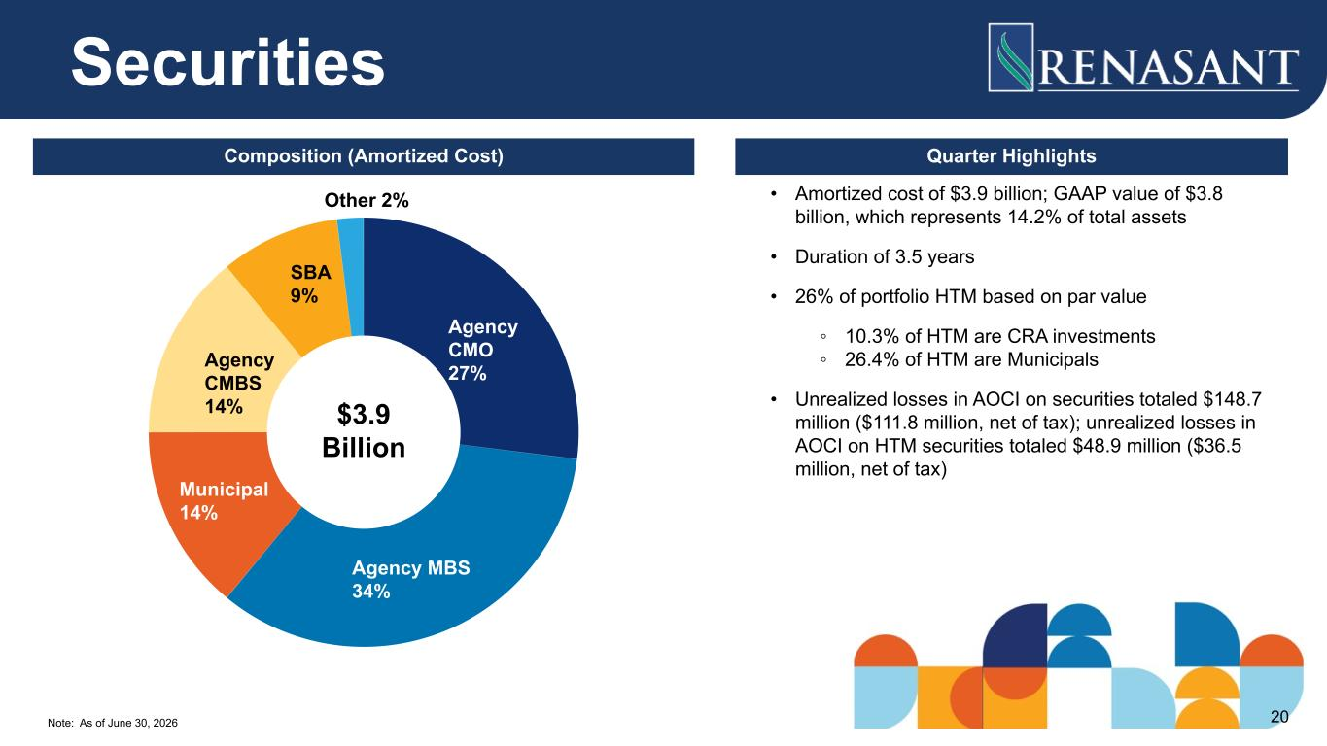
Note: As of June 30, 2026 Agency CMO 27% Agency MBS 34% Municipal 14% Agency CMBS 14% SBA 9% Other 2% • Amortized cost of $3.9 billion; GAAP value of $3.8 billion, which represents 14.2% of total assets • Duration of 3.5 years • 26% of portfolio HTM based on par value ◦ 10.3% of HTM are CRA investments ◦ 26.4% of HTM are Municipals • Unrealized losses in AOCI on securities totaled $148.7 million ($111.8 million, net of tax); unrealized losses in AOCI on HTM securities totaled $48.9 million ($36.5 million, net of tax) $3.9 Billion Securities Composition (Amortized Cost) Quarter Highlights 20

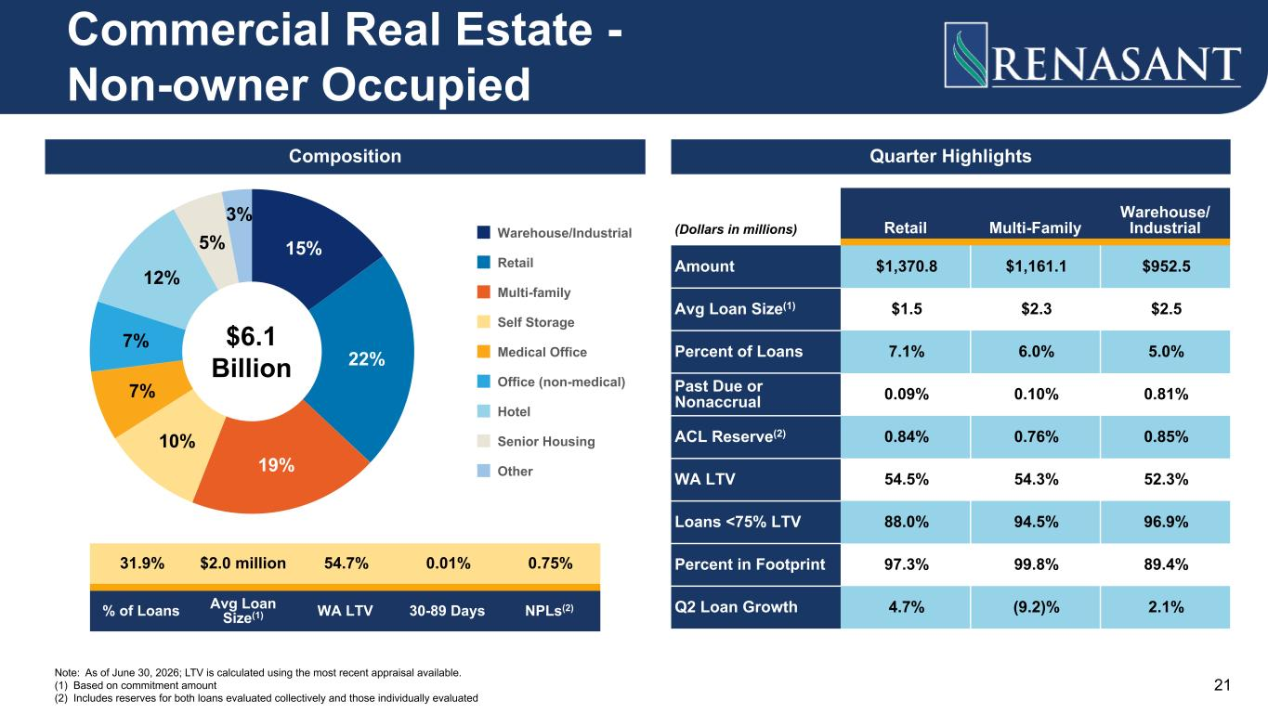
15% 22% 19% 10% 7% 7% 12% 5% 3% Warehouse/Industrial Retail Multi-family Self Storage Medical Office Office (non-medical) Hotel Senior Housing Other Quarter Highlights Note: As of June 30, 2026; LTV is calculated using the most recent appraisal available. (1) Based on commitment amount (2) Includes reserves for both loans evaluated collectively and those individually evaluated (Dollars in millions) Retail Multi-Family Warehouse/ Industrial Amount $1,370.8 $1,161.1 $952.5 Avg Loan Size(1) $1.5 $2.3 $2.5 Percent of Loans 7.1% 6.0% 5.0% Past Due or Nonaccrual 0.09% 0.10% 0.81% ACL Reserve(2) 0.84% 0.76% 0.85% WA LTV 54.5% 54.3% 52.3% Loans <75% LTV 88.0% 94.5% 96.9% Percent in Footprint 97.3% 99.8% 89.4% Q2 Loan Growth 4.7% (9.2)% 2.1% Commercial Real Estate - Non-owner Occupied $6.1 Billion Composition 31.9% $2.0 million 54.7% 0.01% 0.75% % of Loans Avg Loan Size(1) WA LTV 30-89 Days NPLs(2) 21

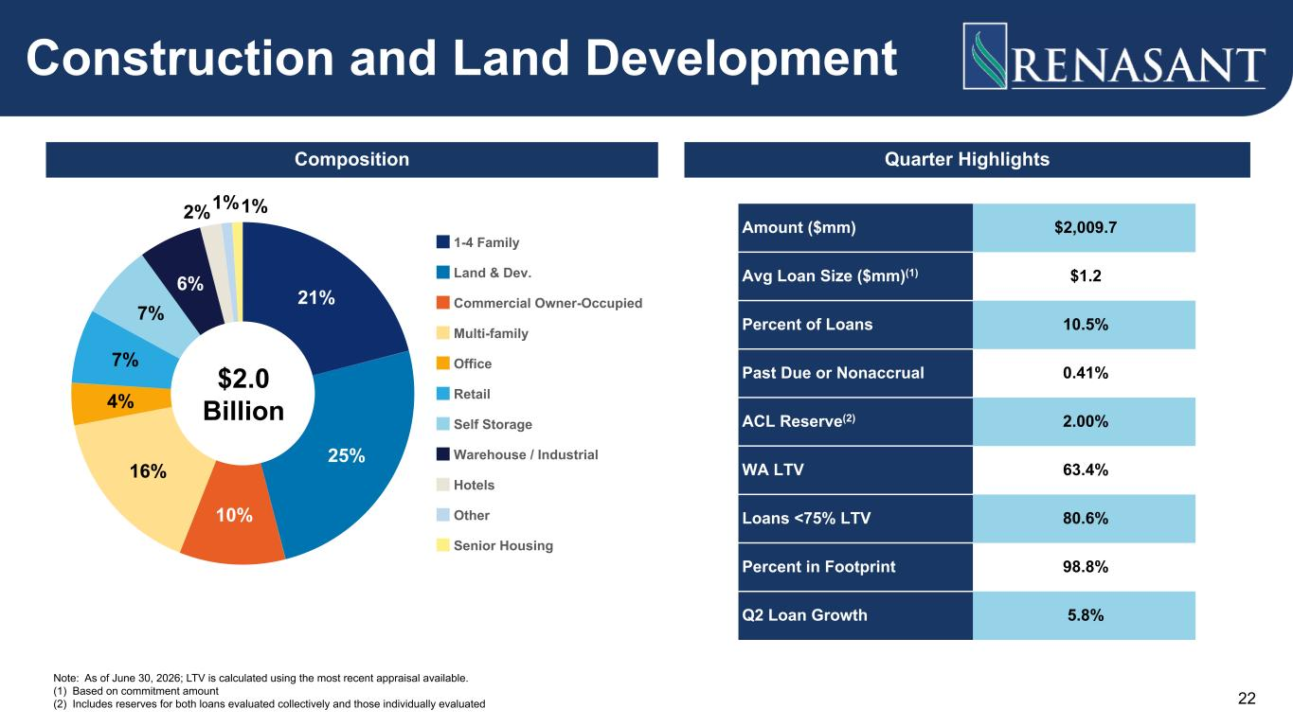
Note: As of June 30, 2026; LTV is calculated using the most recent appraisal available. (1) Based on commitment amount (2) Includes reserves for both loans evaluated collectively and those individually evaluated 21% 25% 10% 16% 4% 7% 7% 6% 2%1%1% 1-4 Family Land & Dev. Commercial Owner-Occupied Multi-family Office Retail Self Storage Warehouse / Industrial Hotels Other Senior Housing Amount ($mm) $2,009.7 Avg Loan Size ($mm)(1) $1.2 Percent of Loans 10.5% Past Due or Nonaccrual 0.41% ACL Reserve(2) 2.00% WA LTV 63.4% Loans <75% LTV 80.6% Percent in Footprint 98.8% Q2 Loan Growth 5.8% Construction and Land Development $2.0 Billion Composition Quarter Highlights 22

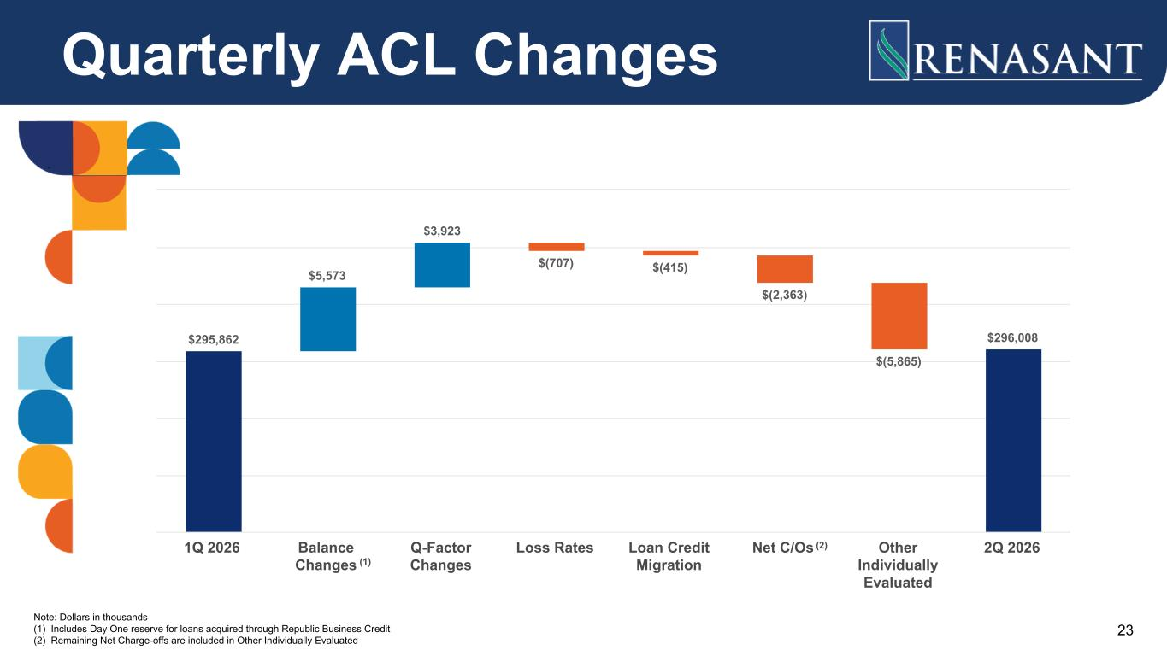
Quarterly ACL Changes $295,862 $5,573 $3,923 $(707) $(415) $(2,363) $(5,865) $296,008 1Q 2026 Balance Changes Q-Factor Changes Loss Rates Loan Credit Migration Net C/Os Other Individually Evaluated 2Q 2026 Note: Dollars in thousands (1) Includes Day One reserve for loans acquired through Republic Business Credit (2) Remaining Net Charge-offs are included in Other Individually Evaluated 23 (2) (1)

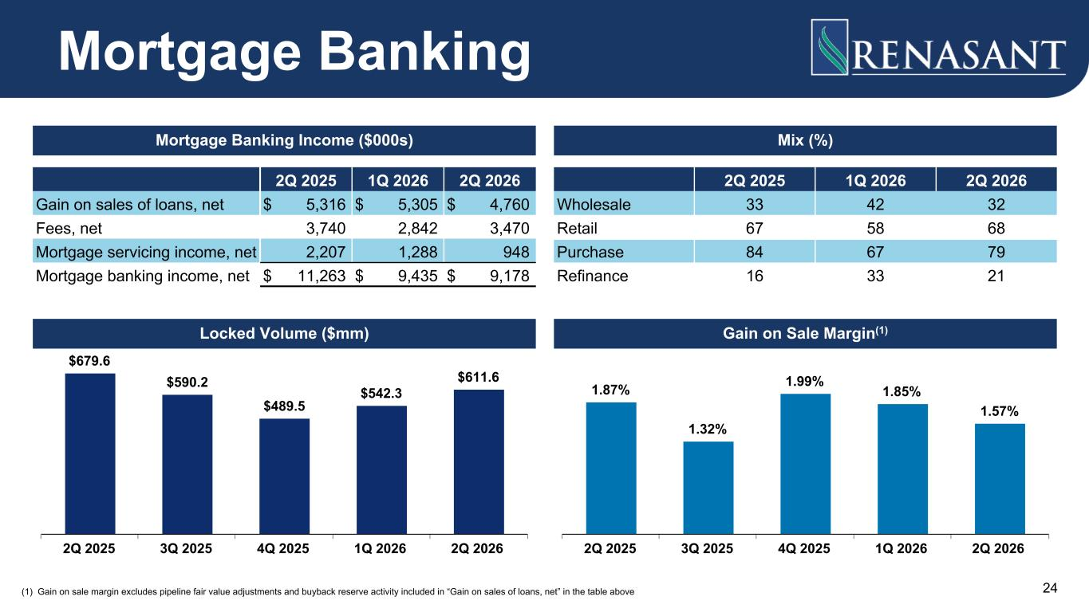
2Q 2025 1Q 2026 2Q 2026 Gain on sales of loans, net $ 5,316 $ 5,305 $ 4,760 Fees, net 3,740 2,842 3,470 Mortgage servicing income, net 2,207 1,288 948 Mortgage banking income, net $ 11,263 $ 9,435 $ 9,178 2Q 2025 1Q 2026 2Q 2026 Wholesale 33 42 32 Retail 67 58 68 Purchase 84 67 79 Refinance 16 33 21 $679.6 $590.2 $489.5 $542.3 $611.6 2Q 2025 3Q 2025 4Q 2025 1Q 2026 2Q 2026 (1) Gain on sale margin excludes pipeline fair value adjustments and buyback reserve activity included in “Gain on sales of loans, net” in the table above 1.87% 1.32% 1.99% 1.85% 1.57% 2Q 2025 3Q 2025 4Q 2025 1Q 2026 2Q 2026 Mortgage Banking Mortgage Banking Income ($000s) Mix (%) Locked Volume ($mm) Gain on Sale Margin(1) 24



