UNITED STATES
SECURITIES AND EXCHANGE COMMISSION
Washington, D.C. 20549

FORM 8-K
CURRENT REPORT
Pursuant to Section 13 OR 15(d) of the Securities Exchange Act of 1934

August 6, 2026
Date of report (Date of earliest event reported)

RENASANT CORPORATION
(Exact name of registrant as specified in its charter)
Mississippi |  |  | 001-13253 |  |  | 64-0676974
(State or other jurisdiction  of incorporation) |  |  | (Commission  File Number) |  |  | (I.R.S. Employer  Identification No.)

209 Troy Street, Tupelo, Mississippi 38804-4827
(Address of principal executive offices)(Zip Code)

Registrant’s telephone number, including area code: (662) 680-1001
Check the appropriate box below if the Form 8-K filing is intended to simultaneously satisfy the filing obligation of the registrant under any of the following provisions:
☐ |  |  | Written communications pursuant to Rule 425 under the Securities Act (17 CFR 230.425)
☐ |  |  | Soliciting material pursuant to Rule 14a-12 under the Exchange Act (17 CFR 240.14a-12)
☐ |  |  | Pre-commencement communications pursuant to Rule 14d-2(b) under the Exchange Act (17 CFR 240.14d-2(b))
☐ |  |  | Pre-commencement communications pursuant to Rule 13e-4(c) under the Exchange Act (17 CFR 240.13e-4(c))
Securities registered pursuant to Section 12(b) of the Act:
Title of each class |  |  | Trading Symbol(s) |  |  | Name of each exchange on which registered
Common stock, $5.00 par value per share |  |  | RNST |  |  | The New York Stock Exchange
Indicate by check mark whether the registrant is an emerging growth company as defined in Rule 405 of the Securities Act of 1933 (17 CFR §230.405) or Rule 12b-2 of the Securities Exchange Act of 1934 (17 CFR §240.12b-2). Emerging growth company ☐
If an emerging growth company, indicate by check mark if the registrant has elected not to use the extended transition period for complying with any new or revised financial accounting standards provided pursuant to Section 13(a) of the Exchange Act. ☐

Item 7.01 Regulation FD Disclosure.
Representatives of Renasant Corporation (“Renasant” or the “Company”) will make presentations to investors during various conferences in the third quarter of 2026. Attached hereto as Exhibit 99.1 of this Form 8-K is a copy of the materials that the Company will make available at these presentations.
In accordance with General Instruction B.2 of Form 8-K, the information in this Item 7.01, including Exhibit 99.1, is being furnished and shall not be deemed to be “filed” for purposes of Section 18 of the Securities Exchange Act of 1934, as amended, or otherwise subject to the liabilities of that section, and shall not be deemed incorporated by reference into any registration statement or other document filed pursuant to the Securities Act of 1933, as amended, or the Securities Exchange Act of 1934, as amended, except as shall be expressly set forth by specific reference in such filing.
CAUTIONARY NOTE REGARDING FORWARD-LOOKING STATEMENTS:
The presentation furnished herewith may contain, or incorporate by reference, statements about Renasant Corporation that constitute “forward-looking statements” within the meaning of Section 27A of the Securities Act of 1933, as amended, and Section 21E of the Securities Exchange Act of 1934, as amended. Statements preceded by, followed by or that otherwise include the words “believes,” “expects,” “projects,” “anticipates,” “intends,” “estimates,” “plans,” “potential,” “focus,” “possible,” “may increase,” “may fluctuate,” “will likely result,” or similar expressions, or future or conditional verbs such as “will,” “should,” “would” and “could,” are generally forward-looking in nature and not historical facts. Forward-looking statements include information about the Company’s future financial performance, business strategy, projected plans and objectives and are based on the current beliefs and expectations of management. The Company’s management believes these forward-looking statements are reasonable, but they are all inherently subject to significant business, economic and competitive risks and uncertainties, many of which are beyond the Company’s control. In addition, these forward-looking statements are subject to assumptions with respect to future business strategies and decisions that are subject to change. Actual results may differ from those indicated or implied in the forward-looking statements, and such differences may be material. Prospective investors are cautioned that any forward-looking statements are not guarantees of future performance and involve risks and uncertainties and, accordingly, investors should not place undue reliance on these forward-looking statements, which speak only as of the date they are made.
Important factors currently known to management that could cause the Company’s actual results to differ materially from those in forward-looking statements include the following: (i) the Company’s ability to efficiently integrate acquisitions into its operations, retain the customers of these businesses, grow the acquired operations and realize the cost savings expected from an acquisition to the extent and in the timeframe anticipated by management (including the possibility that such cost savings will not be realized when expected, or at all, as a result of the impact of, or challenges arising from, the integration of the acquired assets and assumed liabilities into the Company, potential adverse reactions or changes to business or employee relationships, or as a result of other unexpected factors or events); (ii) potential exposure to unknown or contingent risks and liabilities the Company has acquired or may acquire; (iii) the effect of economic conditions and interest rates on a national, regional or international basis; (iv) timing and success of the implementation of changes in operations to achieve enhanced earnings or effect cost savings; (v) the Company’s ability to remediate the material weakness in the Company’s internal control over financial reporting identified in its Annual Report on Form 10-K for the year ended December 31, 2025 filed with the Securities and Exchange Commission (the “SEC”) on March 2, 2026; (vi) competitive pressures in the consumer finance, commercial finance, financial services, asset management, retail banking, factoring and mortgage lending and auto lending industries; (vii) the financial resources of, and products available from, competitors; (viii) changes in laws and regulations as well as changes in accounting standards; (ix) changes in governmental and regulatory policy, whether applicable specifically to financial institutions or impacting the United States generally (such as, for example, changes in trade policy); (x) changes in the securities and foreign exchange markets; (xi) the Company’s potential growth, including its entrance or expansion into new markets, and the need for sufficient capital to support that growth; (xii) changes in the quality or composition of the Company’s loan or investment portfolios, including adverse developments in borrower industries or in the repayment ability of individual borrowers or issuers of investment securities, or the impact of interest rates on the value of the Company’s investment securities portfolio; (xiii) an insufficient allowance for credit losses as a result of inaccurate assumptions; (xiv) changes in the sources

and costs of the capital the Company uses to make loans and otherwise fund the Company’s operations, due to deposit outflows, changes in the mix of deposits and the cost and availability of borrowings; (xv) general economic, market or business conditions, including the impact of inflation; (xvi) changes in demand for loan and deposit products and other financial services; (xvii) concentrations of credit or deposit exposure; (xviii) changes or the lack of changes in interest rates, yield curves and interest rate spread relationships; (xix) losses resulting from fraudulent activity, including loan and deposit fraud and social engineering attacks targeting the Company’s customers, employees and third party vendors; (xx) increased cybersecurity risk, including potential network breaches, business disruptions or financial losses, including as a result of sophisticated attacks using artificial intelligence (“AI”) and similar tools; (xxi) civil unrest, natural disasters, epidemics and other catastrophic events in the Company’s geographic area; (xxii) geopolitical conditions, including acts or threats of terrorism and actions taken by the United States or other governments in response to acts or threats of terrorism and/or military conflicts, which could impact business and economic conditions in the United States and abroad; (xxiii) the impact, extent and timing of technological changes, including the rapid development of AI technologies; and (xxiv) other circumstances, many of which are beyond management’s control.
Management believes that the assumptions underlying the Company’s forward-looking statements are reasonable, but any of the assumptions could prove to be inaccurate. Investors are urged to carefully consider the risks described in the Company’s filings with the SEC from time to time, including its most recent Annual Report on Form 10-K and subsequent Quarterly Reports on Form 10-Q, which are available at www.renasant.com and the SEC’s website at www.sec.gov.
Renasant undertakes no obligation, and specifically disclaims any obligation, to update or revise forward-looking statements, whether as a result of new information or to reflect changed assumptions, the occurrence of unanticipated events or changes to future operating results over time, except as required by federal securities laws.

Item 9.01 Financial Statements and Exhibits.

(d) Exhibits.
The following exhibits are being furnished herewith and this list shall constitute the exhibit index:
Exhibit No. |  |  |  |  |  | Description
99.1 |  |  |  |  |  | Presentation materials that Renasant Corporation intends to provide to investors on or after August 6, 2026.
104 |  |  |  |  |  | The cover page of Renasant Corporation’s Form 8-K is formatted in Inline XBRL.

SIGNATURES
Pursuant to the requirements of the Securities Exchange Act of 1934, the registrant has duly caused this report to be signed on its behalf by the undersigned hereunto duly authorized.
 |  |  |  |  |  | RENASANT CORPORATION
Date: August 6, 2026 |  |  |  |  |  | By: |  |  | /s/ Kevin D. Chapman
 |  |  |  |  |  |  |  |  | Kevin D. Chapman
 |  |  |  |  |  |  |  |  | President and Chief Executive Officer

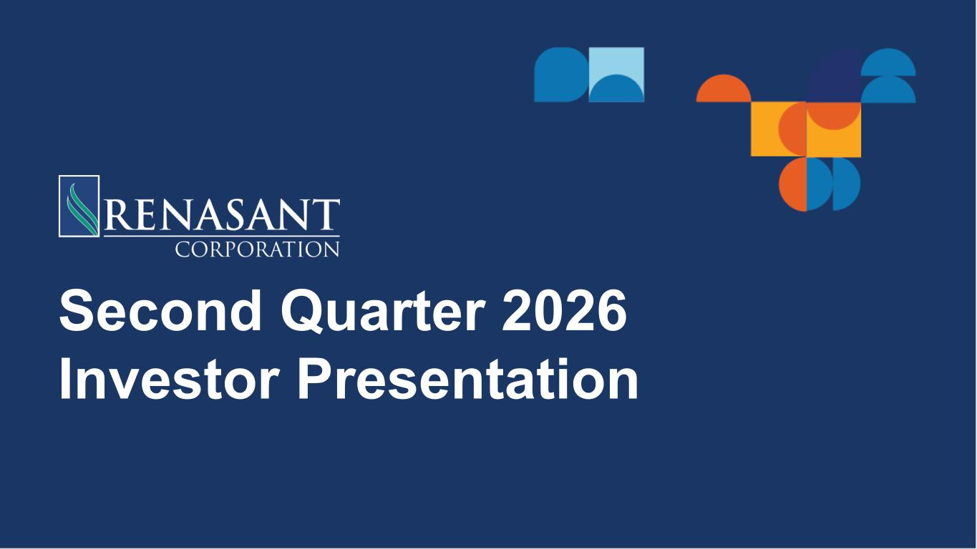

Second Quarter 2026 Investor Presentation

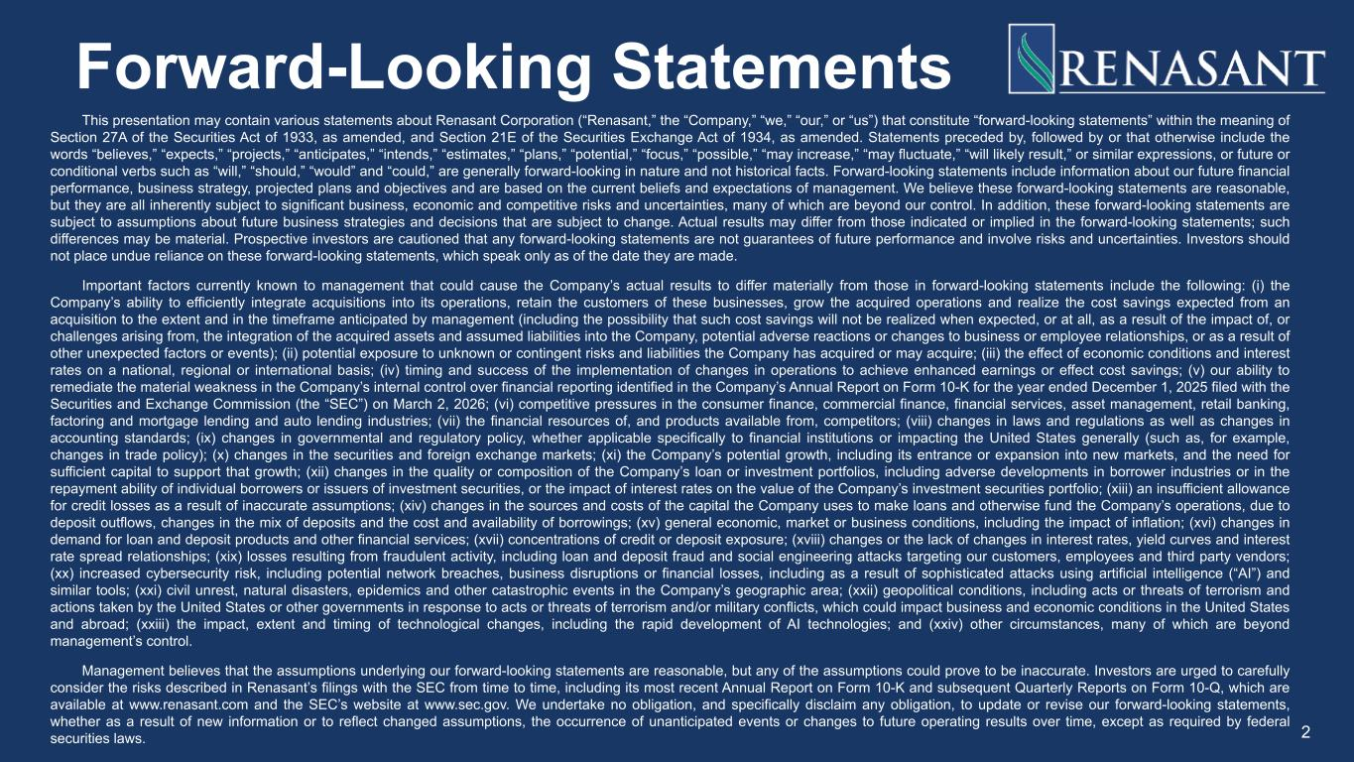
Forward-Looking Statements This presentation may contain various statements about Renasant Corporation (“Renasant,” the “Company,” “we,” “our,” or “us”) that constitute “forward-looking statements” within the meaning of Section 27A of the Securities Act of 1933, as amended, and Section 21E of the Securities Exchange Act of 1934, as amended. Statements preceded by, followed by or that otherwise include the words “believes,” “expects,” “projects,” “anticipates,” “intends,” “estimates,” “plans,” “potential,” “focus,” “possible,” “may increase,” “may fluctuate,” “will likely result,” or similar expressions, or future or conditional verbs such as “will,” “should,” “would” and “could,” are generally forward-looking in nature and not historical facts. Forward-looking statements include information about our future financial performance, business strategy, projected plans and objectives and are based on the current beliefs and expectations of management. We believe these forward-looking statements are reasonable, but they are all inherently subject to significant business, economic and competitive risks and uncertainties, many of which are beyond our control. In addition, these forward-looking statements are subject to assumptions about future business strategies and decisions that are subject to change. Actual results may differ from those indicated or implied in the forward-looking statements; such differences may be material. Prospective investors are cautioned that any forward-looking statements are not guarantees of future performance and involve risks and uncertainties. Investors should not place undue reliance on these forward-looking statements, which speak only as of the date they are made. Important factors currently known to management that could cause the Company’s actual results to differ materially from those in forward-looking statements include the following: (i) the Company’s ability to efficiently integrate acquisitions into its operations, retain the customers of these businesses, grow the acquired operations and realize the cost savings expected from an acquisition to the extent and in the timeframe anticipated by management (including the possibility that such cost savings will not be realized when expected, or at all, as a result of the impact of, or challenges arising from, the integration of the acquired assets and assumed liabilities into the Company, potential adverse reactions or changes to business or employee relationships, or as a result of other unexpected factors or events); (ii) potential exposure to unknown or contingent risks and liabilities the Company has acquired or may acquire; (iii) the effect of economic conditions and interest rates on a national, regional or international basis; (iv) timing and success of the implementation of changes in operations to achieve enhanced earnings or effect cost savings; (v) our ability to remediate the material weakness in the Company’s internal control over financial reporting identified in the Company’s Annual Report on Form 10-K for the year ended December 1, 2025 filed with the Securities and Exchange Commission (the “SEC”) on March 2, 2026; (vi) competitive pressures in the consumer finance, commercial finance, financial services, asset management, retail banking, factoring and mortgage lending and auto lending industries; (vii) the financial resources of, and products available from, competitors; (viii) changes in laws and regulations as well as changes in accounting standards; (ix) changes in governmental and regulatory policy, whether applicable specifically to financial institutions or impacting the United States generally (such as, for example, changes in trade policy); (x) changes in the securities and foreign exchange markets; (xi) the Company’s potential growth, including its entrance or expansion into new markets, and the need for sufficient capital to support that growth; (xii) changes in the quality or composition of the Company’s loan or investment portfolios, including adverse developments in borrower industries or in the repayment ability of individual borrowers or issuers of investment securities, or the impact of interest rates on the value of the Company’s investment securities portfolio; (xiii) an insufficient allowance for credit losses as a result of inaccurate assumptions; (xiv) changes in the sources and costs of the capital the Company uses to make loans and otherwise fund the Company’s operations, due to deposit outflows, changes in the mix of deposits and the cost and availability of borrowings; (xv) general economic, market or business conditions, including the impact of inflation; (xvi) changes in demand for loan and deposit products and other financial services; (xvii) concentrations of credit or deposit exposure; (xviii) changes or the lack of changes in interest rates, yield curves and interest rate spread relationships; (xix) losses resulting from fraudulent activity, including loan and deposit fraud and social engineering attacks targeting our customers, employees and third party vendors; (xx) increased cybersecurity risk, including potential network breaches, business disruptions or financial losses, including as a result of sophisticated attacks using artificial intelligence (“AI”) and similar tools; (xxi) civil unrest, natural disasters, epidemics and other catastrophic events in the Company’s geographic area; (xxii) geopolitical conditions, including acts or threats of terrorism and actions taken by the United States or other governments in response to acts or threats of terrorism and/or military conflicts, which could impact business and economic conditions in the United States and abroad; (xxiii) the impact, extent and timing of technological changes, including the rapid development of AI technologies; and (xxiv) other circumstances, many of which are beyond management’s control. Management believes that the assumptions underlying our forward-looking statements are reasonable, but any of the assumptions could prove to be inaccurate. Investors are urged to carefully consider the risks described in Renasant’s filings with the SEC from time to time, including its most recent Annual Report on Form 10-K and subsequent Quarterly Reports on Form 10-Q, which are available at www.renasant.com and the SEC’s website at www.sec.gov. We undertake no obligation, and specifically disclaim any obligation, to update or revise our forward-looking statements, whether as a result of new information or to reflect changed assumptions, the occurrence of unanticipated events or changes to future operating results over time, except as required by federal securities laws. 2

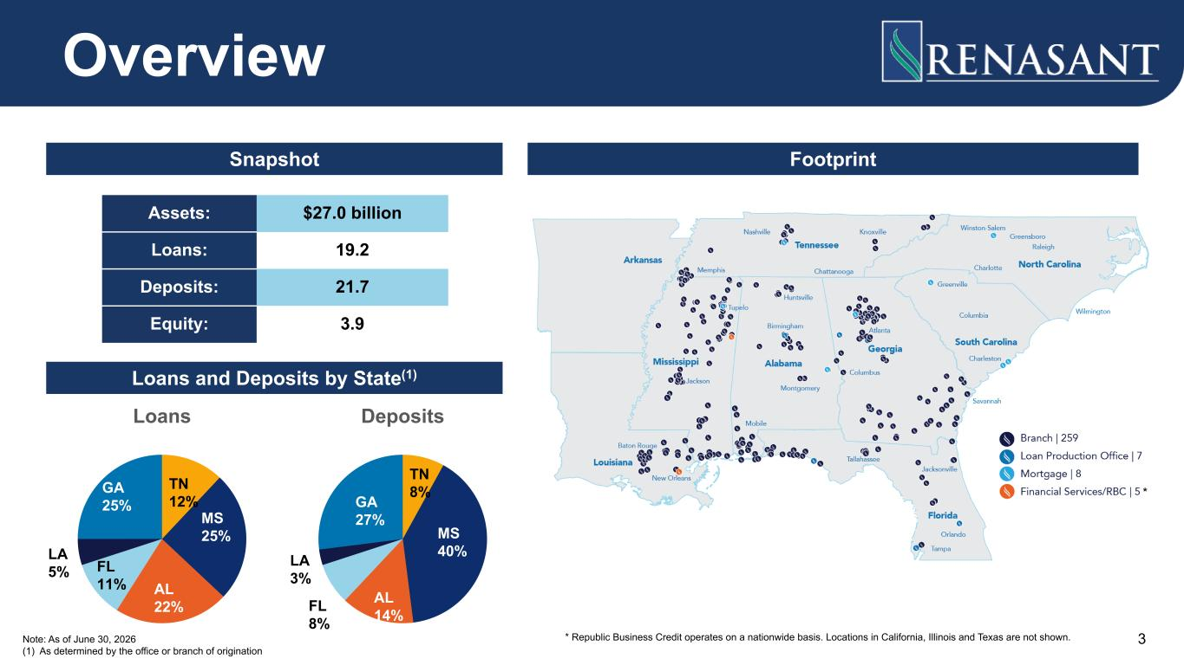
Overview Note: As of June 30, 2026 (1) As determined by the office or branch of origination Snapshot Footprint Loans and Deposits by State(1) * Republic Business Credit operates on a nationwide basis. Locations in California, Illinois and Texas are not shown. Assets: $27.0 billion Loans: 19.2 Deposits: 21.7 Equity: 3.9 Loans TN 12% MS 25% AL 22% FL 11% LA 5% GA 25% Deposits TN 8% MS 40% AL 14%FL 8% LA 3% GA 27% * 3

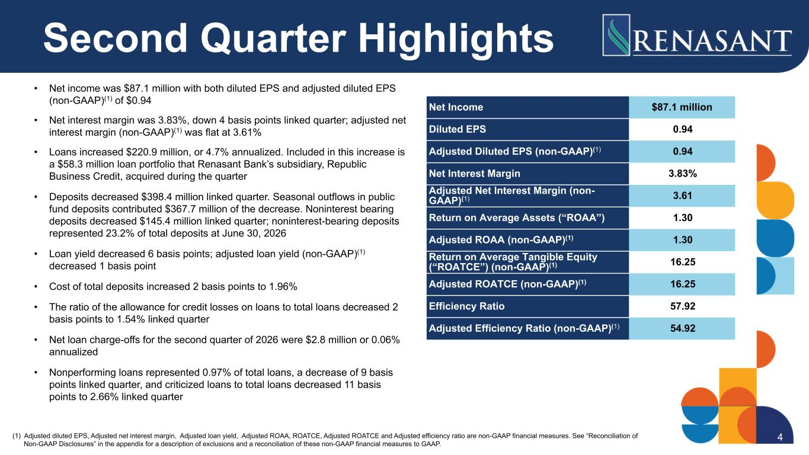
Second Quarter Highlights • Net income was $87.1 million with both diluted EPS and adjusted diluted EPS (non-GAAP)(1) of $0.94 • Net interest margin was 3.83%, down 4 basis points linked quarter; adjusted net interest margin (non-GAAP)(1) was flat at 3.61% • Loans increased $220.9 million, or 4.7% annualized. Included in this increase is a $58.3 million loan portfolio that Renasant Bank’s subsidiary, Republic Business Credit, acquired during the quarter • Deposits decreased $398.4 million linked quarter. Seasonal outflows in public fund deposits contributed $367.7 million of the decrease. Noninterest bearing deposits decreased $145.4 million linked quarter; noninterest-bearing deposits represented 23.2% of total deposits at June 30, 2026 • Loan yield decreased 6 basis points; adjusted loan yield (non-GAAP)(1) decreased 1 basis point • Cost of total deposits increased 2 basis points to 1.96% • The ratio of the allowance for credit losses on loans to total loans decreased 2 basis points to 1.54% linked quarter • Net loan charge-offs for the second quarter of 2026 were $2.8 million or 0.06% annualized • Nonperforming loans represented 0.97% of total loans, a decrease of 9 basis points linked quarter, and criticized loans to total loans decreased 11 basis points to 2.66% linked quarter Net Income $87.1 million Diluted EPS 0.94 Adjusted Diluted EPS (non-GAAP)(1) 0.94 Net Interest Margin 3.83% Adjusted Net Interest Margin (non- GAAP)(1) 3.61 Return on Average Assets (“ROAA”) 1.30 Adjusted ROAA (non-GAAP)(1) 1.30 Return on Average Tangible Equity (“ROATCE”) (non-GAAP)(1) 16.25 Adjusted ROATCE (non-GAAP)(1) 16.25 Efficiency Ratio 57.92 Adjusted Efficiency Ratio (non-GAAP)(1) 54.92 (1) Adjusted diluted EPS, Adjusted net interest margin, Adjusted loan yield, Adjusted ROAA, ROATCE, Adjusted ROATCE and Adjusted efficiency ratio are non-GAAP financial measures. See “Reconciliation of Non-GAAP Disclosures” in the appendix for a description of exclusions and a reconciliation of these non-GAAP financial measures to GAAP. 4

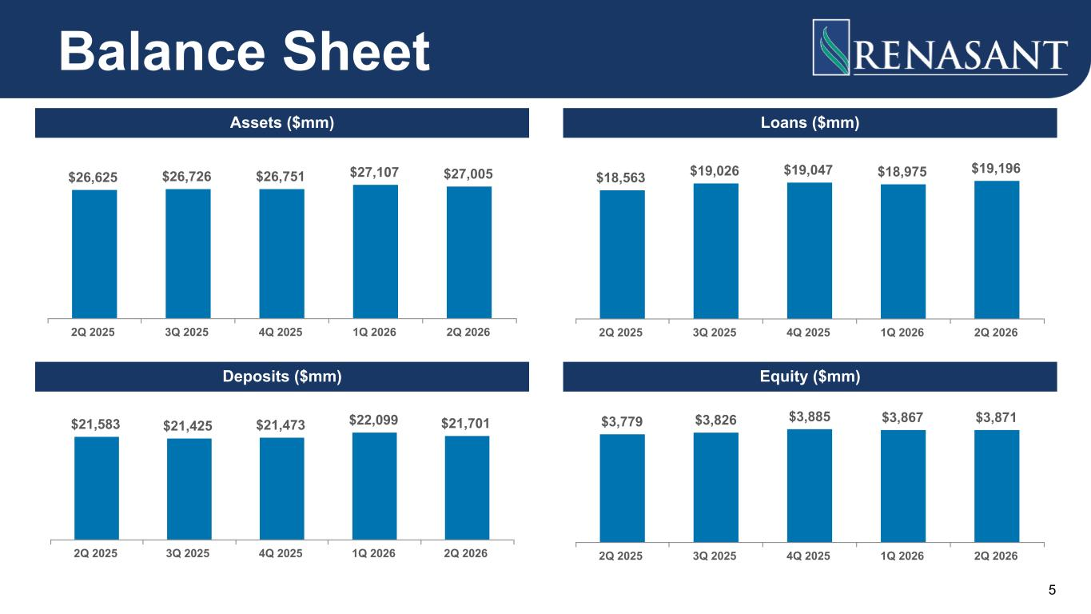
$26,625 $26,726 $26,751 $27,107 $27,005 2Q 2025 3Q 2025 4Q 2025 1Q 2026 2Q 2026 $18,563 $19,026 $19,047 $18,975 $19,196 2Q 2025 3Q 2025 4Q 2025 1Q 2026 2Q 2026 $21,583 $21,425 $21,473 $22,099 $21,701 2Q 2025 3Q 2025 4Q 2025 1Q 2026 2Q 2026 $3,779 $3,826 $3,885 $3,867 $3,871 2Q 2025 3Q 2025 4Q 2025 1Q 2026 2Q 2026 Balance Sheet Assets ($mm) Loans ($mm) Deposits ($mm) Equity ($mm) 5

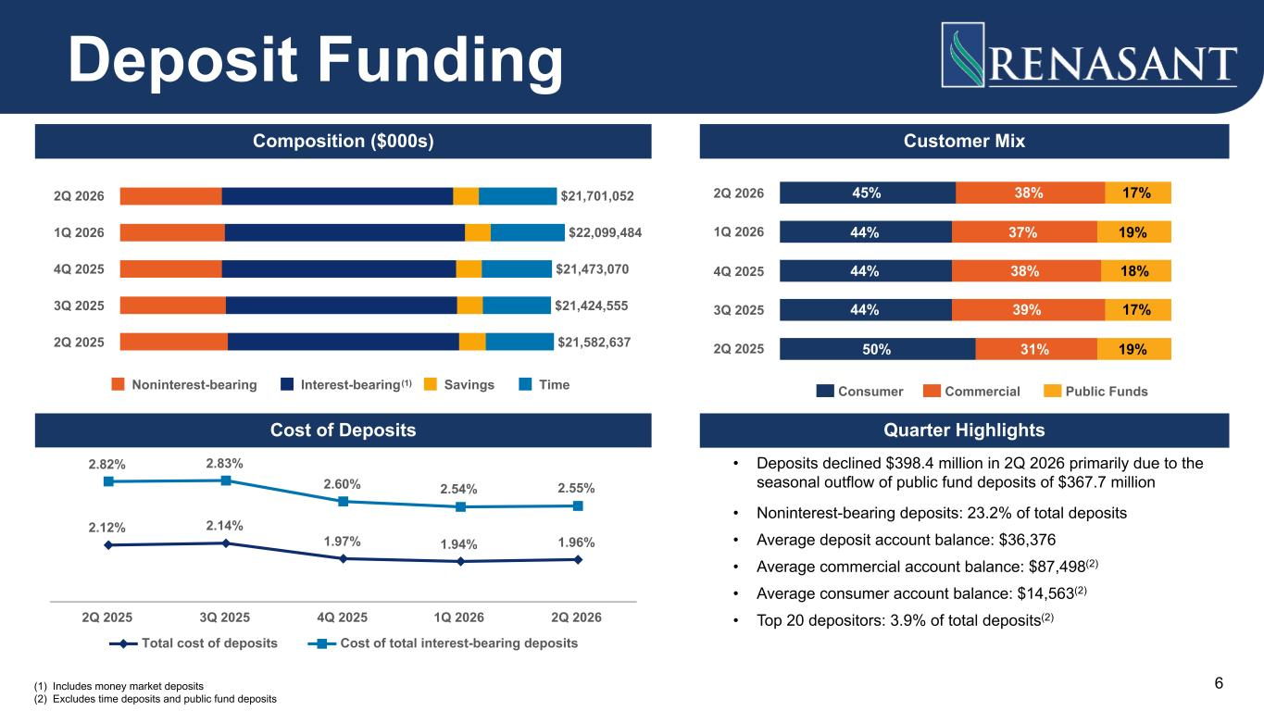
(1) Includes money market deposits (2) Excludes time deposits and public fund deposits Composition ($000s) Quarter Highlights $21,701,052 $22,099,484 $21,473,070 $21,424,555 $21,582,637 Noninterest-bearing Interest-bearing Savings Time 2Q 2026 1Q 2026 4Q 2025 3Q 2025 2Q 2025 Deposit Funding • Deposits declined $398.4 million in 2Q 2026 primarily due to the seasonal outflow of public fund deposits of $367.7 million • Noninterest-bearing deposits: 23.2% of total deposits • Average deposit account balance: $36,376 • Average commercial account balance: $87,498(2) • Average consumer account balance: $14,563(2) • Top 20 depositors: 3.9% of total deposits(2) Customer Mix 45% 44% 44% 44% 50% 38% 37% 38% 39% 31% 17% 19% 18% 17% 19% Consumer Commercial Public Funds 2Q 2026 1Q 2026 4Q 2025 3Q 2025 2Q 2025 Cost of Deposits 2.12% 2.14% 1.97% 1.94% 1.96% 2.82% 2.83% 2.60% 2.54% 2.55% Total cost of deposits Cost of total interest-bearing deposits 2Q 2025 3Q 2025 4Q 2025 1Q 2026 2Q 2026 6 (1)

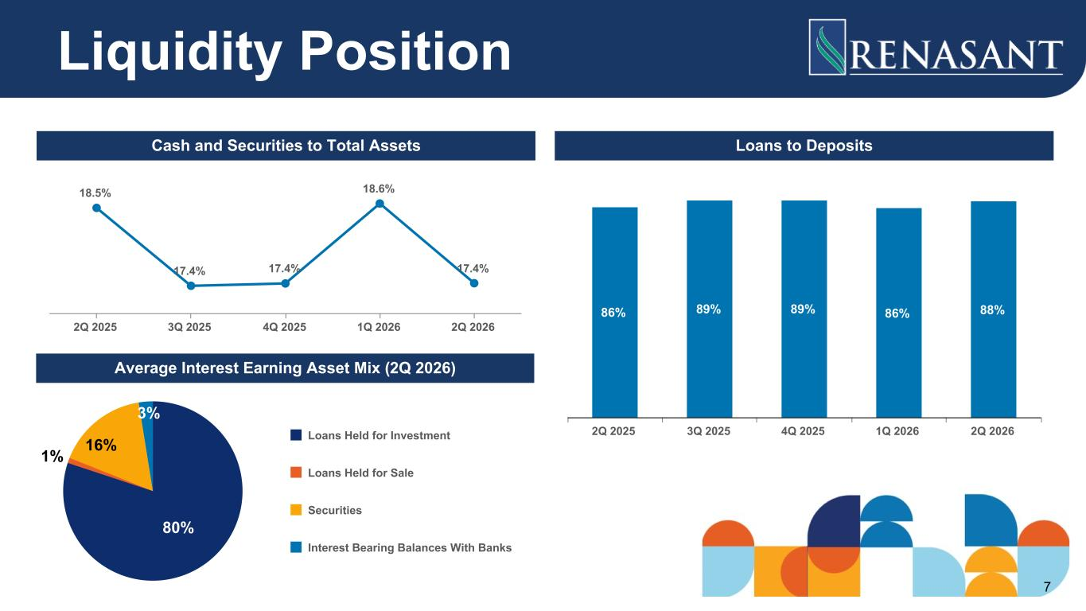
Cash and Securities to Total Assets Loans to Deposits Average Interest Earning Asset Mix (2Q 2026) 18.5% 17.4% 17.4% 18.6% 17.4% 2Q 2025 3Q 2025 4Q 2025 1Q 2026 2Q 2026 86% 89% 89% 86% 88% 2Q 2025 3Q 2025 4Q 2025 1Q 2026 2Q 2026 80% 1% 16% 3% Loans Held for Investment Loans Held for Sale Securities Interest Bearing Balances With Banks Liquidity Position 7

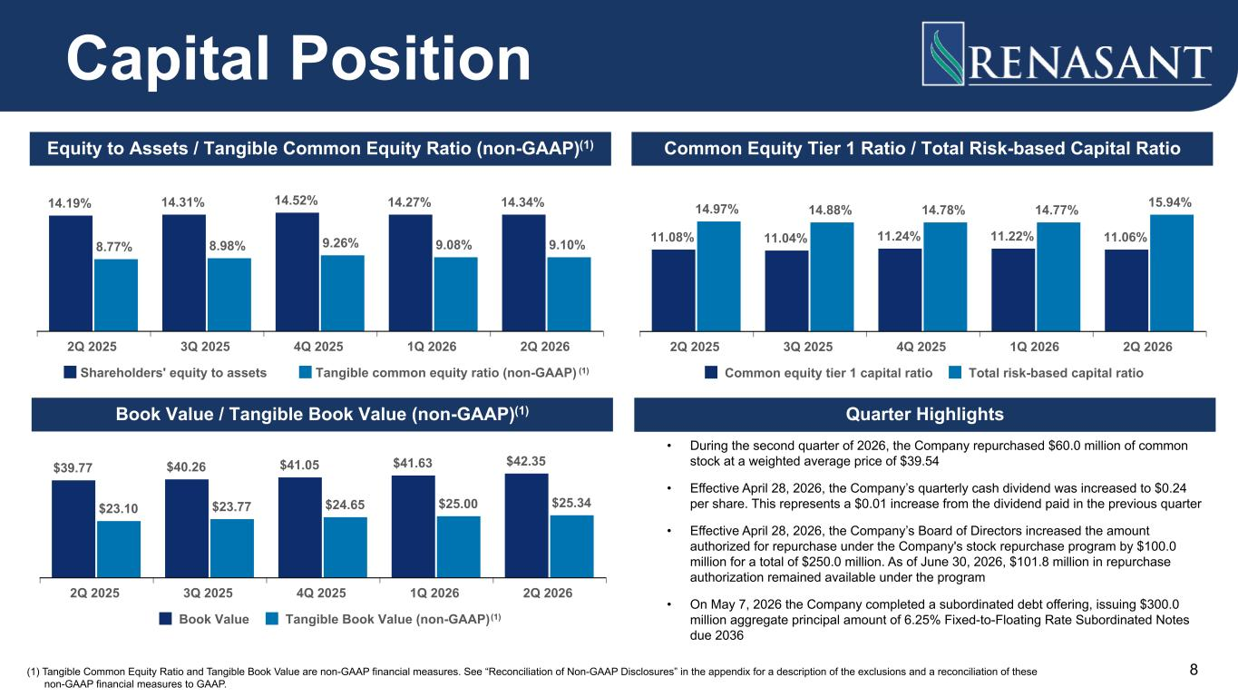
14.19% 14.31% 14.52% 14.27% 14.34% 8.77% 8.98% 9.26% 9.08% 9.10% Shareholders' equity to assets Tangible common equity ratio (non-GAAP) 2Q 2025 3Q 2025 4Q 2025 1Q 2026 2Q 2026 11.08% 11.04% 11.24% 11.22% 11.06% 14.97% 14.88% 14.78% 14.77% 15.94% Common equity tier 1 capital ratio Total risk-based capital ratio 2Q 2025 3Q 2025 4Q 2025 1Q 2026 2Q 2026 Quarter Highlights • During the second quarter of 2026, the Company repurchased $60.0 million of common stock at a weighted average price of $39.54 • Effective April 28, 2026, the Company’s quarterly cash dividend was increased to $0.24 per share. This represents a $0.01 increase from the dividend paid in the previous quarter • Effective April 28, 2026, the Company’s Board of Directors increased the amount authorized for repurchase under the Company's stock repurchase program by $100.0 million for a total of $250.0 million. As of June 30, 2026, $101.8 million in repurchase authorization remained available under the program • On May 7, 2026 the Company completed a subordinated debt offering, issuing $300.0 million aggregate principal amount of 6.25% Fixed-to-Floating Rate Subordinated Notes due 2036 $39.77 $40.26 $41.05 $41.63 $42.35 $23.10 $23.77 $24.65 $25.00 $25.34 Book Value Tangible Book Value (non-GAAP) 2Q 2025 3Q 2025 4Q 2025 1Q 2026 2Q 2026 8 Capital Position Equity to Assets / Tangible Common Equity Ratio (non-GAAP)(1) Common Equity Tier 1 Ratio / Total Risk-based Capital Ratio Book Value / Tangible Book Value (non-GAAP)(1) (1) Tangible Common Equity Ratio and Tangible Book Value are non-GAAP financial measures. See “Reconciliation of Non-GAAP Disclosures” in the appendix for a description of the exclusions and a reconciliation of these non-GAAP financial measures to GAAP. (1) (1)

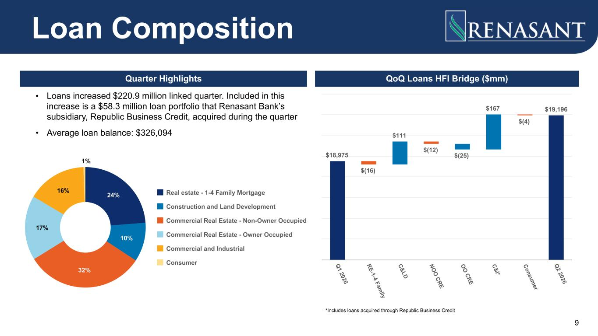
QoQ Loans HFI Bridge ($mm)Quarter Highlights • Loans increased $220.9 million linked quarter. Included in this increase is a $58.3 million loan portfolio that Renasant Bank’s subsidiary, Republic Business Credit, acquired during the quarter • Average loan balance: $326,094 Loan Composition 24% 10% 32% 17% 16% 1% Real estate - 1-4 Family Mortgage Construction and Land Development Commercial Real Estate - Non-Owner Occupied Commercial Real Estate - Owner Occupied Commercial and Industrial Consumer $18,975 $(16) $111 $(12) $(25) $167 $(4) $19,196 Q 1 2026 RE-1-4 Fam ily C&LD NO O CRE O O CRE C&I* Consum er Q 2 2026 *Includes loans acquired through Republic Business Credit 9

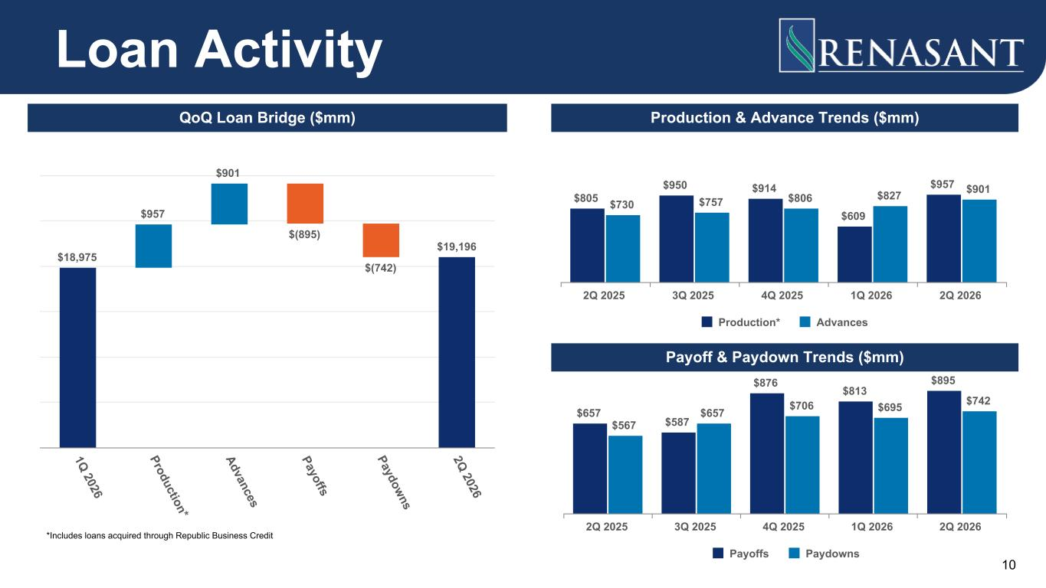
$657 $587 $876 $813 $895 $567 $657 $706 $695 $742 Payoffs Paydowns 2Q 2025 3Q 2025 4Q 2025 1Q 2026 2Q 2026 $18,975 $957 $901 $(895) $(742) $19,196 1Q 2026 Production* Advances Payoffs Paydowns 2Q 2026 Loan Activity 10 QoQ Loan Bridge ($mm) Production & Advance Trends ($mm) Payoff & Paydown Trends ($mm) *Includes loans acquired through Republic Business Credit $805 $950 $914 $609 $957 $730 $757 $806 $827 $901 Production* Advances 2Q 2025 3Q 2025 4Q 2025 1Q 2026 2Q 2026

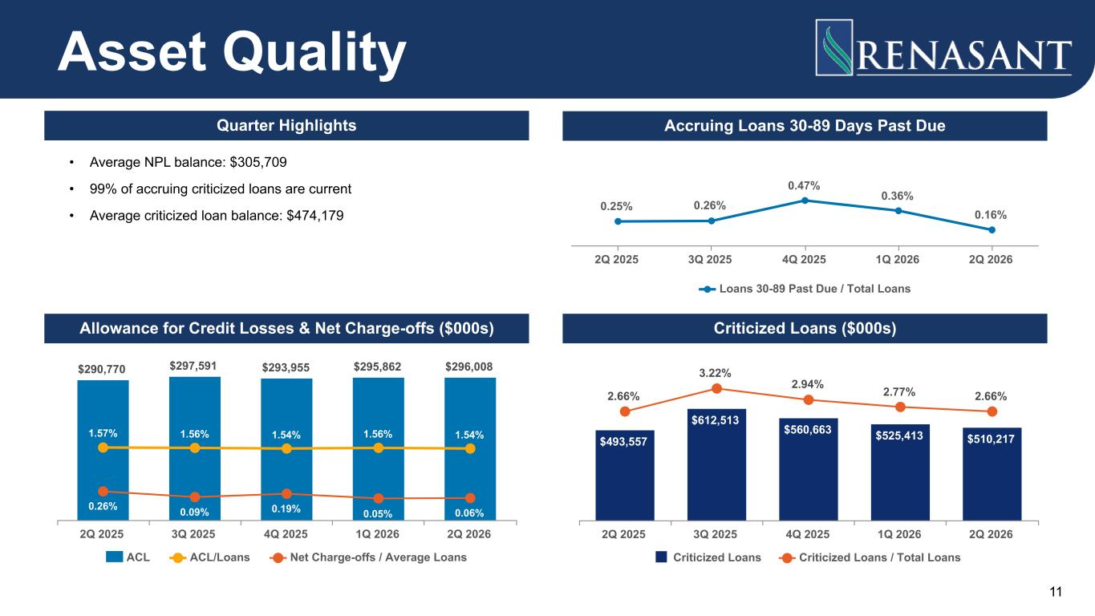
11 $290,770 $297,591 $293,955 $295,862 $296,008 1.57% 1.56% 1.54% 1.56% 1.54% 0.26% 0.09% 0.19% 0.05% 0.06% ACL ACL/Loans Net Charge-offs / Average Loans 2Q 2025 3Q 2025 4Q 2025 1Q 2026 2Q 2026 Asset Quality Criticized Loans ($000s)Allowance for Credit Losses & Net Charge-offs ($000s) Quarter Highlights • Average NPL balance: $305,709 • 99% of accruing criticized loans are current • Average criticized loan balance: $474,179 Accruing Loans 30-89 Days Past Due 0.25% 0.26% 0.47% 0.36% 0.16% Loans 30-89 Past Due / Total Loans 2Q 2025 3Q 2025 4Q 2025 1Q 2026 2Q 2026 $493,557 $612,513 $560,663 $525,413 $510,217 2.66% 3.22% 2.94% 2.77% 2.66% Criticized Loans Criticized Loans / Total Loans 2Q 2025 3Q 2025 4Q 2025 1Q 2026 2Q 2026

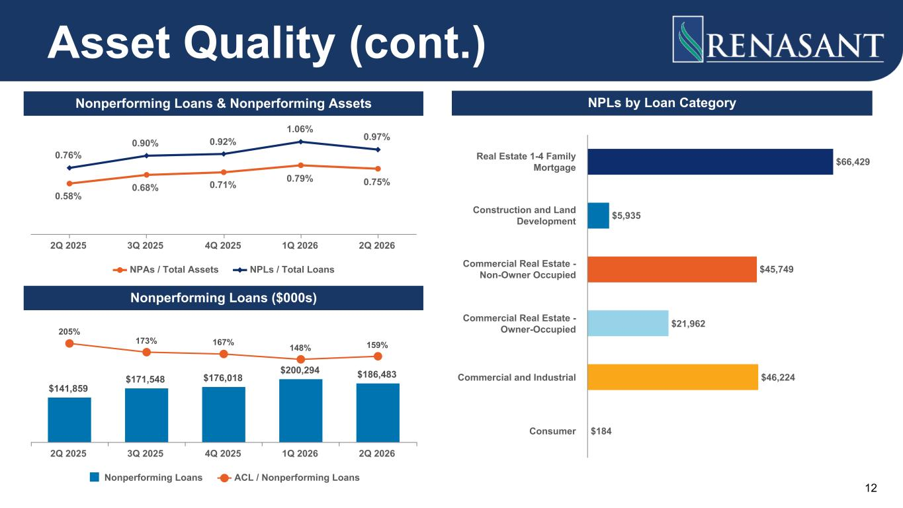
12 NPLs by Loan Category Asset Quality (cont.) Nonperforming Loans & Nonperforming Assets Nonperforming Loans ($000s) 0.58% 0.68% 0.71% 0.79% 0.75% 0.76% 0.90% 0.92% 1.06% 0.97% NPAs / Total Assets NPLs / Total Loans 2Q 2025 3Q 2025 4Q 2025 1Q 2026 2Q 2026 $66,429 $5,935 $45,749 $21,962 $46,224 $184 Real Estate 1-4 Family Mortgage Construction and Land Development Commercial Real Estate - Non-Owner Occupied Commercial Real Estate - Owner-Occupied Commercial and Industrial Consumer $141,859 $171,548 $176,018 $200,294 $186,483 205% 173% 167% 148% 159% Nonperforming Loans ACL / Nonperforming Loans 2Q 2025 3Q 2025 4Q 2025 1Q 2026 2Q 2026

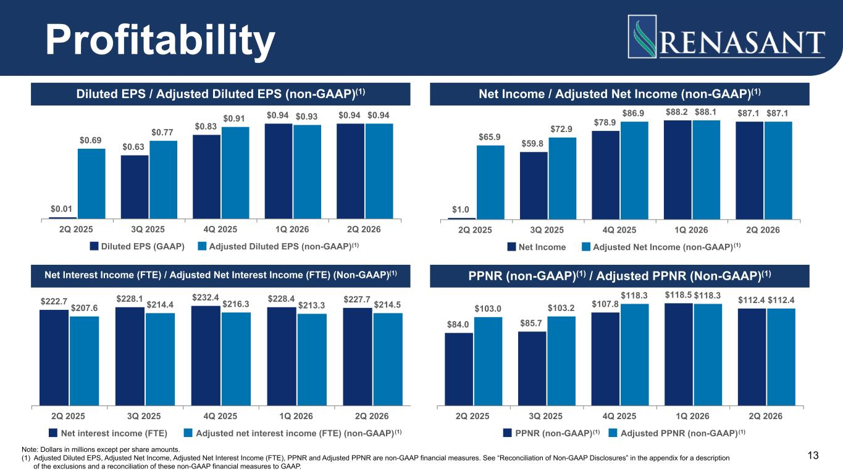
13 Profitability Diluted EPS / Adjusted Diluted EPS (non-GAAP)(1) Net Income / Adjusted Net Income (non-GAAP)(1) PPNR (non-GAAP)(1) / Adjusted PPNR (Non-GAAP)(1)Net Interest Income (FTE) / Adjusted Net Interest Income (FTE) (Non-GAAP)(1) $0.01 $0.63 $0.83 $0.94 $0.94 $0.69 $0.77 $0.91 $0.93 $0.94 Diluted EPS (GAAP) Adjusted Diluted EPS (non-GAAP) 2Q 2025 3Q 2025 4Q 2025 1Q 2026 2Q 2026 $1.0 $59.8 $78.9 $88.2 $87.1 $65.9 $72.9 $86.9 $88.1 $87.1 Net Income Adjusted Net Income (non-GAAP) 2Q 2025 3Q 2025 4Q 2025 1Q 2026 2Q 2026 $222.7 $228.1 $232.4 $228.4 $227.7 $207.6 $214.4 $216.3 $213.3 $214.5 Net interest income (FTE) Adjusted net interest income (FTE) (non-GAAP) 2Q 2025 3Q 2025 4Q 2025 1Q 2026 2Q 2026 $84.0 $85.7 $107.8 $118.5 $112.4 $103.0 $103.2 $118.3 $118.3 $112.4 PPNR (non-GAAP) Adjusted PPNR (non-GAAP) 2Q 2025 3Q 2025 4Q 2025 1Q 2026 2Q 2026 Note: Dollars in millions except per share amounts. (1) Adjusted Diluted EPS, Adjusted Net Income, Adjusted Net Interest Income (FTE), PPNR and Adjusted PPNR are non-GAAP financial measures. See “Reconciliation of Non-GAAP Disclosures” in the appendix for a description of the exclusions and a reconciliation of these non-GAAP financial measures to GAAP. (1) (1) (1)(1)(1)

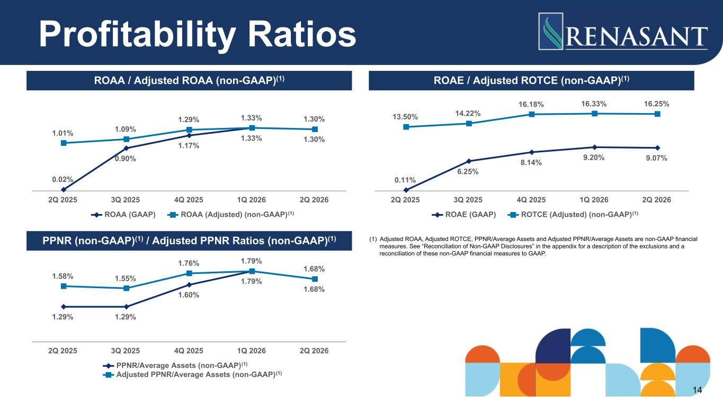
Profitability Ratios ROAA / Adjusted ROAA (non-GAAP)(1) ROAE / Adjusted ROTCE (non-GAAP)(1) PPNR (non-GAAP)(1) / Adjusted PPNR Ratios (non-GAAP)(1) 0.02% 0.90% 1.17% 1.33% 1.30% 1.01% 1.09% 1.29% 1.33% 1.30% ROAA (GAAP) ROAA (Adjusted) (non-GAAP) 2Q 2025 3Q 2025 4Q 2025 1Q 2026 2Q 2026 (1) 0.11% 6.25% 8.14% 9.20% 9.07% 13.50% 14.22% 16.18% 16.33% 16.25% ROAE (GAAP) ROTCE (Adjusted) (non-GAAP) 2Q 2025 3Q 2025 4Q 2025 1Q 2026 2Q 2026 (1) (1) Adjusted ROAA, Adjusted ROTCE, PPNR/Average Assets and Adjusted PPNR/Average Assets are non-GAAP financial measures. See “Reconciliation of Non-GAAP Disclosures” in the appendix for a description of the exclusions and a reconciliation of these non-GAAP financial measures to GAAP. 1.29% 1.29% 1.60% 1.79% 1.68% 1.58% 1.55% 1.76% 1.79% 1.68% PPNR/Average Assets (non-GAAP) Adjusted PPNR/Average Assets (non-GAAP) 2Q 2025 3Q 2025 4Q 2025 1Q 2026 2Q 2026 (1) (1) 14

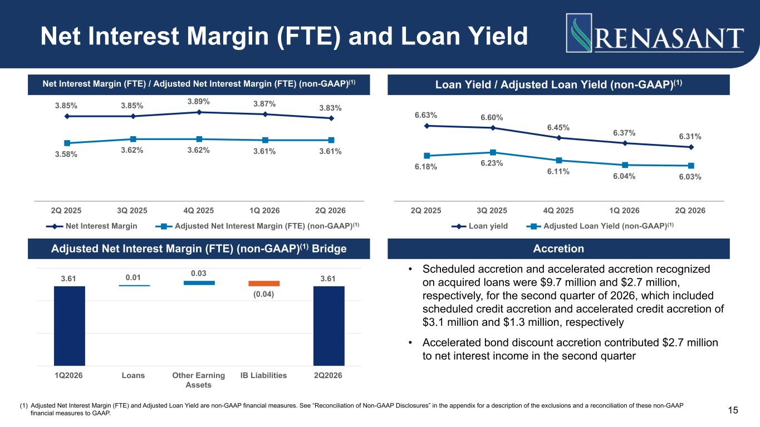
15 Net Interest Margin (FTE) and Loan Yield Net Interest Margin (FTE) / Adjusted Net Interest Margin (FTE) (non-GAAP)(1) Loan Yield / Adjusted Loan Yield (non-GAAP)(1) AccretionAdjusted Net Interest Margin (FTE) (non-GAAP)(1) Bridge 3.85% 3.85% 3.89% 3.87% 3.83% 3.58% 3.62% 3.62% 3.61% 3.61% Net Interest Margin Adjusted Net Interest Margin (FTE) (non-GAAP) 2Q 2025 3Q 2025 4Q 2025 1Q 2026 2Q 2026 (1) 6.63% 6.60% 6.45% 6.37% 6.31% 6.18% 6.23% 6.11% 6.04% 6.03% Loan yield Adjusted Loan Yield (non-GAAP) 2Q 2025 3Q 2025 4Q 2025 1Q 2026 2Q 2026 (1) 3.61 0.01 0.03 (0.04) 3.61 1Q2026 Loans Other Earning Assets IB Liabilities 2Q2026 • Scheduled accretion and accelerated accretion recognized on acquired loans were $9.7 million and $2.7 million, respectively, for the second quarter of 2026, which included scheduled credit accretion and accelerated credit accretion of $3.1 million and $1.3 million, respectively • Accelerated bond discount accretion contributed $2.7 million to net interest income in the second quarter (1) Adjusted Net Interest Margin (FTE) and Adjusted Loan Yield are non-GAAP financial measures. See “Reconciliation of Non-GAAP Disclosures” in the appendix for a description of the exclusions and a reconciliation of these non-GAAP financial measures to GAAP.

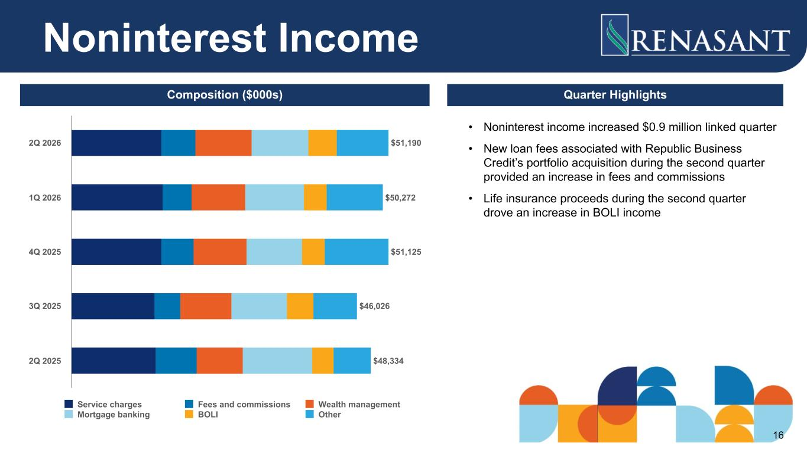
Noninterest Income Composition ($000s) Quarter Highlights $51,190 $50,272 $51,125 $46,026 $48,334 Service charges Fees and commissions Wealth management Mortgage banking BOLI Other 2Q 2026 1Q 2026 4Q 2025 3Q 2025 2Q 2025 • Noninterest income increased $0.9 million linked quarter • New loan fees associated with Republic Business Credit’s portfolio acquisition during the second quarter provided an increase in fees and commissions • Life insurance proceeds during the second quarter drove an increase in BOLI income 16

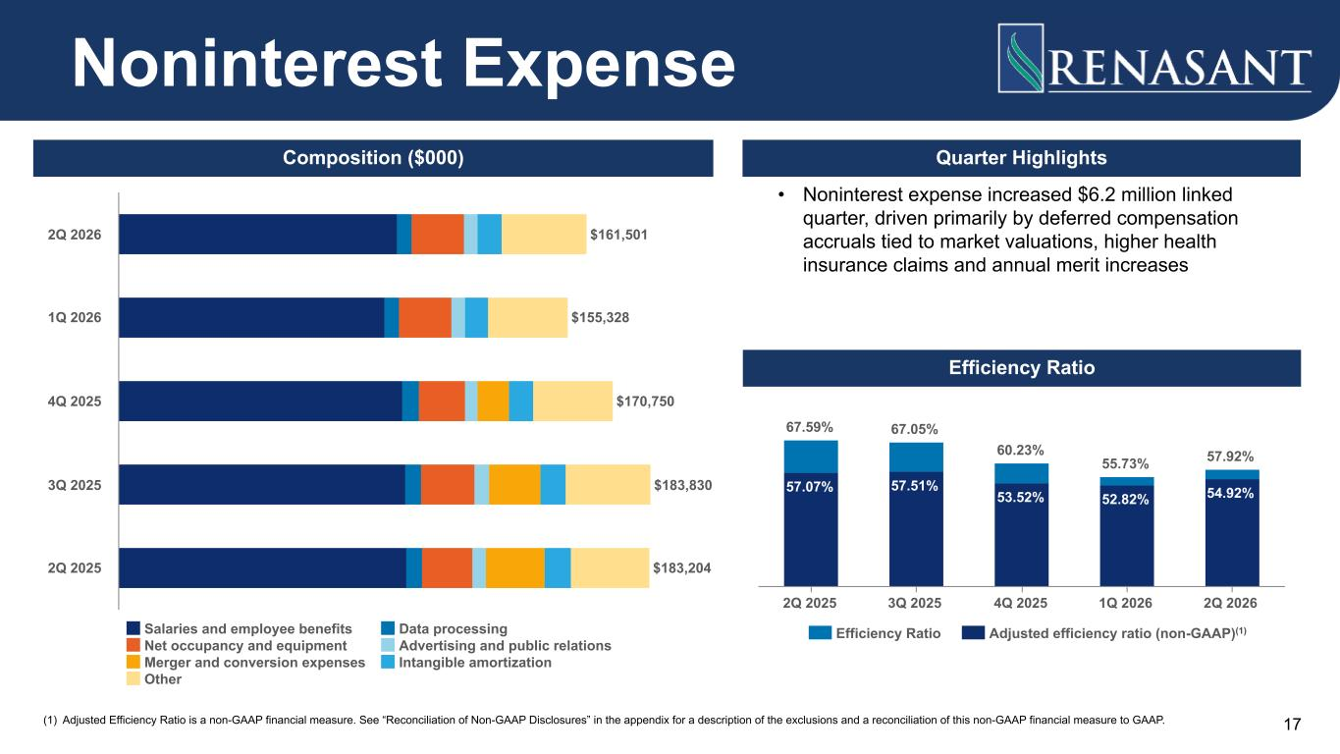
17 Quarter Highlights Noninterest Expense Efficiency Ratio Composition ($000) $161,501 $155,328 $170,750 $183,830 $183,204 Salaries and employee benefits Data processing Net occupancy and equipment Advertising and public relations Merger and conversion expenses Intangible amortization Other 2Q 2026 1Q 2026 4Q 2025 3Q 2025 2Q 2025 • Noninterest expense increased $6.2 million linked quarter, driven primarily by deferred compensation accruals tied to market valuations, higher health insurance claims and annual merit increases 57.07% 57.51% 53.52% 52.82% 54.92% 67.59% 67.05% 60.23% 55.73% 57.92% Efficiency Ratio Adjusted efficiency ratio (non-GAAP) 2Q 2025 3Q 2025 4Q 2025 1Q 2026 2Q 2026 (1) (1) Adjusted Efficiency Ratio is a non-GAAP financial measure. See “Reconciliation of Non-GAAP Disclosures” in the appendix for a description of the exclusions and a reconciliation of this non-GAAP financial measure to GAAP.

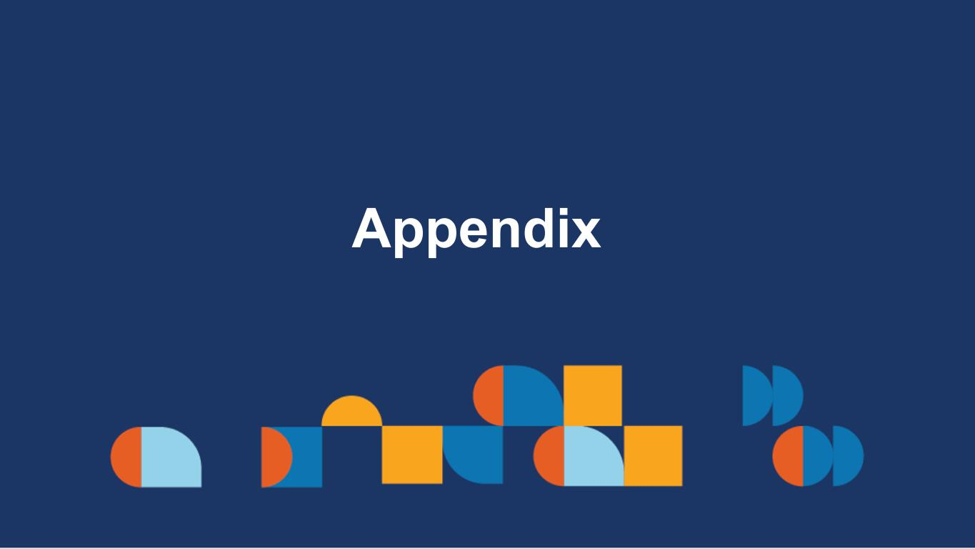
Appendix

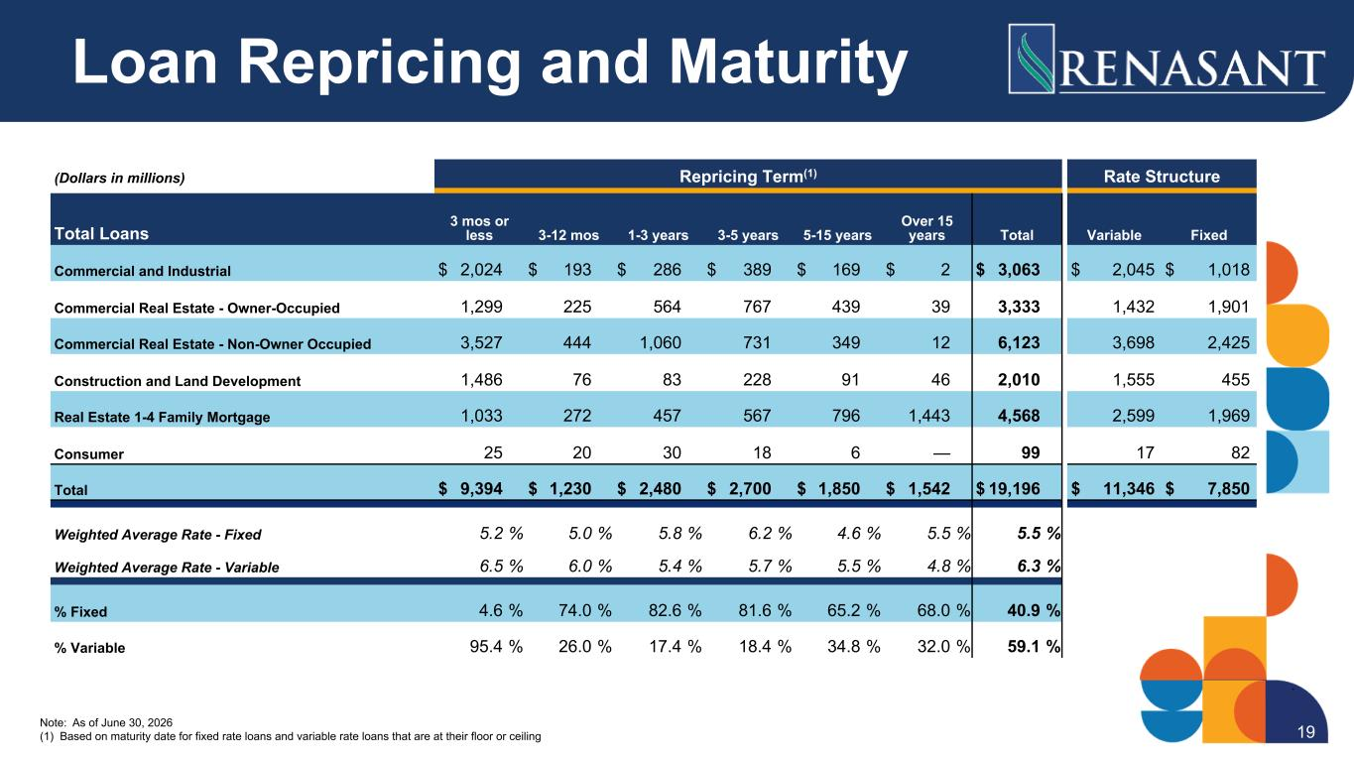
(Dollars in millions) Repricing Term(1) Rate Structure Total Loans 3 mos or less 3-12 mos 1-3 years 3-5 years 5-15 years Over 15 years Total Variable Fixed Commercial and Industrial $ 2,024 $ 193 $ 286 $ 389 $ 169 $ 2 $ 3,063 $ 2,045 $ 1,018 Commercial Real Estate - Owner-Occupied 1,299 225 564 767 439 39 3,333 1,432 1,901 Commercial Real Estate - Non-Owner Occupied 3,527 444 1,060 731 349 12 6,123 3,698 2,425 Construction and Land Development 1,486 76 83 228 91 46 2,010 1,555 455 Real Estate 1-4 Family Mortgage 1,033 272 457 567 796 1,443 4,568 2,599 1,969 Consumer 25 20 30 18 6 — 99 17 82 Total $ 9,394 $ 1,230 $ 2,480 $ 2,700 $ 1,850 $ 1,542 $ 19,196 $ 11,346 $ 7,850 Weighted Average Rate - Fixed 5.2 % 5.0 % 5.8 % 6.2 % 4.6 % 5.5 % 5.5 % Weighted Average Rate - Variable 6.5 % 6.0 % 5.4 % 5.7 % 5.5 % 4.8 % 6.3 % % Fixed 4.6 % 74.0 % 82.6 % 81.6 % 65.2 % 68.0 % 40.9 % % Variable 95.4 % 26.0 % 17.4 % 18.4 % 34.8 % 32.0 % 59.1 % Loan Repricing and Maturity Note: As of June 30, 2026 (1) Based on maturity date for fixed rate loans and variable rate loans that are at their floor or ceiling 19

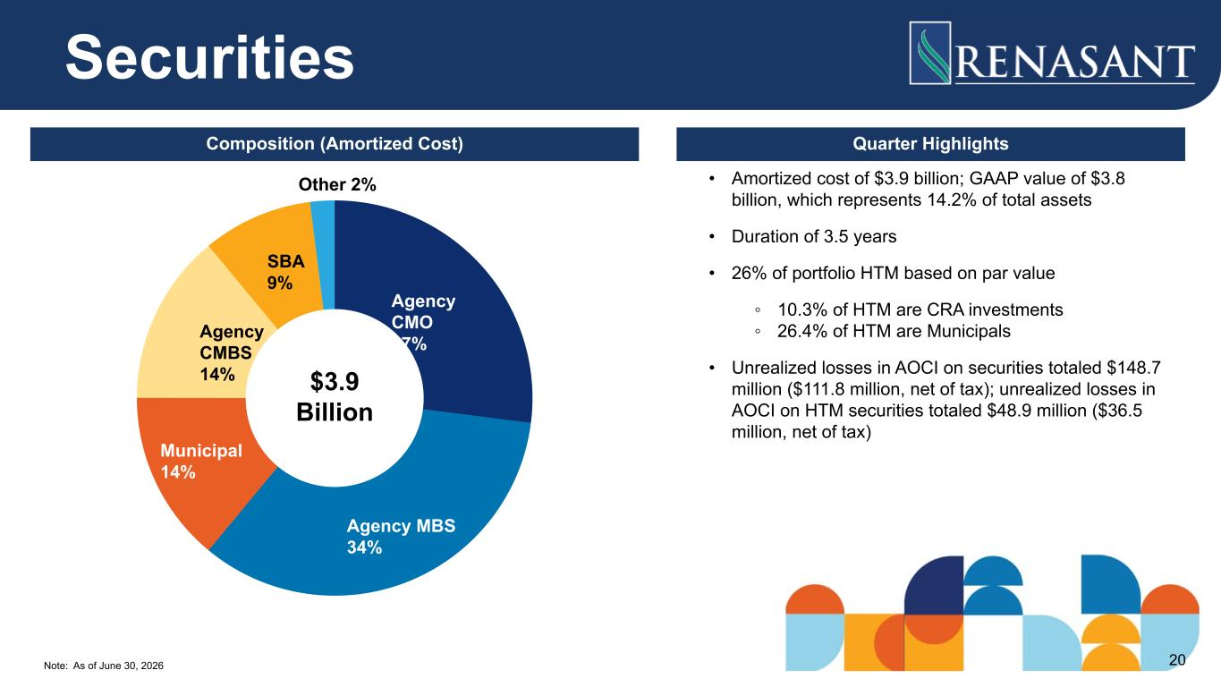
Note: As of June 30, 2026 • Amortized cost of $3.9 billion; GAAP value of $3.8 billion, which represents 14.2% of total assets • Duration of 3.5 years • 26% of portfolio HTM based on par value ◦ 10.3% of HTM are CRA investments ◦ 26.4% of HTM are Municipals • Unrealized losses in AOCI on securities totaled $148.7 million ($111.8 million, net of tax); unrealized losses in AOCI on HTM securities totaled $48.9 million ($36.5 million, net of tax) Securities Composition (Amortized Cost) Quarter Highlights Agency CMO 27% Agency MBS 34% Municipal 14% Agency CMBS 14% SBA 9% Other 2% $3.9 Billion 20

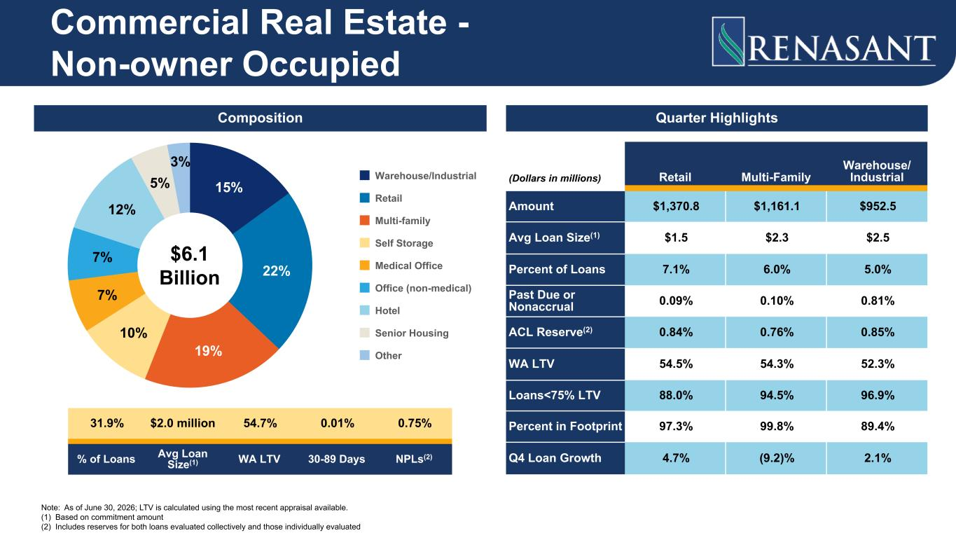
Quarter Highlights (Dollars in millions) Retail Multi-Family Warehouse/ Industrial Amount $1,370.8 $1,161.1 $952.5 Avg Loan Size(1) $1.5 $2.3 $2.5 Percent of Loans 7.1% 6.0% 5.0% Past Due or Nonaccrual 0.09% 0.10% 0.81% ACL Reserve(2) 0.84% 0.76% 0.85% WA LTV 54.5% 54.3% 52.3% Loans<75% LTV 88.0% 94.5% 96.9% Percent in Footprint 97.3% 99.8% 89.4% Q4 Loan Growth 4.7% (9.2)% 2.1% Commercial Real Estate - Non-owner Occupied Composition 15% 22% 19% 10% 7% 7% 12% 5% 3% Warehouse/Industrial Retail Multi-family Self Storage Medical Office Office (non-medical) Hotel Senior Housing Other $6.1 Billion 31.9% $2.0 million 54.7% 0.01% 0.75% % of Loans Avg Loan Size(1) WA LTV 30-89 Days NPLs(2) Note: As of June 30, 2026; LTV is calculated using the most recent appraisal available. (1) Based on commitment amount (2) Includes reserves for both loans evaluated collectively and those individually evaluated

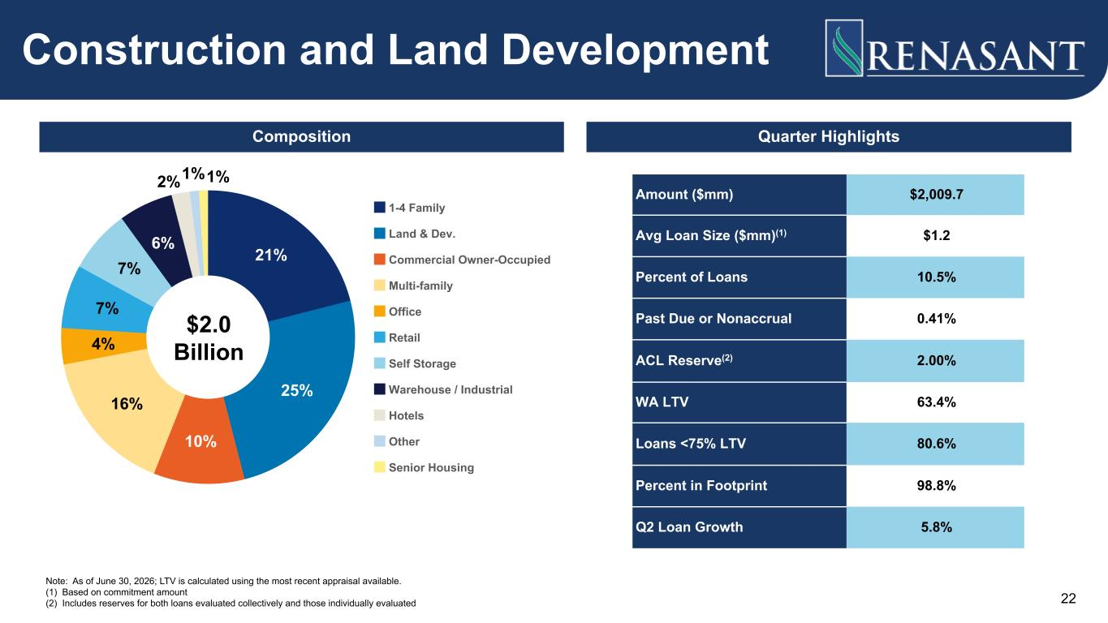
22 Amount ($mm) $2,009.7 Avg Loan Size ($mm)(1) $1.2 Percent of Loans 10.5% Past Due or Nonaccrual 0.41% ACL Reserve(2) 2.00% WA LTV 63.4% Loans <75% LTV 80.6% Percent in Footprint 98.8% Q2 Loan Growth 5.8% Construction and Land Development Composition Quarter Highlights 21% 25% 10% 16% 4% 7% 7% 6% 2%1%1% 1-4 Family Land & Dev. Commercial Owner-Occupied Multi-family Office Retail Self Storage Warehouse / Industrial Hotels Other Senior Housing $2.0 Billion Note: As of June 30, 2026; LTV is calculated using the most recent appraisal available. (1) Based on commitment amount (2) Includes reserves for both loans evaluated collectively and those individually evaluated

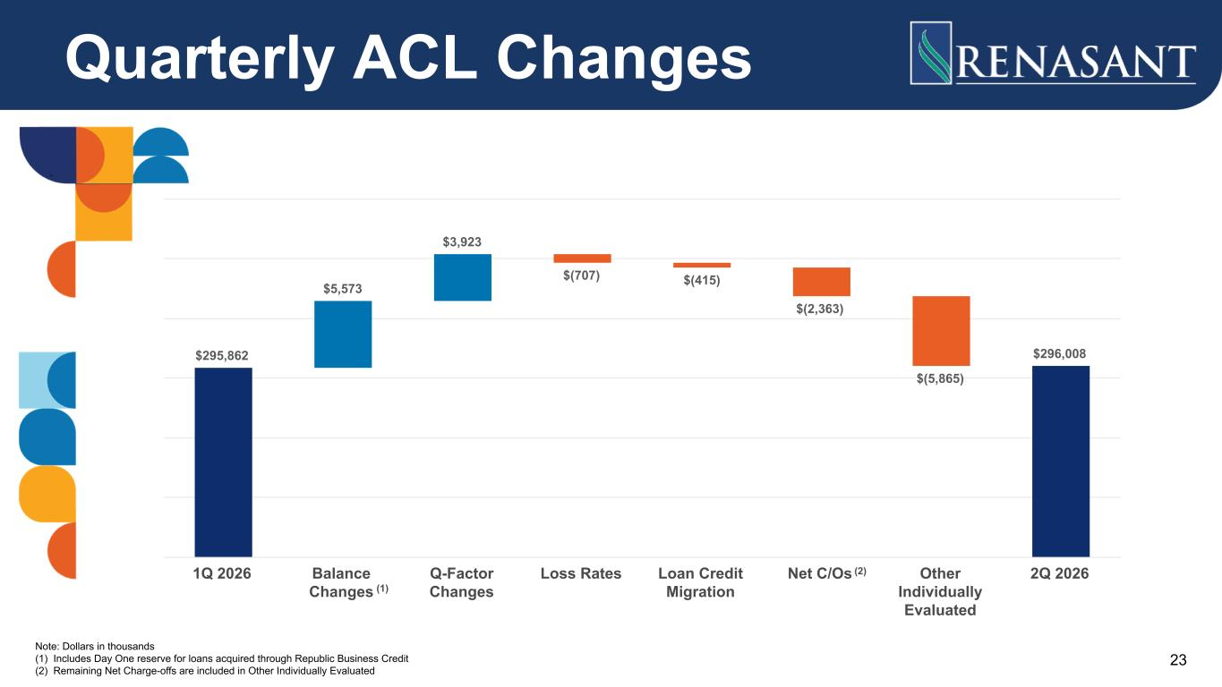
Quarterly ACL Changes 23 $295,862 $5,573 $3,923 $(707) $(415) $(2,363) $(5,865) $296,008 1Q 2026 Balance Changes Q-Factor Changes Loss Rates Loan Credit Migration Net C/Os Other Individually Evaluated 2Q 2026 Note: Dollars in thousands (1) Includes Day One reserve for loans acquired through Republic Business Credit (2) Remaining Net Charge-offs are included in Other Individually Evaluated (1) (2)

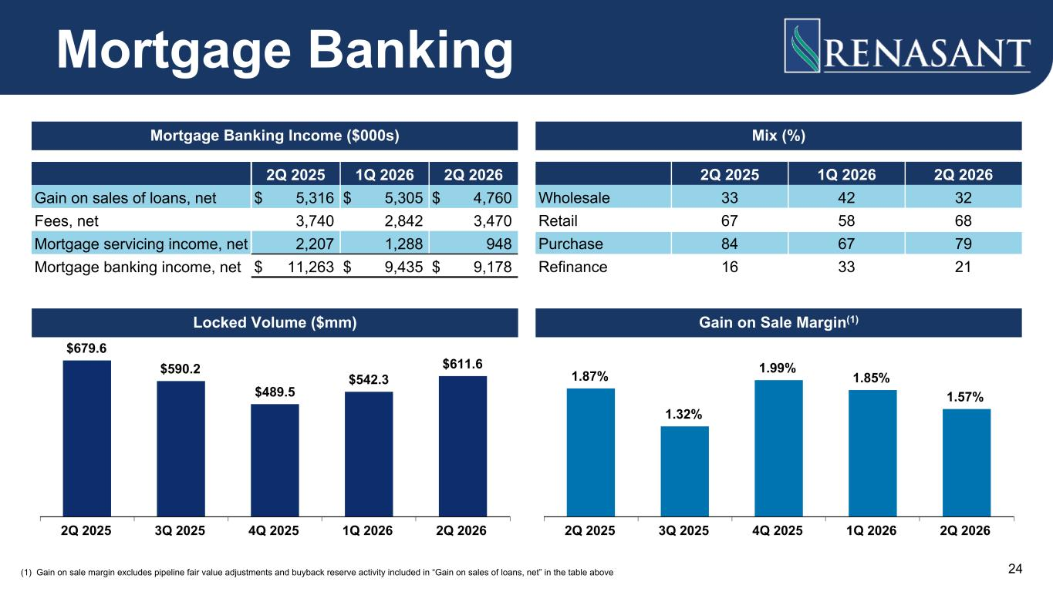
2Q 2025 1Q 2026 2Q 2026 Gain on sales of loans, net $ 5,316 $ 5,305 $ 4,760 Fees, net 3,740 2,842 3,470 Mortgage servicing income, net 2,207 1,288 948 Mortgage banking income, net $ 11,263 $ 9,435 $ 9,178 2Q 2025 1Q 2026 2Q 2026 Wholesale 33 42 32 Retail 67 58 68 Purchase 84 67 79 Refinance 16 33 21 $679.6 $590.2 $489.5 $542.3 $611.6 2Q 2025 3Q 2025 4Q 2025 1Q 2026 2Q 2026 1.87% 1.32% 1.99% 1.85% 1.57% 2Q 2025 3Q 2025 4Q 2025 1Q 2026 2Q 2026 Mortgage Banking Mortgage Banking Income ($000s) Mix (%) Locked Volume ($mm) Gain on Sale Margin(1) (1) Gain on sale margin excludes pipeline fair value adjustments and buyback reserve activity included in “Gain on sales of loans, net” in the table above 24


Reconciliation of Non-GAAP Disclosures

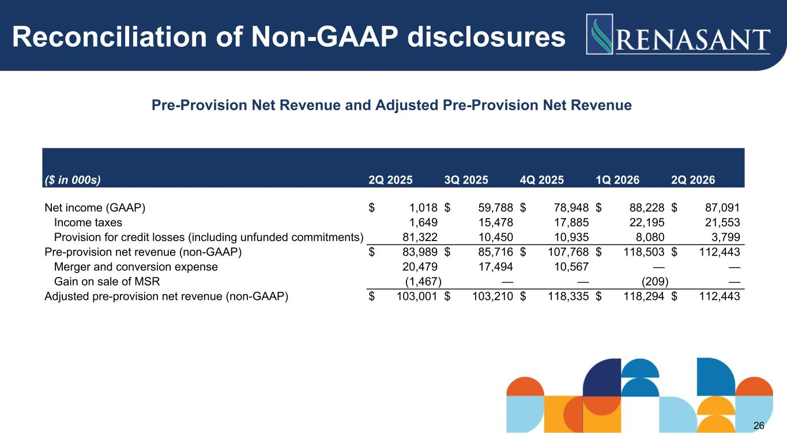
Reconciliation of Non-GAAP disclosures Pre-Provision Net Revenue and Adjusted Pre-Provision Net Revenue ($ in 000s) 2Q 2025 3Q 2025 4Q 2025 1Q 2026 2Q 2026 Net income (GAAP) $ 1,018 $ 59,788 $ 78,948 $ 88,228 $ 87,091 Income taxes 1,649 15,478 17,885 22,195 21,553 Provision for credit losses (including unfunded commitments) 81,322 10,450 10,935 8,080 3,799 Pre-provision net revenue (non-GAAP) $ 83,989 $ 85,716 $ 107,768 $ 118,503 $ 112,443 Merger and conversion expense 20,479 17,494 10,567 — — Gain on sale of MSR (1,467) — — (209) — Adjusted pre-provision net revenue (non-GAAP) $ 103,001 $ 103,210 $ 118,335 $ 118,294 $ 112,443 26

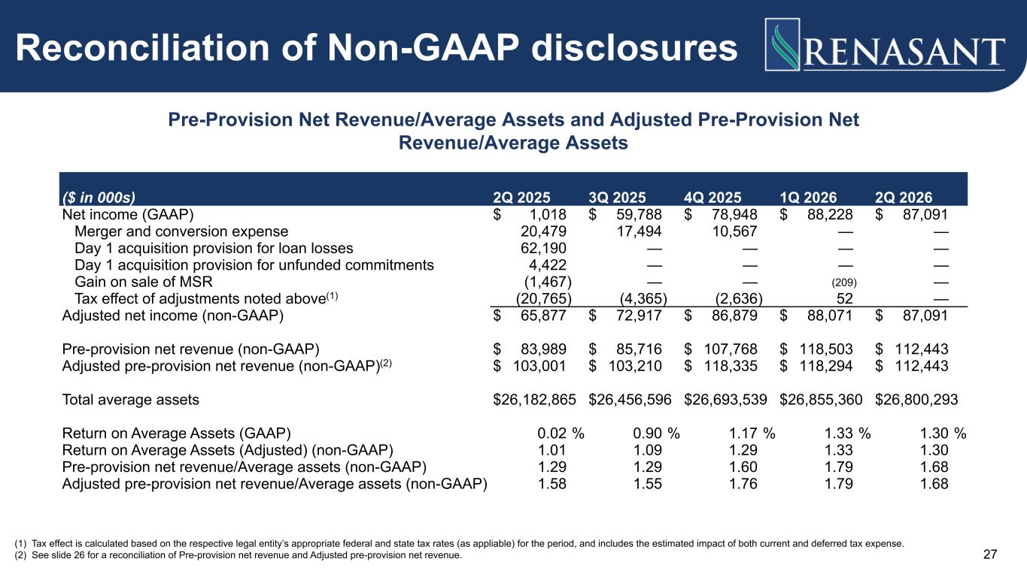
Reconciliation of Non-GAAP disclosures Pre-Provision Net Revenue/Average Assets and Adjusted Pre-Provision Net Revenue/Average Assets (1) Tax effect is calculated based on the respective legal entity’s appropriate federal and state tax rates (as appliable) for the period, and includes the estimated impact of both current and deferred tax expense. (2) See slide 26 for a reconciliation of Pre-provision net revenue and Adjusted pre-provision net revenue. ($ in 000s) 2Q 2025 3Q 2025 4Q 2025 1Q 2026 2Q 2026 Net income (GAAP) $ 1,018 $ 59,788 $ 78,948 $ 88,228 $ 87,091 Merger and conversion expense 20,479 17,494 10,567 — — Day 1 acquisition provision for loan losses 62,190 — — — — Day 1 acquisition provision for unfunded commitments 4,422 — — — — Gain on sale of MSR (1,467) — — (209) — Tax effect of adjustments noted above(1) (20,765) (4,365) (2,636) 52 — Adjusted net income (non-GAAP) $ 65,877 $ 72,917 $ 86,879 $ 88,071 $ 87,091 Pre-provision net revenue (non-GAAP) $ 83,989 $ 85,716 $ 107,768 $ 118,503 $ 112,443 Adjusted pre-provision net revenue (non-GAAP)(2) $ 103,001 $ 103,210 $ 118,335 $ 118,294 $ 112,443 Total average assets $ 26,182,865 $ 26,456,596 $ 26,693,539 $ 26,855,360 $ 26,800,293 Return on Average Assets (GAAP) 0.02 % 0.90 % 1.17 % 1.33 % 1.30 % Return on Average Assets (Adjusted) (non-GAAP) 1.01 1.09 1.29 1.33 1.30 Pre-provision net revenue/Average assets (non-GAAP) 1.29 1.29 1.60 1.79 1.68 Adjusted pre-provision net revenue/Average assets (non-GAAP) 1.58 1.55 1.76 1.79 1.68 27

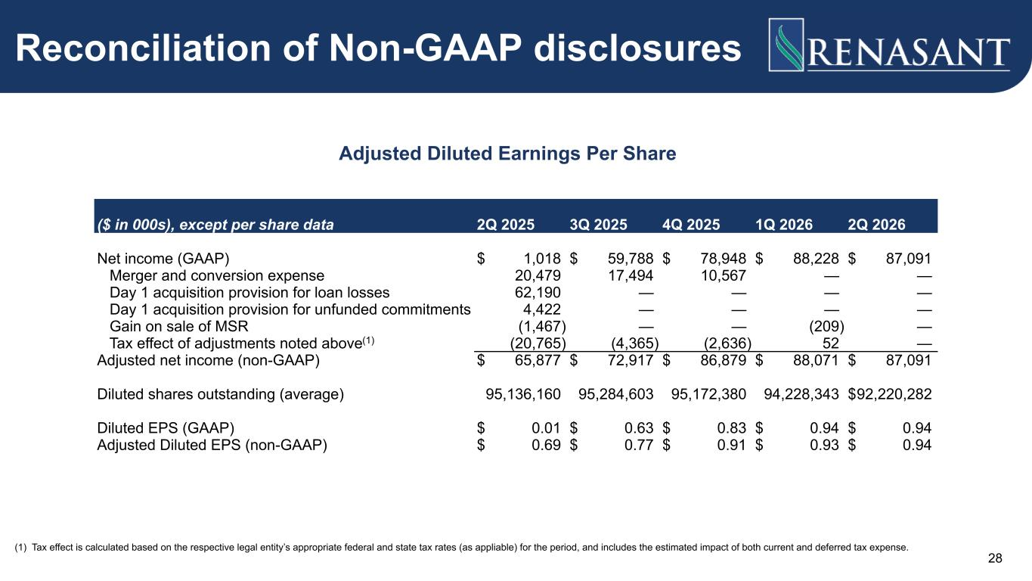
Reconciliation of Non-GAAP disclosures Adjusted Diluted Earnings Per Share ($ in 000s), except per share data 2Q 2025 3Q 2025 4Q 2025 1Q 2026 2Q 2026 Net income (GAAP) $ 1,018 $ 59,788 $ 78,948 $ 88,228 $ 87,091 Merger and conversion expense 20,479 17,494 10,567 — — Day 1 acquisition provision for loan losses 62,190 — — — — Day 1 acquisition provision for unfunded commitments 4,422 — — — — Gain on sale of MSR (1,467) — — (209) — Tax effect of adjustments noted above(1) (20,765) (4,365) (2,636) 52 — Adjusted net income (non-GAAP) $ 65,877 $ 72,917 $ 86,879 $ 88,071 $ 87,091 Diluted shares outstanding (average) 95,136,160 95,284,603 95,172,380 94,228,343 $ 92,220,282 Diluted EPS (GAAP) $ 0.01 $ 0.63 $ 0.83 $ 0.94 $ 0.94 Adjusted Diluted EPS (non-GAAP) $ 0.69 $ 0.77 $ 0.91 $ 0.93 $ 0.94 (1) Tax effect is calculated based on the respective legal entity’s appropriate federal and state tax rates (as appliable) for the period, and includes the estimated impact of both current and deferred tax expense. 28

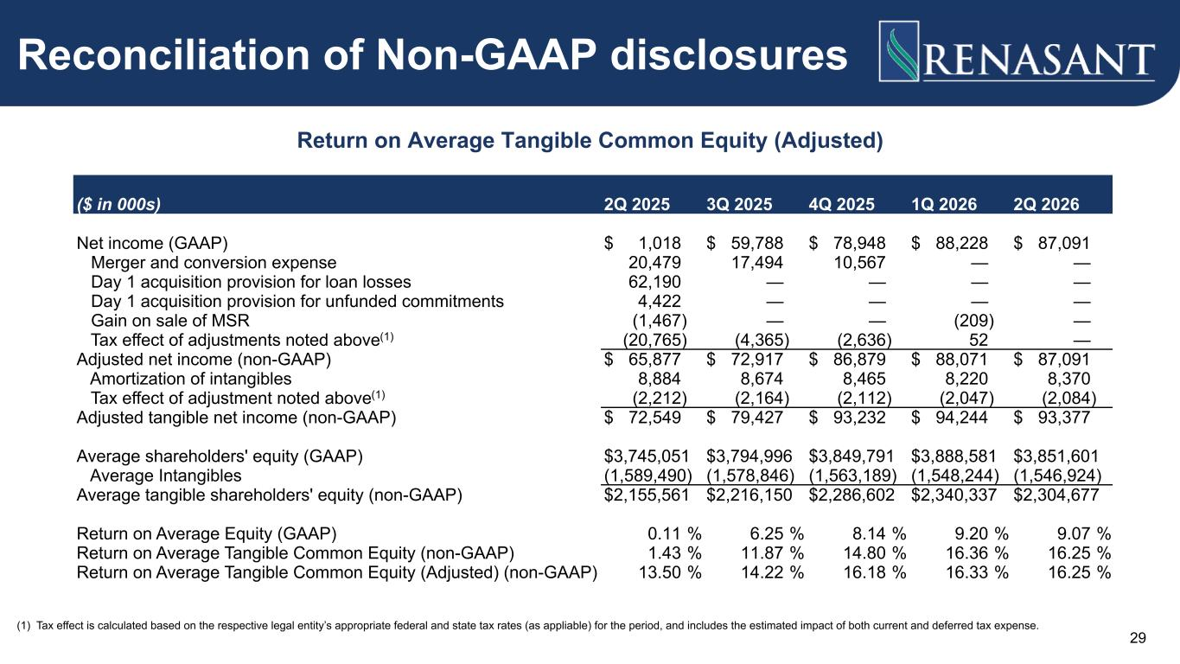
Reconciliation of Non-GAAP disclosures Return on Average Tangible Common Equity (Adjusted) ($ in 000s) 2Q 2025 3Q 2025 4Q 2025 1Q 2026 2Q 2026 Net income (GAAP) $ 1,018 $ 59,788 $ 78,948 $ 88,228 $ 87,091 Merger and conversion expense 20,479 17,494 10,567 — — Day 1 acquisition provision for loan losses 62,190 — — — — Day 1 acquisition provision for unfunded commitments 4,422 — — — — Gain on sale of MSR (1,467) — — (209) — Tax effect of adjustments noted above(1) (20,765) (4,365) (2,636) 52 — Adjusted net income (non-GAAP) $ 65,877 $ 72,917 $ 86,879 $ 88,071 $ 87,091 Amortization of intangibles 8,884 8,674 8,465 8,220 8,370 Tax effect of adjustment noted above(1) (2,212) (2,164) (2,112) (2,047) (2,084) Adjusted tangible net income (non-GAAP) $ 72,549 $ 79,427 $ 93,232 $ 94,244 $ 93,377 Average shareholders' equity (GAAP) $ 3,745,051 $ 3,794,996 $ 3,849,791 $ 3,888,581 $ 3,851,601 Average Intangibles (1,589,490) (1,578,846) (1,563,189) (1,548,244) (1,546,924) Average tangible shareholders' equity (non-GAAP) $ 2,155,561 $ 2,216,150 $ 2,286,602 $ 2,340,337 $ 2,304,677 Return on Average Equity (GAAP) 0.11 % 6.25 % 8.14 % 9.20 % 9.07 % Return on Average Tangible Common Equity (non-GAAP) 1.43 % 11.87 % 14.80 % 16.36 % 16.25 % Return on Average Tangible Common Equity (Adjusted) (non-GAAP) 13.50 % 14.22 % 16.18 % 16.33 % 16.25 % (1) Tax effect is calculated based on the respective legal entity’s appropriate federal and state tax rates (as appliable) for the period, and includes the estimated impact of both current and deferred tax expense. 29

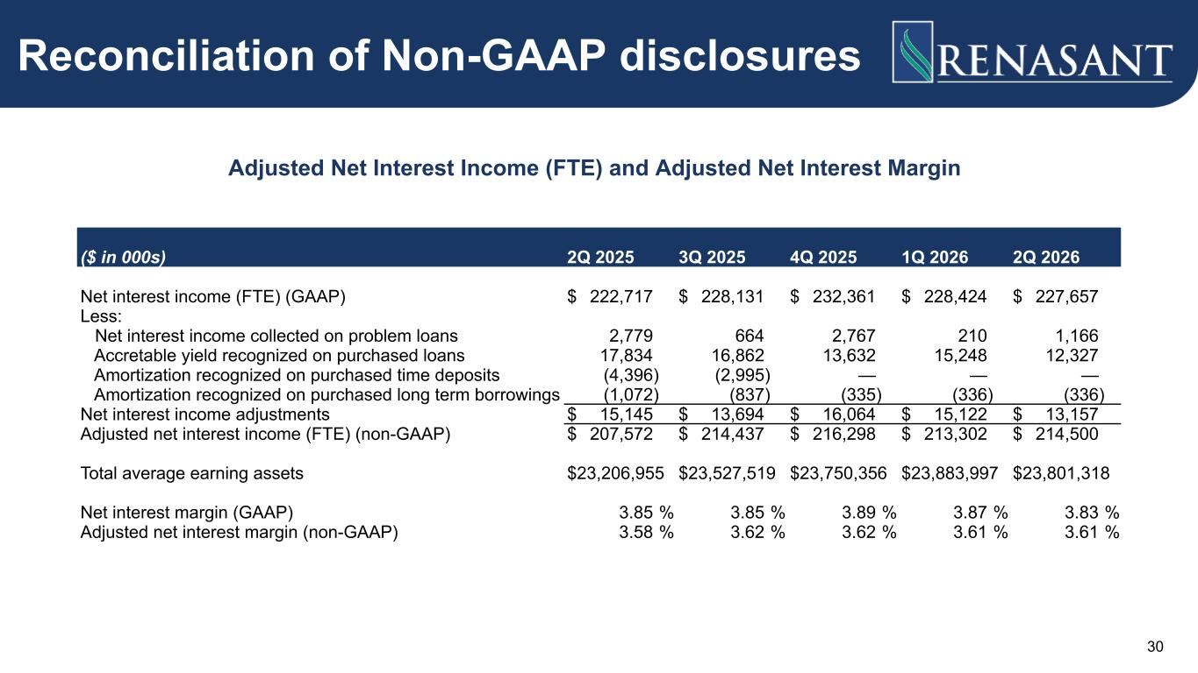
Adjusted Net Interest Income (FTE) and Adjusted Net Interest Margin Reconciliation of Non-GAAP disclosures ($ in 000s) 2Q 2025 3Q 2025 4Q 2025 1Q 2026 2Q 2026 Net interest income (FTE) (GAAP) $ 222,717 $ 228,131 $ 232,361 $ 228,424 $ 227,657 Less: Net interest income collected on problem loans 2,779 664 2,767 210 1,166 Accretable yield recognized on purchased loans 17,834 16,862 13,632 15,248 12,327 Amortization recognized on purchased time deposits (4,396) (2,995) — — — Amortization recognized on purchased long term borrowings (1,072) (837) (335) (336) (336) Net interest income adjustments $ 15,145 $ 13,694 $ 16,064 $ 15,122 $ 13,157 Adjusted net interest income (FTE) (non-GAAP) $ 207,572 $ 214,437 $ 216,298 $ 213,302 $ 214,500 Total average earning assets $ 23,206,955 $ 23,527,519 $ 23,750,356 $ 23,883,997 $ 23,801,318 Net interest margin (GAAP) 3.85 % 3.85 % 3.89 % 3.87 % 3.83 % Adjusted net interest margin (non-GAAP) 3.58 % 3.62 % 3.62 % 3.61 % 3.61 % 30

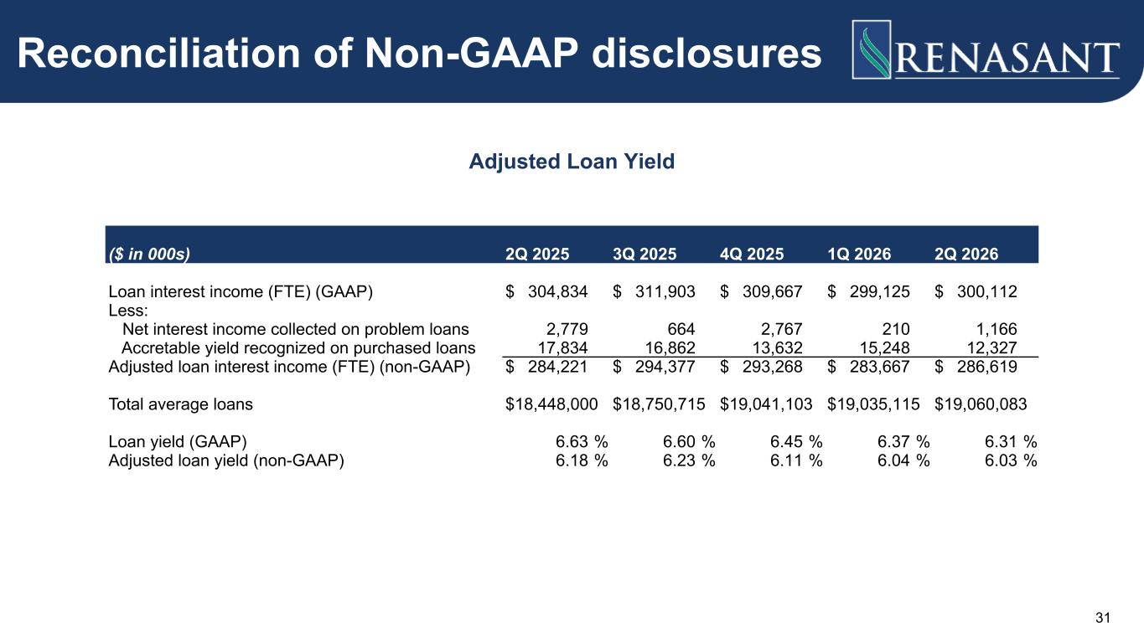
Adjusted Loan Yield Reconciliation of Non-GAAP disclosures ($ in 000s) 2Q 2025 3Q 2025 4Q 2025 1Q 2026 2Q 2026 Loan interest income (FTE) (GAAP) $ 304,834 $ 311,903 $ 309,667 $ 299,125 $ 300,112 Less: Net interest income collected on problem loans 2,779 664 2,767 210 1,166 Accretable yield recognized on purchased loans 17,834 16,862 13,632 15,248 12,327 Adjusted loan interest income (FTE) (non-GAAP) $ 284,221 $ 294,377 $ 293,268 $ 283,667 $ 286,619 Total average loans $ 18,448,000 $ 18,750,715 $ 19,041,103 $ 19,035,115 $ 19,060,083 Loan yield (GAAP) 6.63 % 6.60 % 6.45 % 6.37 % 6.31 % Adjusted loan yield (non-GAAP) 6.18 % 6.23 % 6.11 % 6.04 % 6.03 % 31

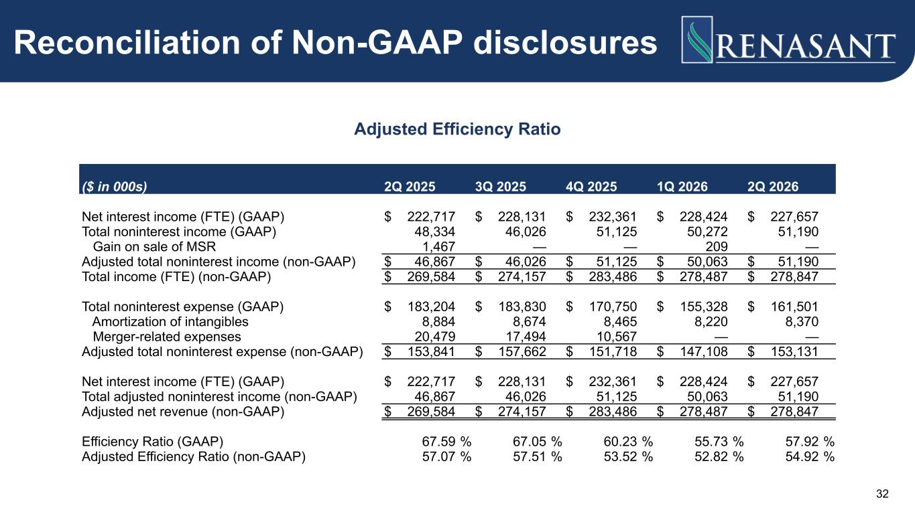
Reconciliation of Non-GAAP disclosures Adjusted Efficiency Ratio ($ in 000s) 2Q 2025 3Q 2025 4Q 2025 1Q 2026 2Q 2026 Net interest income (FTE) (GAAP) $ 222,717 $ 228,131 $ 232,361 $ 228,424 $ 227,657 Total noninterest income (GAAP) 48,334 46,026 51,125 50,272 51,190 Gain on sale of MSR 1,467 — — 209 — Adjusted total noninterest income (non-GAAP) $ 46,867 $ 46,026 $ 51,125 $ 50,063 $ 51,190 Total income (FTE) (non-GAAP) $ 269,584 $ 274,157 $ 283,486 $ 278,487 $ 278,847 Total noninterest expense (GAAP) $ 183,204 $ 183,830 $ 170,750 $ 155,328 $ 161,501 Amortization of intangibles 8,884 8,674 8,465 8,220 8,370 Merger-related expenses 20,479 17,494 10,567 — — Adjusted total noninterest expense (non-GAAP) $ 153,841 $ 157,662 $ 151,718 $ 147,108 $ 153,131 Net interest income (FTE) (GAAP) $ 222,717 $ 228,131 $ 232,361 $ 228,424 $ 227,657 Total adjusted noninterest income (non-GAAP) 46,867 46,026 51,125 50,063 51,190 Adjusted net revenue (non-GAAP) $ 269,584 $ 274,157 $ 283,486 $ 278,487 $ 278,847 Efficiency Ratio (GAAP) 67.59 % 67.05 % 60.23 % 55.73 % 57.92 % Adjusted Efficiency Ratio (non-GAAP) 57.07 % 57.51 % 53.52 % 52.82 % 54.92 % 32

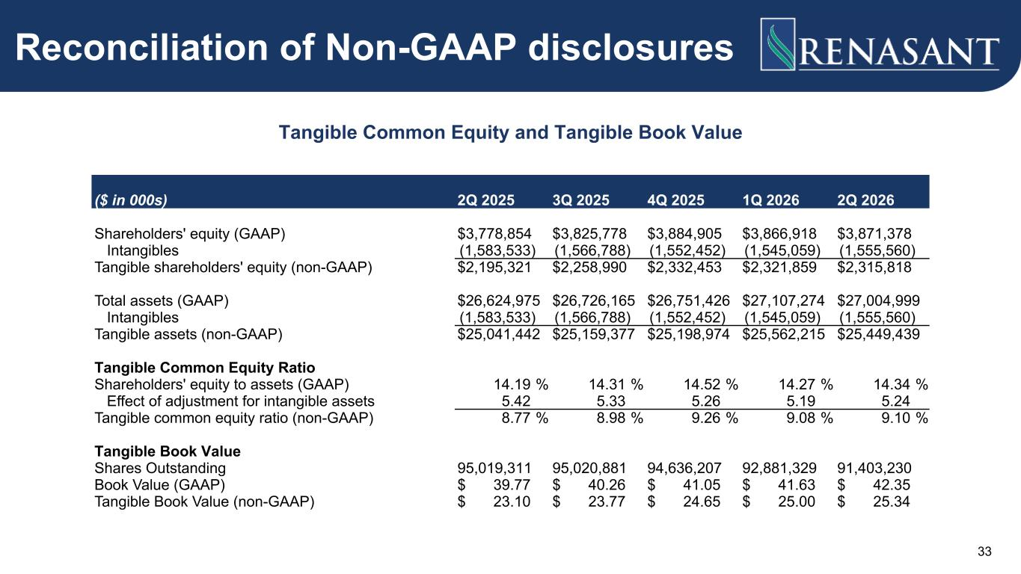
Reconciliation of Non-GAAP disclosures Tangible Common Equity and Tangible Book Value ($ in 000s) 2Q 2025 3Q 2025 4Q 2025 1Q 2026 2Q 2026 Shareholders' equity (GAAP) $ 3,778,854 $ 3,825,778 $ 3,884,905 $ 3,866,918 $ 3,871,378 Intangibles (1,583,533) (1,566,788) (1,552,452) (1,545,059) (1,555,560) Tangible shareholders' equity (non-GAAP) $ 2,195,321 $ 2,258,990 $ 2,332,453 $ 2,321,859 $ 2,315,818 Total assets (GAAP) $ 26,624,975 $ 26,726,165 $ 26,751,426 $ 27,107,274 $ 27,004,999 Intangibles (1,583,533) (1,566,788) (1,552,452) (1,545,059) (1,555,560) Tangible assets (non-GAAP) $ 25,041,442 $ 25,159,377 $ 25,198,974 $ 25,562,215 $ 25,449,439 Tangible Common Equity Ratio Shareholders' equity to assets (GAAP) 14.19 % 14.31 % 14.52 % 14.27 % 14.34 % Effect of adjustment for intangible assets 5.42 5.33 5.26 5.19 5.24 Tangible common equity ratio (non-GAAP) 8.77 % 8.98 % 9.26 % 9.08 % 9.10 % Tangible Book Value Shares Outstanding 95,019,311 95,020,881 94,636,207 92,881,329 91,403,230 Book Value (GAAP) $ 39.77 $ 40.26 $ 41.05 $ 41.63 $ 42.35 Tangible Book Value (non-GAAP) $ 23.10 $ 23.77 $ 24.65 $ 25.00 $ 25.34 33



