UNITED STATES
SECURITIES AND EXCHANGE COMMISSION
Washington, D.C. 20549

FORM 8-K
CURRENT REPORT
Pursuant to Section 13 OR 15(d) of the Securities Exchange Act of 1934

May 15, 2026
Date of report (Date of earliest event reported)

RENASANT CORPORATION
(Exact name of registrant as specified in its charter)
Mississippi |  |  | 001-13253 |  |  | 64-0676974
(State or other jurisdiction  of incorporation) |  |  | (Commission  File Number) |  |  | (I.R.S. Employer  Identification No.)

209 Troy Street, Tupelo, Mississippi 38804-4827
(Address of principal executive offices)(Zip Code)

Registrant’s telephone number, including area code: (662) 680-1001
Check the appropriate box below if the Form 8-K filing is intended to simultaneously satisfy the filing obligation of the registrant under any of the following provisions:
☐ |  |  | Written communications pursuant to Rule 425 under the Securities Act (17 CFR 230.425)
☐ |  |  | Soliciting material pursuant to Rule 14a-12 under the Exchange Act (17 CFR 240.14a-12)
☐ |  |  | Pre-commencement communications pursuant to Rule 14d-2(b) under the Exchange Act (17 CFR 240.14d-2(b))
☐ |  |  | Pre-commencement communications pursuant to Rule 13e-4(c) under the Exchange Act (17 CFR 240.13e-4(c))
Securities registered pursuant to Section 12(b) of the Act:
Title of each class |  |  | Trading Symbol(s) |  |  | Name of each exchange on which registered
Common stock, $5.00 par value per share |  |  | RNST |  |  | The New York Stock Exchange
Indicate by check mark whether the registrant is an emerging growth company as defined in Rule 405 of the Securities Act of 1933 (17 CFR §230.405) or Rule 12b-2 of the Securities Exchange Act of 1934 (17 CFR §240.12b-2). Emerging growth company ☐
If an emerging growth company, indicate by check mark if the registrant has elected not to use the extended transition period for complying with any new or revised financial accounting standards provided pursuant to Section 13(a) of the Exchange Act. ☐

Item 7.01 Regulation FD Disclosure.

Representatives of Renasant Corporation (“Renasant” or the “Company”) will make presentations to investors during various conferences in the second quarter of 2026. Attached hereto as Exhibit 99.1 of this Form 8-K is a copy of the materials that the Company will make available at these presentations.

In accordance with General Instruction B.2 of Form 8-K, the information in this Item 7.01, including Exhibit 99.1, is being furnished and shall not be deemed to be “filed” for purposes of Section 18 of the Securities Exchange Act of 1934, as amended, or otherwise subject to the liabilities of that section, and shall not be deemed incorporated by reference into any registration statement or other document filed pursuant to the Securities Act of 1933, as amended, or the Securities Exchange Act of 1934, as amended, except as shall be expressly set forth by specific reference in such filing.

CAUTIONARY NOTE REGARDING FORWARD-LOOKING STATEMENTS:
The presentation furnished herewith may contain, or incorporate by reference, statements about Renasant Corporation that constitute “forward-looking statements” within the meaning of Section 27A of the Securities Act of 1933, as amended, and Section 21E of the Securities Exchange Act of 1934, as amended. Statements preceded by, followed by or that otherwise include the words “believes,” “expects,” “projects,” “anticipates,” “intends,” “estimates,” “plans,” “potential,” “focus,” “possible,” “may increase,” “may fluctuate,” “will likely result,” or similar expressions, or future or conditional verbs such as “will,” “should,” “would” and “could,” are generally forward-looking in nature and not historical facts. Forward-looking statements include information about the Company’s future financial performance, business strategy, projected plans and objectives and are based on the current beliefs and expectations of management. The Company’s management believes these forward-looking statements are reasonable, but they are all inherently subject to significant business, economic and competitive risks and uncertainties, many of which are beyond the Company’s control. In addition, these forward-looking statements are subject to assumptions with respect to future business strategies and decisions that are subject to change. Actual results may differ from those indicated or implied in the forward-looking statements, and such differences may be material. Prospective investors are cautioned that any forward-looking statements are not guarantees of future performance and involve risks and uncertainties and, accordingly, investors should not place undue reliance on these forward-looking statements, which speak only as of the date they are made.

Important factors currently known to management that could cause the Company’s actual results to differ materially from those in forward-looking statements include the following: (i) the Company’s ability to efficiently integrate acquisitions into its operations, retain the customers of these businesses, grow the acquired operations and realize the cost savings expected from an acquisition to the extent and in the timeframe anticipated by management (including the possibility that such cost savings will not be realized when expected, or at all, as a result of the impact of, or challenges arising from, the integration of the acquired assets and assumed liabilities into the Company, potential adverse reactions or changes to business or employee relationships, or as a result of other unexpected factors or events); (ii) potential exposure to unknown or contingent risks and liabilities the Company has acquired or may acquire; (iii) the effect of economic conditions and interest rates on a national, regional or international basis; (iv) timing and success of the implementation of changes in operations to achieve enhanced earnings or effect cost savings; (v) our ability to remediate the material weakness in the Company’s internal control over financial reporting identified in the Company’s most recent Annual Report on Form 10-K; (vi) competitive pressures in the consumer finance, commercial finance, financial services, asset management, retail banking, factoring and mortgage lending and auto lending industries; (vii) the financial resources of, and products available from, competitors; (viii) changes in laws and regulations as well as changes in accounting standards; (ix) changes in governmental and regulatory policy, whether applicable specifically to financial institutions or impacting the United States generally (such as, for example, changes in trade policy); (x) changes in the securities and foreign exchange markets; (xi) the Company’s potential growth, including its entrance or expansion into new markets, and the need for sufficient capital to support that growth; (xii) changes in the quality or composition of the Company’s loan or investment portfolios, including adverse developments in borrower industries or in the repayment ability of individual borrowers or issuers of investment securities, or the impact of interest rates on the value of the Company’s investment securities portfolio; (xiii) an insufficient allowance for credit losses as a result of inaccurate assumptions; (xiv) changes in the sources and costs of the capital the Company uses to make loans and otherwise fund the Company’s operations, due to

deposit outflows, changes in the mix of deposits and the cost and availability of borrowings; (xv) general economic, market or business conditions, including the impact of inflation; (xvi) changes in demand for loan and deposit products and other financial services; (xvii) concentrations of credit or deposit exposure; (xviii) changes or the lack of changes in interest rates, yield curves and interest rate spread relationships; (xix) losses resulting from fraudulent activity, including loan and deposit fraud and social engineering attacks targeting our customers, employees and third party vendors; (xx) increased cybersecurity risk, including potential network breaches, business disruptions or financial losses, including as a result of sophisticated attacks using artificial intelligence (“AI”) and similar tools; (xxi) civil unrest, natural disasters, epidemics and other catastrophic events in the Company’s geographic area; (xxii) geopolitical conditions, including acts or threats of terrorism and actions taken by the United States or other governments in response to acts or threats of terrorism and/or military conflicts, which could impact business and economic conditions in the United States and abroad; (xxiii) the impact, extent and timing of technological changes, including the rapid development of AI technologies; and (xxiv) other circumstances, many of which are beyond management’s control.

Management believes that the assumptions underlying Company’s forward-looking statements are reasonable, but any of the assumptions could prove to be inaccurate. Investors are urged to carefully consider the risks described in the Company’s filings with the Securities and Exchange Commission (the “SEC”) from time to time, including its most recent Annual Report on Form 10-K and subsequent Quarterly Reports on Form 10-Q, which are available at www.renasant.com and the SEC’s website at www.sec.gov.

Renasant undertakes no obligation, and specifically disclaims any obligation, to update or revise forward-looking statements, whether as a result of new information or to reflect changed assumptions, the occurrence of unanticipated events or changes to future operating results over time, except as required by federal securities laws.

Item 9.01 Financial Statements and Exhibits.

(d) Exhibits.
The following exhibits are being furnished herewith and this list shall constitute the exhibit index:
Exhibit No. |  |  |  |  |  | Description
99.1 |  |  |  |  |  | Presentation materials that Renasant Corporation intends to provide to investors on or after May 15, 2026.
104 |  |  |  |  |  | The cover page of Renasant Corporation’s Form 8-K is formatted in Inline XBRL.

SIGNATURES
Pursuant to the requirements of the Securities Exchange Act of 1934, the registrant has duly caused this report to be signed on its behalf by the undersigned hereunto duly authorized.
 |  |  |  |  |  | RENASANT CORPORATION
Date: May 15, 2026 |  |  |  |  |  | By: |  |  | /s/ Kevin D. Chapman
 |  |  |  |  |  |  |  |  | Kevin D. Chapman
 |  |  |  |  |  |  |  |  | President and Chief Executive Officer

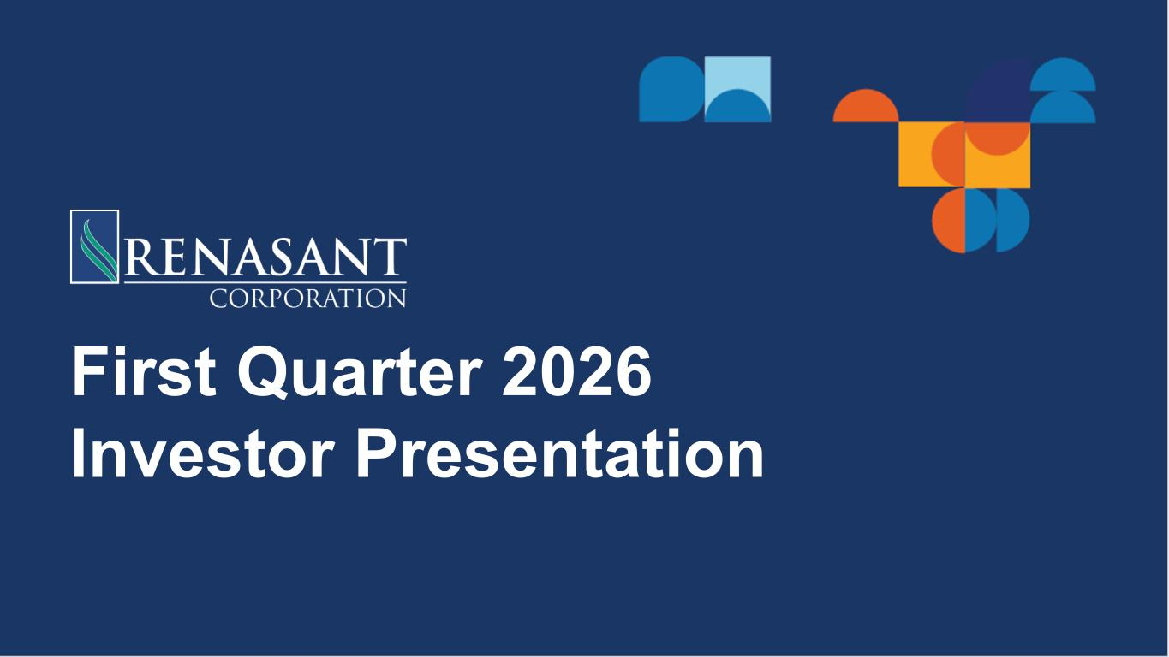

First Quarter 2026 Investor Presentation

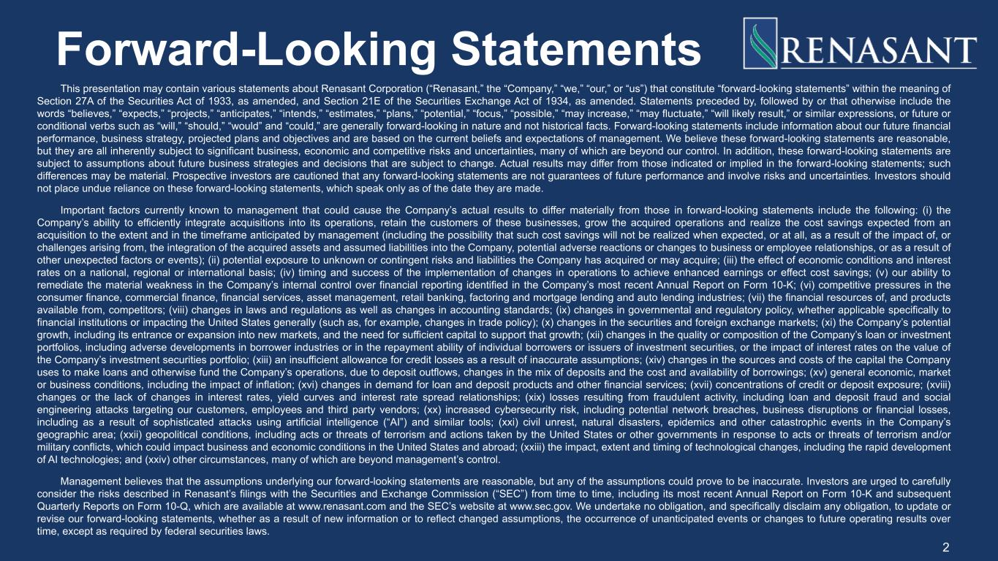
Forward-Looking Statements This presentation may contain various statements about Renasant Corporation (“Renasant,” the “Company,” “we,” “our,” or “us”) that constitute “forward-looking statements” within the meaning of Section 27A of the Securities Act of 1933, as amended, and Section 21E of the Securities Exchange Act of 1934, as amended. Statements preceded by, followed by or that otherwise include the words “believes,” “expects,” “projects,” “anticipates,” “intends,” “estimates,” “plans,” “potential,” “focus,” “possible,” “may increase,” “may fluctuate,” “will likely result,” or similar expressions, or future or conditional verbs such as “will,” “should,” “would” and “could,” are generally forward-looking in nature and not historical facts. Forward-looking statements include information about our future financial performance, business strategy, projected plans and objectives and are based on the current beliefs and expectations of management. We believe these forward-looking statements are reasonable, but they are all inherently subject to significant business, economic and competitive risks and uncertainties, many of which are beyond our control. In addition, these forward-looking statements are subject to assumptions about future business strategies and decisions that are subject to change. Actual results may differ from those indicated or implied in the forward-looking statements; such differences may be material. Prospective investors are cautioned that any forward-looking statements are not guarantees of future performance and involve risks and uncertainties. Investors should not place undue reliance on these forward-looking statements, which speak only as of the date they are made. Important factors currently known to management that could cause the Company’s actual results to differ materially from those in forward-looking statements include the following: (i) the Company’s ability to efficiently integrate acquisitions into its operations, retain the customers of these businesses, grow the acquired operations and realize the cost savings expected from an acquisition to the extent and in the timeframe anticipated by management (including the possibility that such cost savings will not be realized when expected, or at all, as a result of the impact of, or challenges arising from, the integration of the acquired assets and assumed liabilities into the Company, potential adverse reactions or changes to business or employee relationships, or as a result of other unexpected factors or events); (ii) potential exposure to unknown or contingent risks and liabilities the Company has acquired or may acquire; (iii) the effect of economic conditions and interest rates on a national, regional or international basis; (iv) timing and success of the implementation of changes in operations to achieve enhanced earnings or effect cost savings; (v) our ability to remediate the material weakness in the Company’s internal control over financial reporting identified in the Company’s most recent Annual Report on Form 10-K; (vi) competitive pressures in the consumer finance, commercial finance, financial services, asset management, retail banking, factoring and mortgage lending and auto lending industries; (vii) the financial resources of, and products available from, competitors; (viii) changes in laws and regulations as well as changes in accounting standards; (ix) changes in governmental and regulatory policy, whether applicable specifically to financial institutions or impacting the United States generally (such as, for example, changes in trade policy); (x) changes in the securities and foreign exchange markets; (xi) the Company’s potential growth, including its entrance or expansion into new markets, and the need for sufficient capital to support that growth; (xii) changes in the quality or composition of the Company’s loan or investment portfolios, including adverse developments in borrower industries or in the repayment ability of individual borrowers or issuers of investment securities, or the impact of interest rates on the value of the Company’s investment securities portfolio; (xiii) an insufficient allowance for credit losses as a result of inaccurate assumptions; (xiv) changes in the sources and costs of the capital the Company uses to make loans and otherwise fund the Company’s operations, due to deposit outflows, changes in the mix of deposits and the cost and availability of borrowings; (xv) general economic, market or business conditions, including the impact of inflation; (xvi) changes in demand for loan and deposit products and other financial services; (xvii) concentrations of credit or deposit exposure; (xviii) changes or the lack of changes in interest rates, yield curves and interest rate spread relationships; (xix) losses resulting from fraudulent activity, including loan and deposit fraud and social engineering attacks targeting our customers, employees and third party vendors; (xx) increased cybersecurity risk, including potential network breaches, business disruptions or financial losses, including as a result of sophisticated attacks using artificial intelligence (“AI”) and similar tools; (xxi) civil unrest, natural disasters, epidemics and other catastrophic events in the Company’s geographic area; (xxii) geopolitical conditions, including acts or threats of terrorism and actions taken by the United States or other governments in response to acts or threats of terrorism and/or military conflicts, which could impact business and economic conditions in the United States and abroad; (xxiii) the impact, extent and timing of technological changes, including the rapid development of AI technologies; and (xxiv) other circumstances, many of which are beyond management’s control. Management believes that the assumptions underlying our forward-looking statements are reasonable, but any of the assumptions could prove to be inaccurate. Investors are urged to carefully consider the risks described in Renasant’s filings with the Securities and Exchange Commission (“SEC”) from time to time, including its most recent Annual Report on Form 10-K and subsequent Quarterly Reports on Form 10-Q, which are available at www.renasant.com and the SEC’s website at www.sec.gov. We undertake no obligation, and specifically disclaim any obligation, to update or revise our forward-looking statements, whether as a result of new information or to reflect changed assumptions, the occurrence of unanticipated events or changes to future operating results over time, except as required by federal securities laws. 2

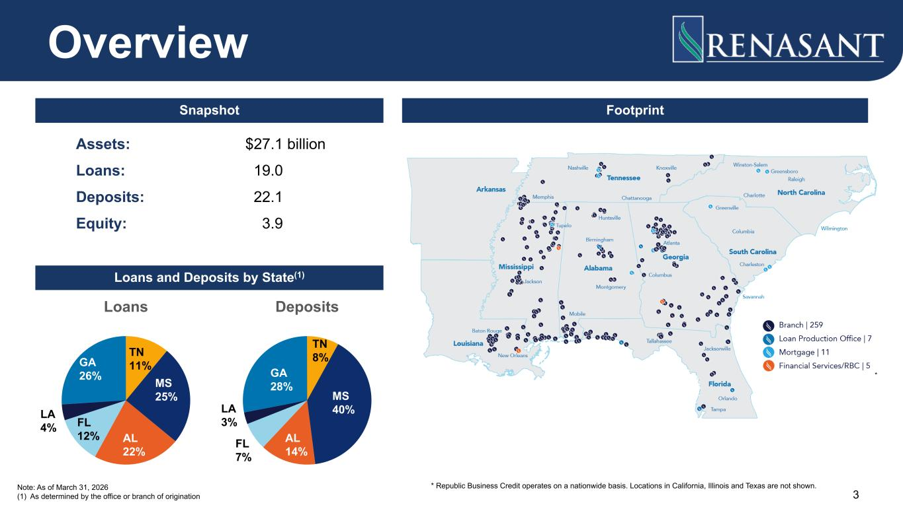
Assets: $27.1 billion Loans: 19.0 Deposits: 22.1 Equity: 3.9 Loans TN 11% MS 25% AL 22% FL 12% LA 4% GA 26% Deposits TN 8% MS 40% AL 14% FL 7% LA 3% GA 28% * 3 Overview Note: As of March 31, 2026 (1) As determined by the office or branch of origination Snapshot Footprint Loans and Deposits by State(1) * Republic Business Credit operates on a nationwide basis. Locations in California, Illinois and Texas are not shown.

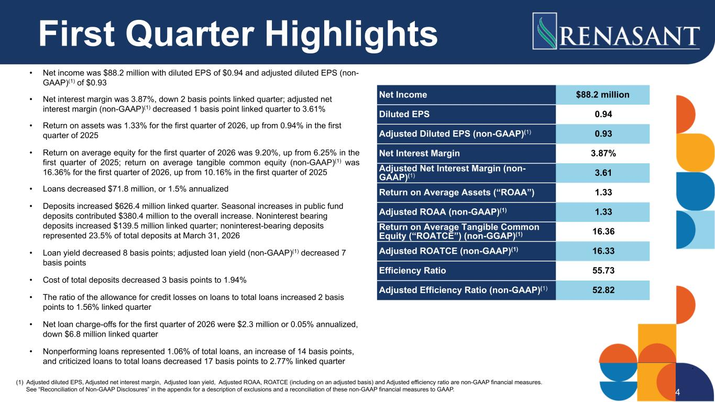
First Quarter Highlights • Net income was $88.2 million with diluted EPS of $0.94 and adjusted diluted EPS (non- GAAP)(1) of $0.93 • Net interest margin was 3.87%, down 2 basis points linked quarter; adjusted net interest margin (non-GAAP)(1) decreased 1 basis point linked quarter to 3.61% • Return on assets was 1.33% for the first quarter of 2026, up from 0.94% in the first quarter of 2025 • Return on average equity for the first quarter of 2026 was 9.20%, up from 6.25% in the first quarter of 2025; return on average tangible common equity (non-GAAP)(1) was 16.36% for the first quarter of 2026, up from 10.16% in the first quarter of 2025 • Loans decreased $71.8 million, or 1.5% annualized • Deposits increased $626.4 million linked quarter. Seasonal increases in public fund deposits contributed $380.4 million to the overall increase. Noninterest bearing deposits increased $139.5 million linked quarter; noninterest-bearing deposits represented 23.5% of total deposits at March 31, 2026 • Loan yield decreased 8 basis points; adjusted loan yield (non-GAAP)(1) decreased 7 basis points • Cost of total deposits decreased 3 basis points to 1.94% • The ratio of the allowance for credit losses on loans to total loans increased 2 basis points to 1.56% linked quarter • Net loan charge-offs for the first quarter of 2026 were $2.3 million or 0.05% annualized, down $6.8 million linked quarter • Nonperforming loans represented 1.06% of total loans, an increase of 14 basis points, and criticized loans to total loans decreased 17 basis points to 2.77% linked quarter 4 Net Income $88.2 million Diluted EPS 0.94 Adjusted Diluted EPS (non-GAAP)(1) 0.93 Net Interest Margin 3.87% Adjusted Net Interest Margin (non- GAAP)(1) 3.61 Return on Average Assets (“ROAA”) 1.33 Adjusted ROAA (non-GAAP)(1) 1.33 Return on Average Tangible Common Equity (“ROATCE”) (non-GGAP)(1) 16.36 Adjusted ROATCE (non-GAAP)(1) 16.33 Efficiency Ratio 55.73 Adjusted Efficiency Ratio (non-GAAP)(1) 52.82 (1) Adjusted diluted EPS, Adjusted net interest margin, Adjusted loan yield, Adjusted ROAA, ROATCE (including on an adjusted basis) and Adjusted efficiency ratio are non-GAAP financial measures. See “Reconciliation of Non-GAAP Disclosures” in the appendix for a description of exclusions and a reconciliation of these non-GAAP financial measures to GAAP.

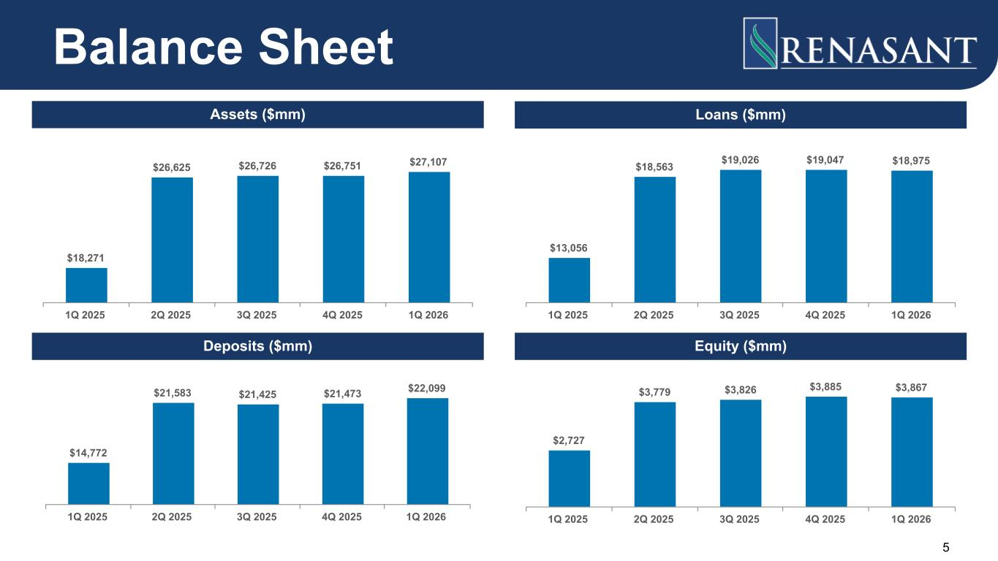
$18,271 $26,625 $26,726 $26,751 $27,107 1Q 2025 2Q 2025 3Q 2025 4Q 2025 1Q 2026 $13,056 $18,563 $19,026 $19,047 $18,975 1Q 2025 2Q 2025 3Q 2025 4Q 2025 1Q 2026 $14,772 $21,583 $21,425 $21,473 $22,099 1Q 2025 2Q 2025 3Q 2025 4Q 2025 1Q 2026 $2,727 $3,779 $3,826 $3,885 $3,867 1Q 2025 2Q 2025 3Q 2025 4Q 2025 1Q 2026 5 Balance Sheet Assets ($mm) Loans ($mm) Deposits ($mm) Equity ($mm)

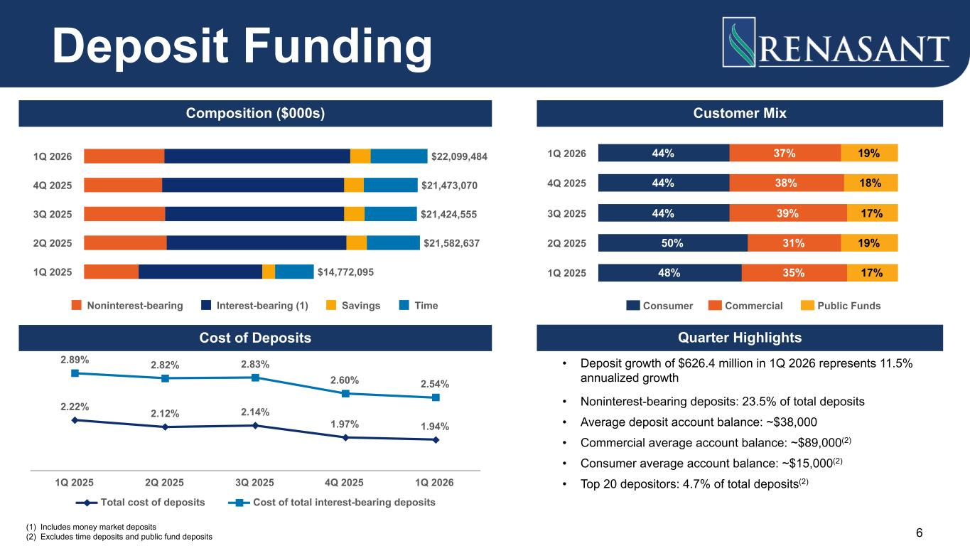
(1) Includes money market deposits (2) Excludes time deposits and public fund deposits Composition ($000s) Quarter Highlights 6 $22,099,484 $21,473,070 $21,424,555 $21,582,637 $14,772,095 Noninterest-bearing Interest-bearing (1) Savings Time 1Q 2026 4Q 2025 3Q 2025 2Q 2025 1Q 2025 Deposit Funding • Deposit growth of $626.4 million in 1Q 2026 represents 11.5% annualized growth • Noninterest-bearing deposits: 23.5% of total deposits • Average deposit account balance: ~$38,000 • Commercial average account balance: ~$89,000(2) • Consumer average account balance: ~$15,000(2) • Top 20 depositors: 4.7% of total deposits(2) Customer Mix 44% 44% 44% 50% 48% 37% 38% 39% 31% 35% 19% 18% 17% 19% 17% Consumer Commercial Public Funds 1Q 2026 4Q 2025 3Q 2025 2Q 2025 1Q 2025 Cost of Deposits 2.22% 2.12% 2.14% 1.97% 1.94% 2.89% 2.82% 2.83% 2.60% 2.54% Total cost of deposits Cost of total interest-bearing deposits 1Q 2025 2Q 2025 3Q 2025 4Q 2025 1Q 2026

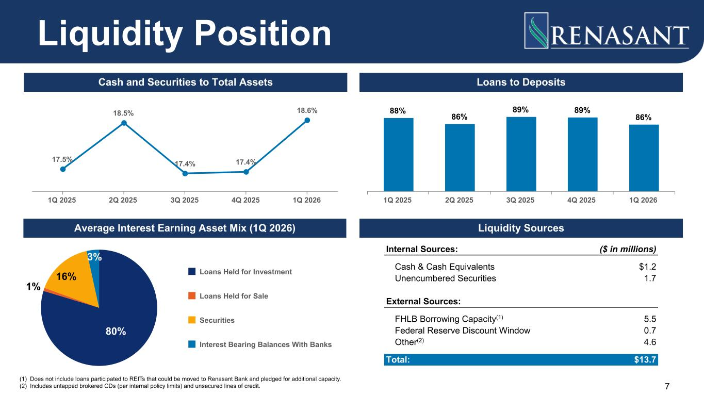
Cash and Securities to Total Assets Loans to Deposits Average Interest Earning Asset Mix (1Q 2026) 17.5% 18.5% 17.4% 17.4% 18.6% 1Q 2025 2Q 2025 3Q 2025 4Q 2025 1Q 2026 88% 86% 89% 89% 86% 1Q 2025 2Q 2025 3Q 2025 4Q 2025 1Q 2026 80% 1% 16% 3% Loans Held for Investment Loans Held for Sale Securities Interest Bearing Balances With Banks 7 Liquidity Position Liquidity Sources Internal Sources: ($ in millions) Cash & Cash Equivalents $1.2 Unencumbered Securities 1.7 External Sources: FHLB Borrowing Capacity(1) 5.5 Federal Reserve Discount Window 0.7 Other(2) 4.6 Total: $13.7 (1) Does not include loans participated to REITs that could be moved to Renasant Bank and pledged for additional capacity. (2) Includes untapped brokered CDs (per internal policy limits) and unsecured lines of credit.

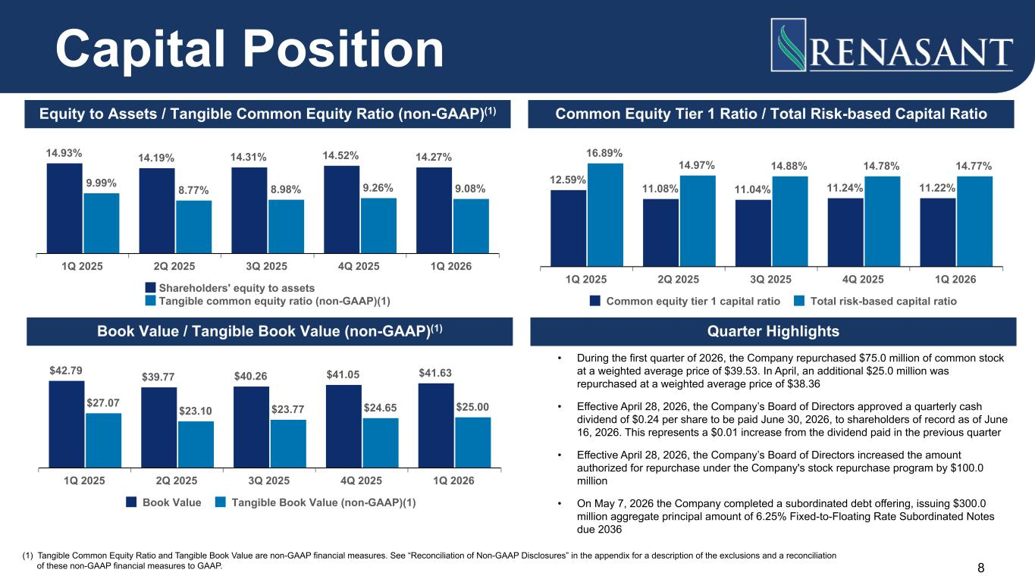
14.93% 14.19% 14.31% 14.52% 14.27% 9.99% 8.77% 8.98% 9.26% 9.08% Shareholders' equity to assets Tangible common equity ratio (non-GAAP)(1) 1Q 2025 2Q 2025 3Q 2025 4Q 2025 1Q 2026 12.59% 11.08% 11.04% 11.24% 11.22% 16.89% 14.97% 14.88% 14.78% 14.77% Common equity tier 1 capital ratio Total risk-based capital ratio 1Q 2025 2Q 2025 3Q 2025 4Q 2025 1Q 2026 Quarter Highlights • During the first quarter of 2026, the Company repurchased $75.0 million of common stock at a weighted average price of $39.53. In April, an additional $25.0 million was repurchased at a weighted average price of $38.36 • Effective April 28, 2026, the Company’s Board of Directors approved a quarterly cash dividend of $0.24 per share to be paid June 30, 2026, to shareholders of record as of June 16, 2026. This represents a $0.01 increase from the dividend paid in the previous quarter • Effective April 28, 2026, the Company’s Board of Directors increased the amount authorized for repurchase under the Company's stock repurchase program by $100.0 million • On May 7, 2026 the Company completed a subordinated debt offering, issuing $300.0 million aggregate principal amount of 6.25% Fixed-to-Floating Rate Subordinated Notes due 2036 $42.79 $39.77 $40.26 $41.05 $41.63 $27.07 $23.10 $23.77 $24.65 $25.00 Book Value Tangible Book Value (non-GAAP)(1) 1Q 2025 2Q 2025 3Q 2025 4Q 2025 1Q 2026 8 Capital Position Equity to Assets / Tangible Common Equity Ratio (non-GAAP)(1) Common Equity Tier 1 Ratio / Total Risk-based Capital Ratio Book Value / Tangible Book Value (non-GAAP)(1) (1) Tangible Common Equity Ratio and Tangible Book Value are non-GAAP financial measures. See “Reconciliation of Non-GAAP Disclosures” in the appendix for a description of the exclusions and a reconciliation of these non-GAAP financial measures to GAAP.

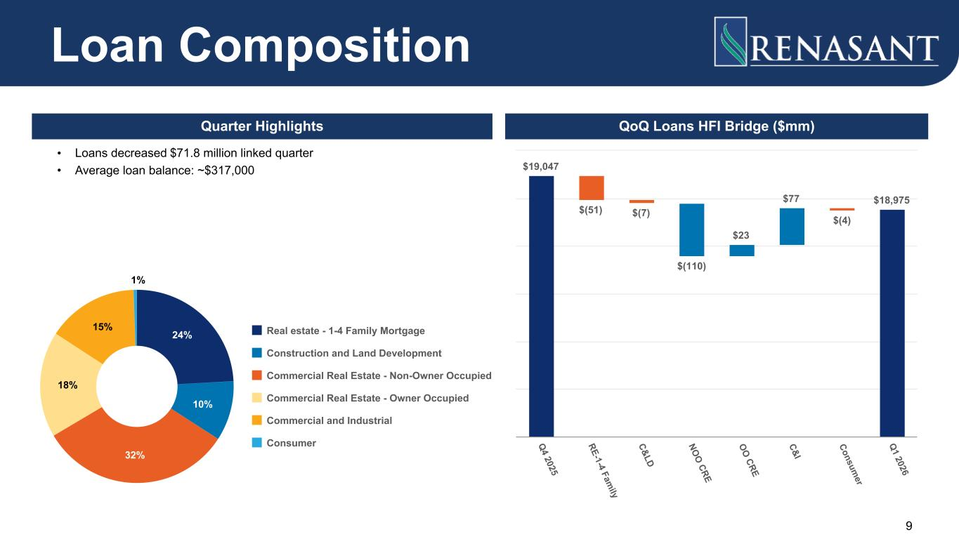
QoQ Loans HFI Bridge ($mm) $19,047 $(51) $(7) $(110) $23 $77 $(4) $18,975 Q 4 2025 RE-1-4 Fam ily C&LD NO O CRE O O CRE C&I Consum er Q 1 2026 Quarter Highlights • Loans decreased $71.8 million linked quarter • Average loan balance: ~$317,000 24% 10% 32% 18% 15% 1% Real estate - 1-4 Family Mortgage Construction and Land Development Commercial Real Estate - Non-Owner Occupied Commercial Real Estate - Owner Occupied Commercial and Industrial Consumer Loan Composition 9

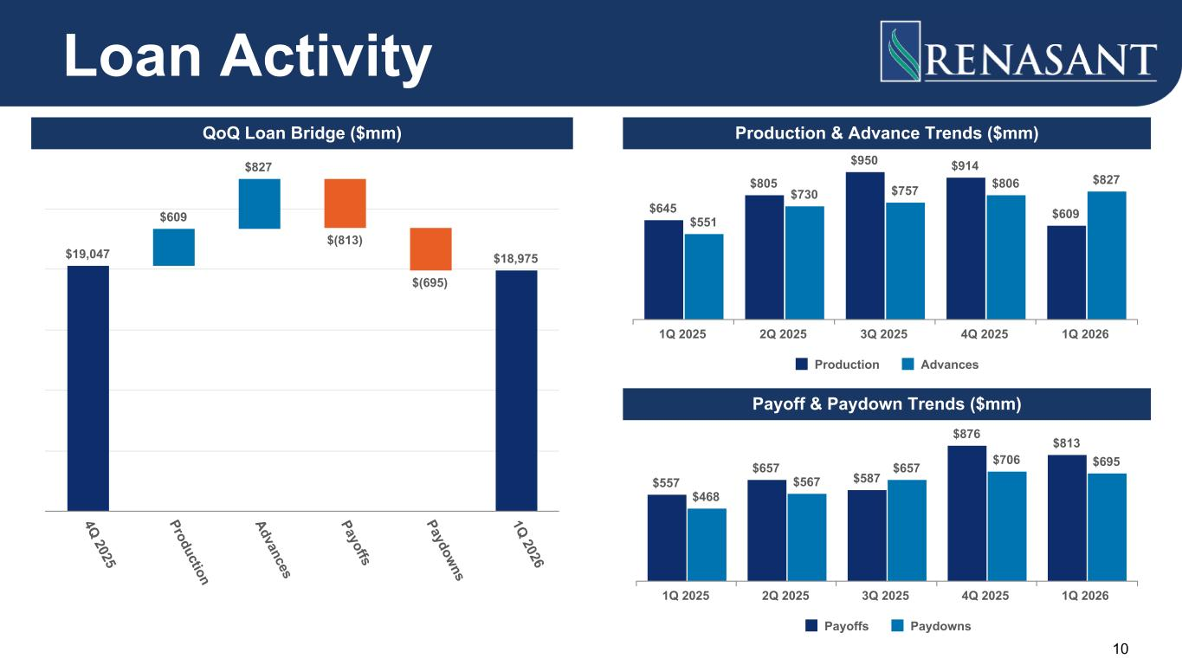
$645 $805 $950 $914 $609$551 $730 $757 $806 $827 Production Advances 1Q 2025 2Q 2025 3Q 2025 4Q 2025 1Q 2026 $557 $657 $587 $876 $813 $468 $567 $657 $706 $695 Payoffs Paydowns 1Q 2025 2Q 2025 3Q 2025 4Q 2025 1Q 2026 $19,047 $609 $827 $(813) $(695) $18,975 4Q 2025 Production Advances Payoffs Paydowns 1Q 2026 Loan Activity 10 QoQ Loan Bridge ($mm) Production & Advance Trends ($mm) Payoff & Paydown Trends ($mm)

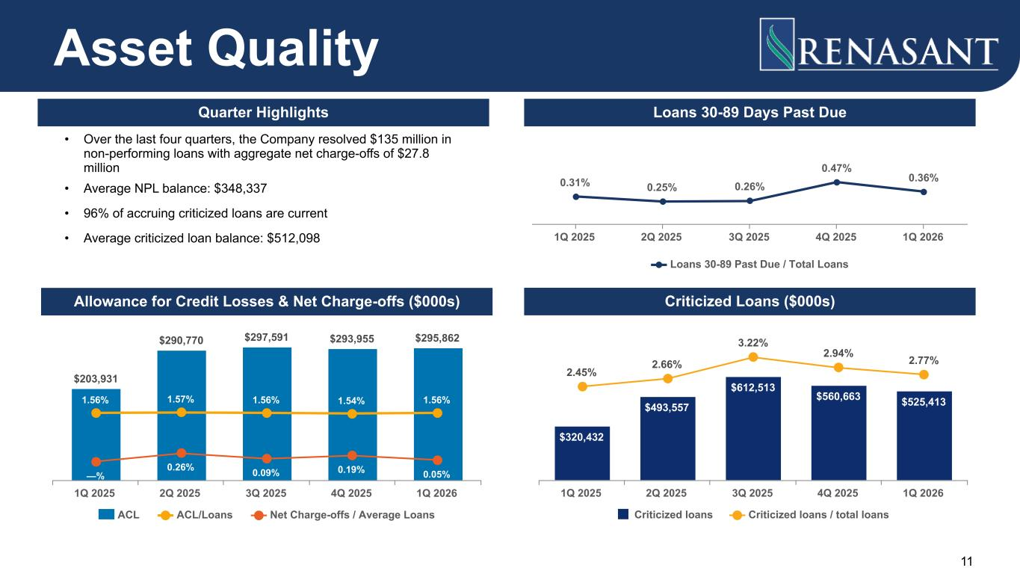
11 $203,931 $290,770 $297,591 $293,955 $295,862 1.56% 1.57% 1.56% 1.54% 1.56% —% 0.26% 0.09% 0.19% 0.05% ACL ACL/Loans Net Charge-offs / Average Loans 1Q 2025 2Q 2025 3Q 2025 4Q 2025 1Q 2026 $320,432 $493,557 $612,513 $560,663 $525,413 2.45% 2.66% 3.22% 2.94% 2.77% Criticized loans Criticized loans / total loans 1Q 2025 2Q 2025 3Q 2025 4Q 2025 1Q 2026 Asset Quality Criticized Loans ($000s)Allowance for Credit Losses & Net Charge-offs ($000s) 0.31% 0.25% 0.26% 0.47% 0.36% Loans 30-89 Past Due / Total Loans 1Q 2025 2Q 2025 3Q 2025 4Q 2025 1Q 2026 Loans 30-89 Days Past DueQuarter Highlights • Over the last four quarters, the Company resolved $135 million in non-performing loans with aggregate net charge-offs of $27.8 million • Average NPL balance: $348,337 • 96% of accruing criticized loans are current • Average criticized loan balance: $512,098

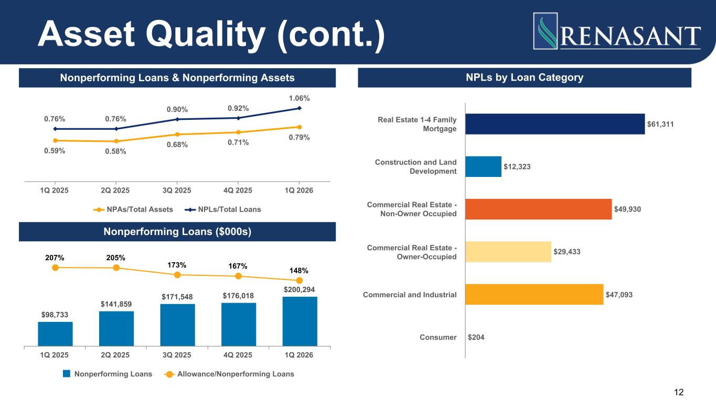
0.59% 0.58% 0.68% 0.71% 0.79% 0.76% 0.76% 0.90% 0.92% 1.06% NPAs/Total Assets NPLs/Total Loans 1Q 2025 2Q 2025 3Q 2025 4Q 2025 1Q 2026 12 $61,311 $12,323 $49,930 $29,433 $47,093 $204 Real Estate 1-4 Family Mortgage Construction and Land Development Commercial Real Estate - Non-Owner Occupied Commercial Real Estate - Owner-Occupied Commercial and Industrial Consumer NPLs by Loan Category Asset Quality (cont.) Nonperforming Loans & Nonperforming Assets $98,733 $141,859 $171,548 $176,018 $200,294 207% 205% 173% 167% 148% Nonperforming Loans Allowance/Nonperforming Loans 1Q 2025 2Q 2025 3Q 2025 4Q 2025 1Q 2026 Nonperforming Loans ($000s)

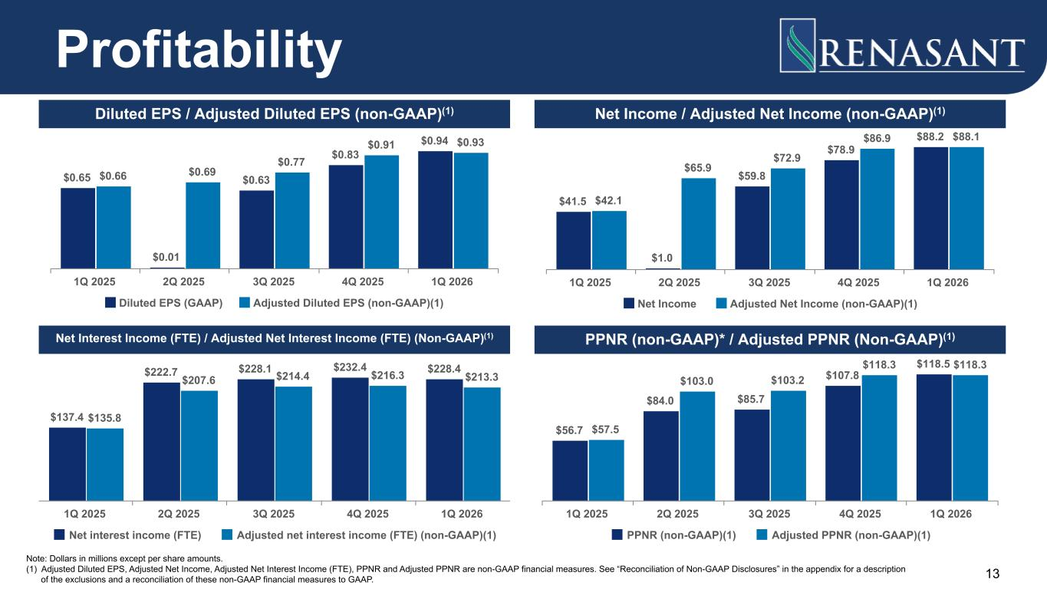
$0.65 $0.01 $0.63 $0.83 $0.94 $0.66 $0.69 $0.77 $0.91 $0.93 Diluted EPS (GAAP) Adjusted Diluted EPS (non-GAAP)(1) 1Q 2025 2Q 2025 3Q 2025 4Q 2025 1Q 2026 $137.4 $222.7 $228.1 $232.4 $228.4 $135.8 $207.6 $214.4 $216.3 $213.3 Net interest income (FTE) Adjusted net interest income (FTE) (non-GAAP)(1) 1Q 2025 2Q 2025 3Q 2025 4Q 2025 1Q 2026 $56.7 $84.0 $85.7 $107.8 $118.5 $57.5 $103.0 $103.2 $118.3 $118.3 PPNR (non-GAAP)(1) Adjusted PPNR (non-GAAP)(1) 1Q 2025 2Q 2025 3Q 2025 4Q 2025 1Q 2026 $41.5 $1.0 $59.8 $78.9 $88.2 $42.1 $65.9 $72.9 $86.9 $88.1 Net Income Adjusted Net Income (non-GAAP)(1) 1Q 2025 2Q 2025 3Q 2025 4Q 2025 1Q 2026 13 Profitability Diluted EPS / Adjusted Diluted EPS (non-GAAP)(1) Net Income / Adjusted Net Income (non-GAAP)(1) PPNR (non-GAAP)* / Adjusted PPNR (Non-GAAP)(1)Net Interest Income (FTE) / Adjusted Net Interest Income (FTE) (Non-GAAP)(1) Note: Dollars in millions except per share amounts. (1) Adjusted Diluted EPS, Adjusted Net Income, Adjusted Net Interest Income (FTE), PPNR and Adjusted PPNR are non-GAAP financial measures. See “Reconciliation of Non-GAAP Disclosures” in the appendix for a description of the exclusions and a reconciliation of these non-GAAP financial measures to GAAP.

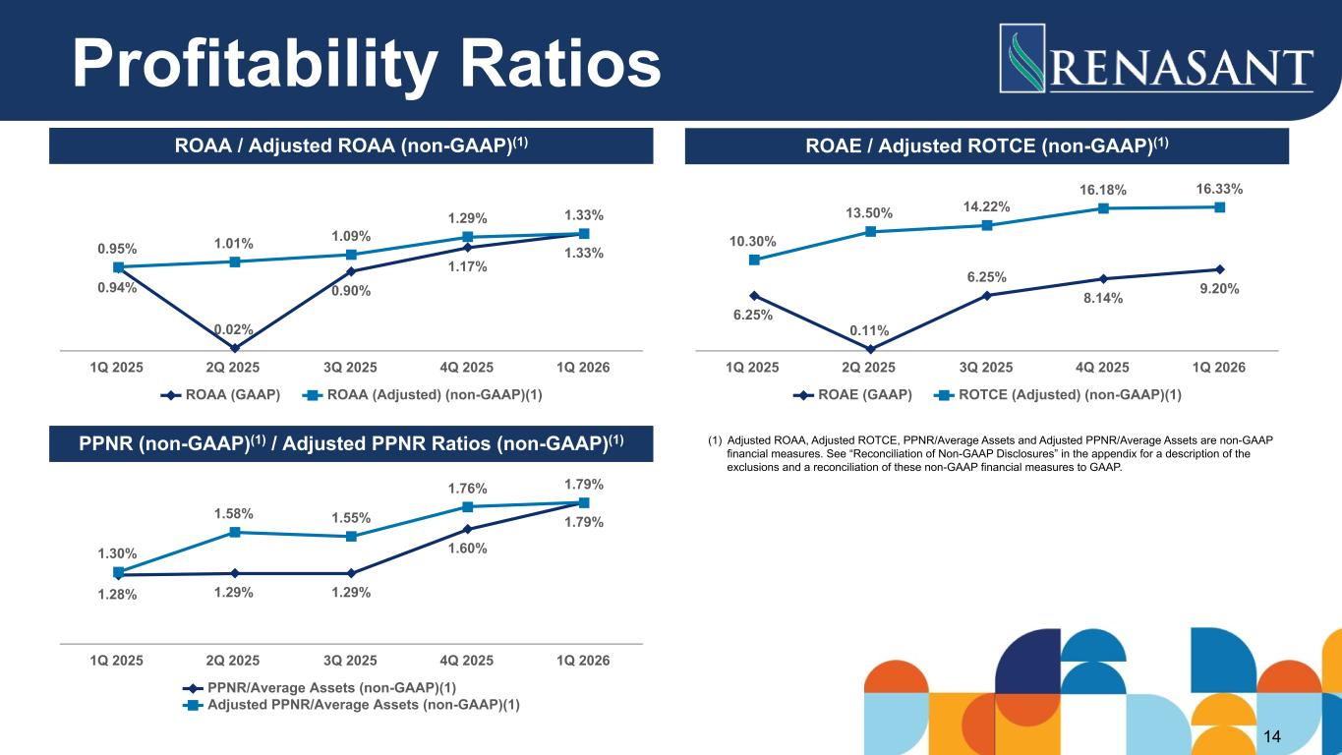
0.94% 0.02% 0.90% 1.17% 1.33%0.95% 1.01% 1.09% 1.29% 1.33% ROAA (GAAP) ROAA (Adjusted) (non-GAAP)(1) 1Q 2025 2Q 2025 3Q 2025 4Q 2025 1Q 2026 6.25% 0.11% 6.25% 8.14% 9.20% 10.30% 13.50% 14.22% 16.18% 16.33% ROAE (GAAP) ROTCE (Adjusted) (non-GAAP)(1) 1Q 2025 2Q 2025 3Q 2025 4Q 2025 1Q 2026 1.28% 1.29% 1.29% 1.60% 1.79% 1.30% 1.58% 1.55% 1.76% 1.79% PPNR/Average Assets (non-GAAP)(1) Adjusted PPNR/Average Assets (non-GAAP)(1) 1Q 2025 2Q 2025 3Q 2025 4Q 2025 1Q 2026 14 Profitability Ratios ROAA / Adjusted ROAA (non-GAAP)(1) ROAE / Adjusted ROTCE (non-GAAP)(1) PPNR (non-GAAP)(1) / Adjusted PPNR Ratios (non-GAAP)(1) (1) Adjusted ROAA, Adjusted ROTCE, PPNR/Average Assets and Adjusted PPNR/Average Assets are non-GAAP financial measures. See “Reconciliation of Non-GAAP Disclosures” in the appendix for a description of the exclusions and a reconciliation of these non-GAAP financial measures to GAAP.

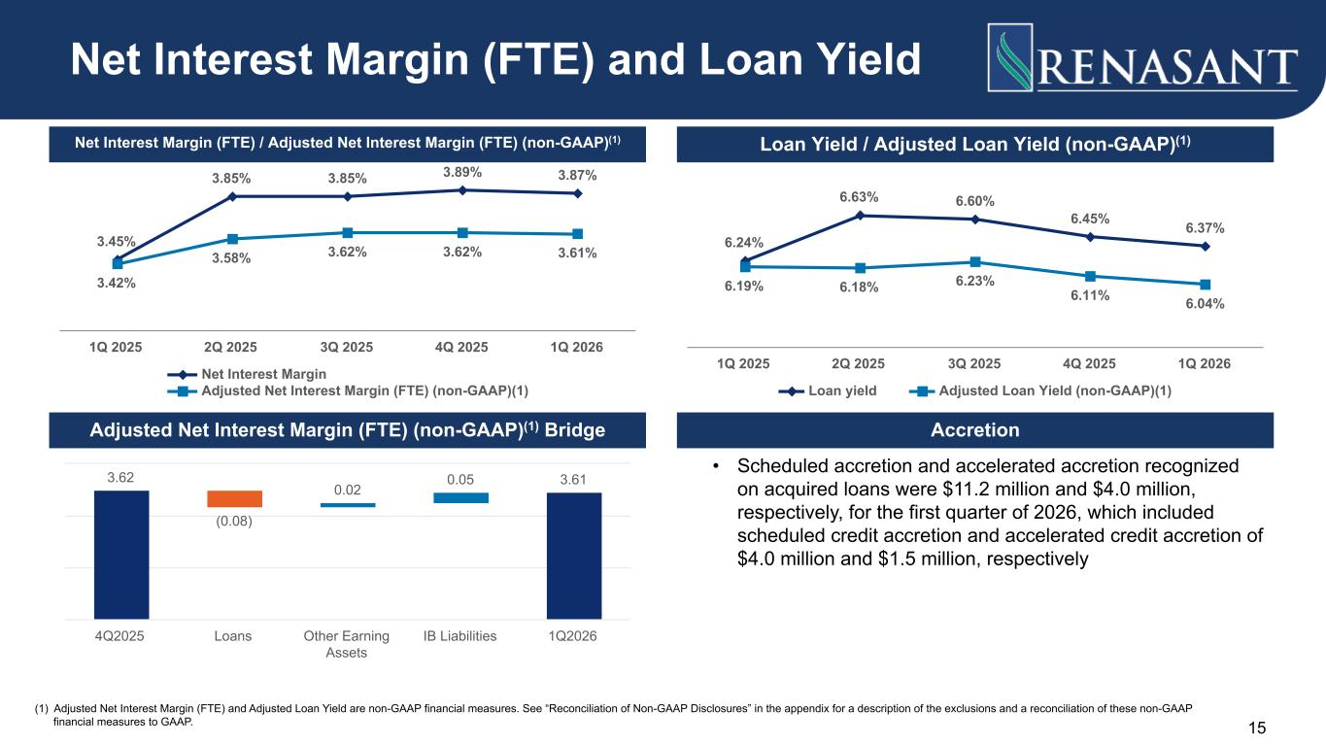
3.45% 3.85% 3.85% 3.89% 3.87% 3.42% 3.58% 3.62% 3.62% 3.61% Net Interest Margin Adjusted Net Interest Margin (FTE) (non-GAAP)(1) 1Q 2025 2Q 2025 3Q 2025 4Q 2025 1Q 2026 6.24% 6.63% 6.60% 6.45% 6.37% 6.19% 6.18% 6.23% 6.11% 6.04% Loan yield Adjusted Loan Yield (non-GAAP)(1) 1Q 2025 2Q 2025 3Q 2025 4Q 2025 1Q 2026 • Scheduled accretion and accelerated accretion recognized on acquired loans were $11.2 million and $4.0 million, respectively, for the first quarter of 2026, which included scheduled credit accretion and accelerated credit accretion of $4.0 million and $1.5 million, respectively 15 Net Interest Margin (FTE) and Loan Yield Net Interest Margin (FTE) / Adjusted Net Interest Margin (FTE) (non-GAAP)(1) Loan Yield / Adjusted Loan Yield (non-GAAP)(1) Accretion (1) Adjusted Net Interest Margin (FTE) and Adjusted Loan Yield are non-GAAP financial measures. See “Reconciliation of Non-GAAP Disclosures” in the appendix for a description of the exclusions and a reconciliation of these non-GAAP financial measures to GAAP. Adjusted Net Interest Margin (FTE) (non-GAAP)(1) Bridge 3.62 (0.08) 0.02 0.05 3.61 4Q2025 Loans Other Earning Assets IB Liabilities 1Q2026

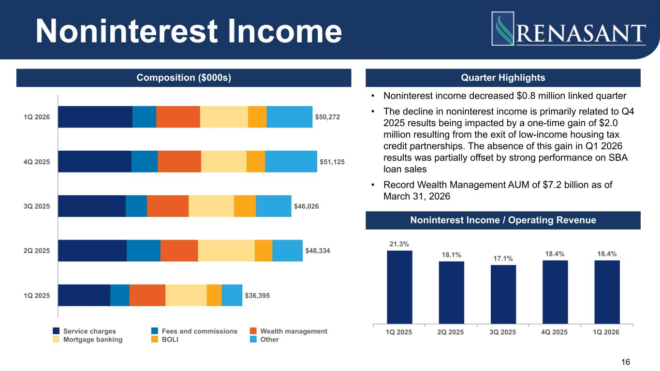
• Noninterest income decreased $0.8 million linked quarter • The decline in noninterest income is primarily related to Q4 2025 results being impacted by a one-time gain of $2.0 million resulting from the exit of low-income housing tax credit partnerships. The absence of this gain in Q1 2026 results was partially offset by strong performance on SBA loan sales • Record Wealth Management AUM of $7.2 billion as of March 31, 2026 16 $50,272 $51,125 $46,026 $48,334 $36,395 Service charges Fees and commissions Wealth management Mortgage banking BOLI Other 1Q 2026 4Q 2025 3Q 2025 2Q 2025 1Q 2025 Noninterest Income Composition ($000s) Quarter Highlights Noninterest Income / Operating Revenue 21.3% 18.1% 17.1% 18.4% 18.4% 1Q 2025 2Q 2025 3Q 2025 4Q 2025 1Q 2026

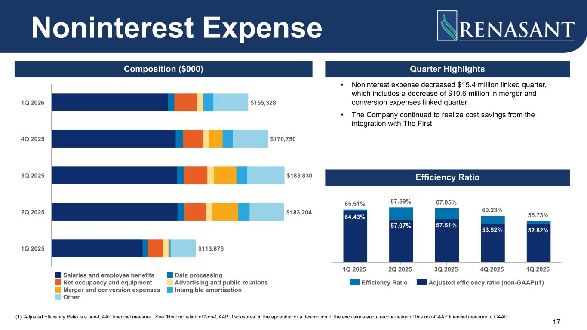
• Noninterest expense decreased $15.4 million linked quarter, which includes a decrease of $10.6 million in merger and conversion expenses linked quarter • The Company continued to realize cost savings from the integration with The First 17 Quarter Highlights 64.43% 57.07% 57.51% 53.52% 52.82% 65.51% 67.59% 67.05% 60.23% 55.73% Efficiency Ratio Adjusted efficiency ratio (non-GAAP)(1) 1Q 2025 2Q 2025 3Q 2025 4Q 2025 1Q 2026 $155,328 $170,750 $183,830 $183,204 $113,876 Salaries and employee benefits Data processing Net occupancy and equipment Advertising and public relations Merger and conversion expenses Intangible amortization Other 1Q 2026 4Q 2025 3Q 2025 2Q 2025 1Q 2025 Noninterest Expense Efficiency Ratio Composition ($000) (1) Adjusted Efficiency Ratio is a non-GAAP financial measure. See “Reconciliation of Non-GAAP Disclosures” in the appendix for a description of the exclusions and a reconciliation of this non-GAAP financial measure to GAAP.

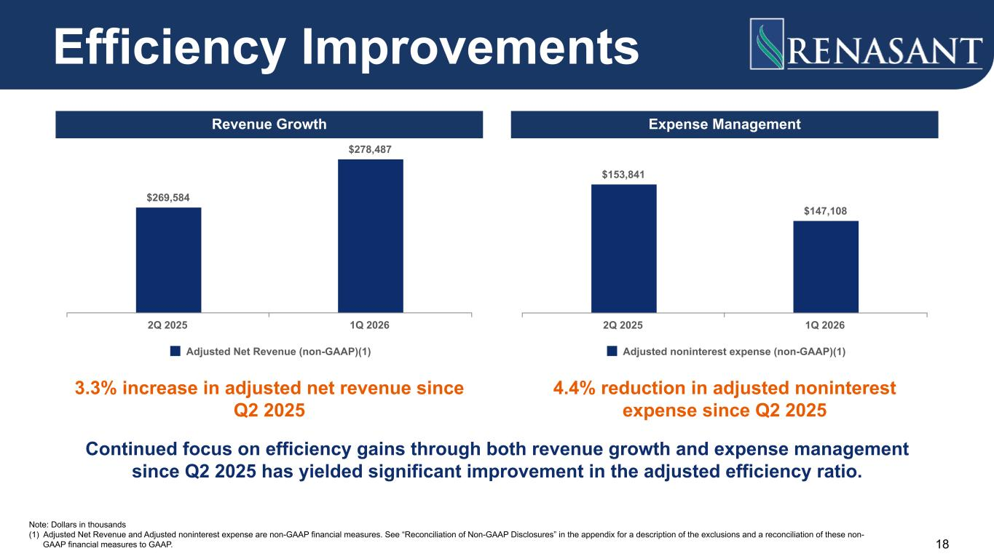
$153,841 $147,108 Adjusted noninterest expense (non-GAAP)(1) 2Q 2025 1Q 2026 Efficiency Improvements 3.3% increase in adjusted net revenue since Q2 2025 $269,584 $278,487 Adjusted Net Revenue (non-GAAP)(1) 2Q 2025 1Q 2026 4.4% reduction in adjusted noninterest expense since Q2 2025 Continued focus on efficiency gains through both revenue growth and expense management since Q2 2025 has yielded significant improvement in the adjusted efficiency ratio. Note: Dollars in thousands (1) Adjusted Net Revenue and Adjusted noninterest expense are non-GAAP financial measures. See “Reconciliation of Non-GAAP Disclosures” in the appendix for a description of the exclusions and a reconciliation of these non- GAAP financial measures to GAAP. 18 Expense ManagementRevenue Growth

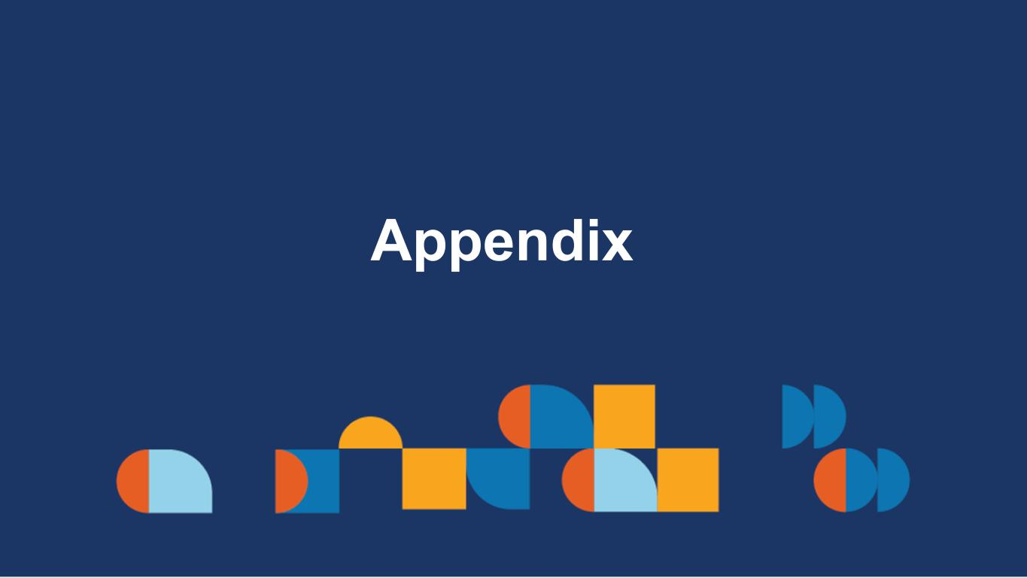
Appendix

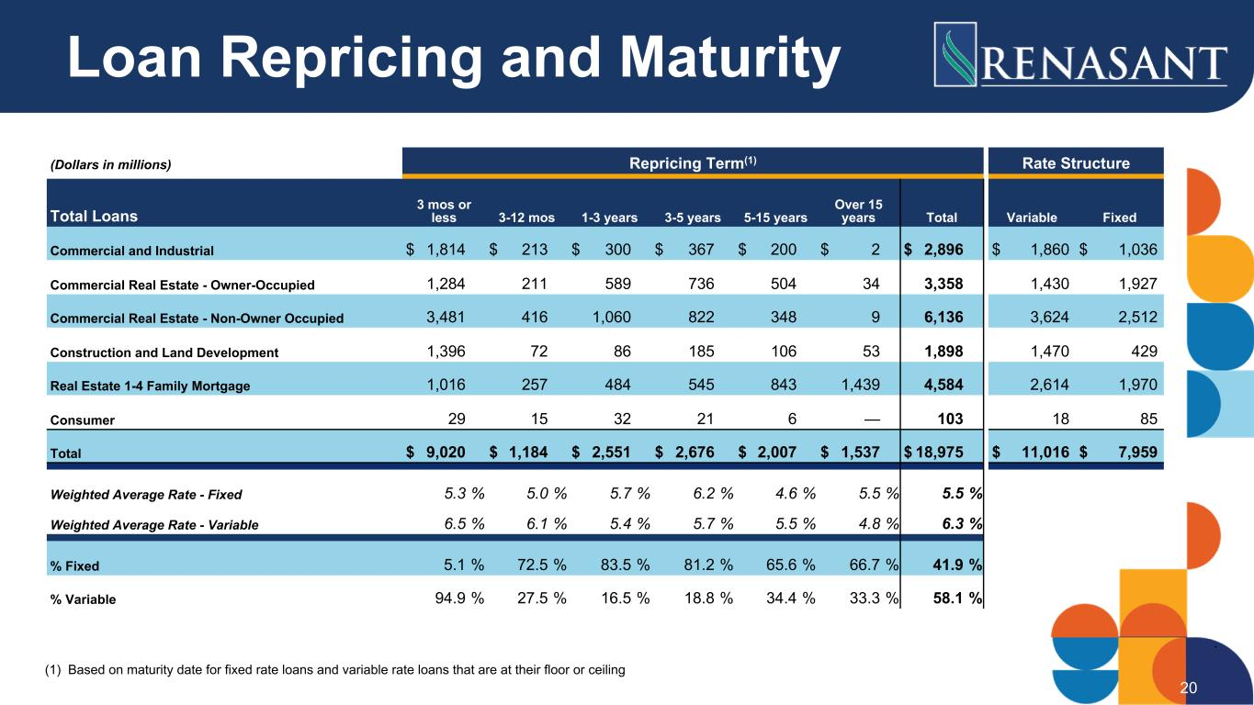
(Dollars in millions) Repricing Term(1) Rate Structure Total Loans 3 mos or less 3-12 mos 1-3 years 3-5 years 5-15 years Over 15 years Total Variable Fixed Commercial and Industrial $ 1,814 $ 213 $ 300 $ 367 $ 200 $ 2 $ 2,896 $ 1,860 $ 1,036 Commercial Real Estate - Owner-Occupied 1,284 211 589 736 504 34 3,358 1,430 1,927 Commercial Real Estate - Non-Owner Occupied 3,481 416 1,060 822 348 9 6,136 3,624 2,512 Construction and Land Development 1,396 72 86 185 106 53 1,898 1,470 429 Real Estate 1-4 Family Mortgage 1,016 257 484 545 843 1,439 4,584 2,614 1,970 Consumer 29 15 32 21 6 — 103 18 85 Total $ 9,020 $ 1,184 $ 2,551 $ 2,676 $ 2,007 $ 1,537 $ 18,975 $ 11,016 $ 7,959 Weighted Average Rate - Fixed 5.3 % 5.0 % 5.7 % 6.2 % 4.6 % 5.5 % 5.5 % Weighted Average Rate - Variable 6.5 % 6.1 % 5.4 % 5.7 % 5.5 % 4.8 % 6.3 % % Fixed 5.1 % 72.5 % 83.5 % 81.2 % 65.6 % 66.7 % 41.9 % % Variable 94.9 % 27.5 % 16.5 % 18.8 % 34.4 % 33.3 % 58.1 % (1) Based on maturity date for fixed rate loans and variable rate loans that are at their floor or ceiling 20 Loan Repricing and Maturity

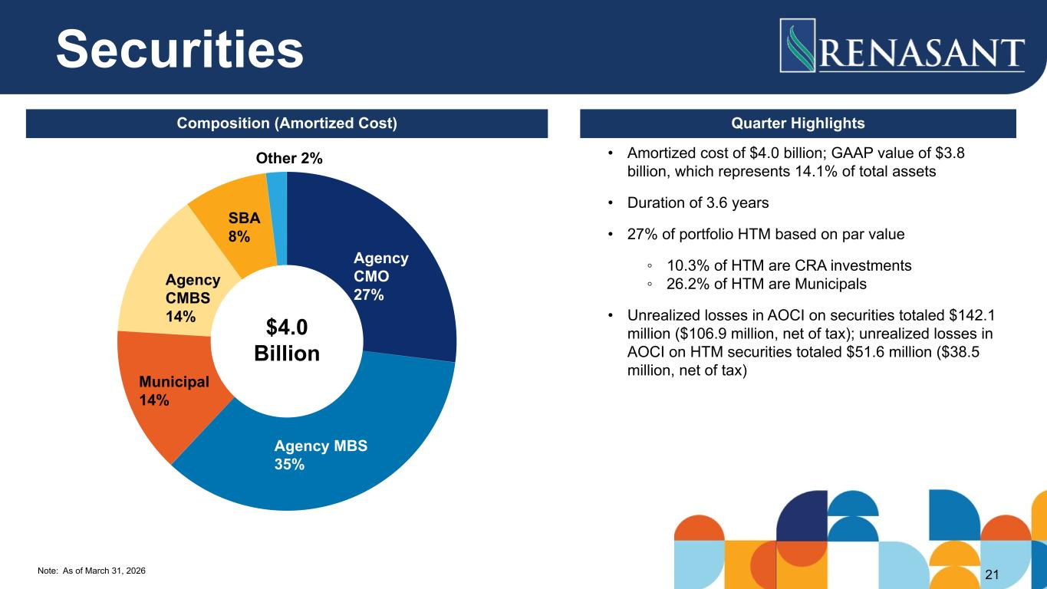
Note: As of March 31, 2026 Agency CMO 27% Agency MBS 35% Municipal 14% Agency CMBS 14% SBA 8% Other 2% 21 • Amortized cost of $4.0 billion; GAAP value of $3.8 billion, which represents 14.1% of total assets • Duration of 3.6 years • 27% of portfolio HTM based on par value ◦ 10.3% of HTM are CRA investments ◦ 26.2% of HTM are Municipals • Unrealized losses in AOCI on securities totaled $142.1 million ($106.9 million, net of tax); unrealized losses in AOCI on HTM securities totaled $51.6 million ($38.5 million, net of tax) $4.0 Billion Securities Composition (Amortized Cost) Quarter Highlights

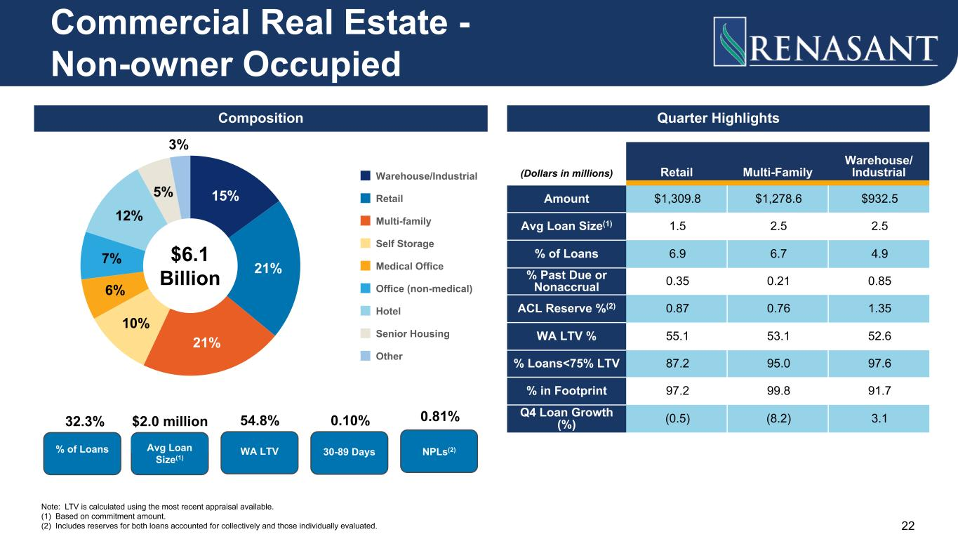
15% 21% 21% 10% 6% 7% 12% 5% 3% Warehouse/Industrial Retail Multi-family Self Storage Medical Office Office (non-medical) Hotel Senior Housing Other Quarter Highlights Note: LTV is calculated using the most recent appraisal available. (1) Based on commitment amount. (2) Includes reserves for both loans accounted for collectively and those individually evaluated. % of Loans Avg Loan Size(1) 32.3% $2.0 million WA LTV 54.8% 0.10% 30-89 Days 0.81% NPLs(2) (Dollars in millions) Retail Multi-Family Warehouse/ Industrial Amount $1,309.8 $1,278.6 $932.5 Avg Loan Size(1) 1.5 2.5 2.5 % of Loans 6.9 6.7 4.9 % Past Due or Nonaccrual 0.35 0.21 0.85 ACL Reserve %(2) 0.87 0.76 1.35 WA LTV % 55.1 53.1 52.6 % Loans<75% LTV 87.2 95.0 97.6 % in Footprint 97.2 99.8 91.7 Q4 Loan Growth (%) (0.5) (8.2) 3.1 22 Commercial Real Estate - Non-owner Occupied $6.1 Billion Composition

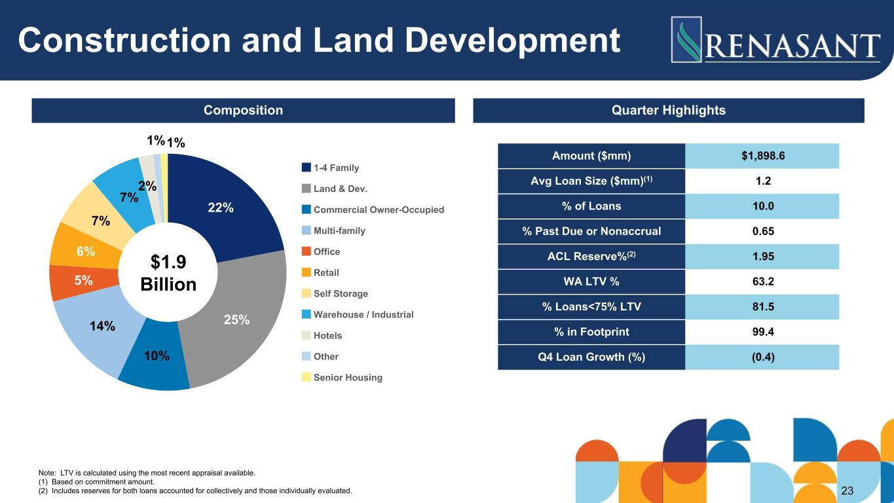
23 22% 25% 10% 14% 5% 6% 7% 7% 2% 1%1% 1-4 Family Land & Dev. Commercial Owner-Occupied Multi-family Office Retail Self Storage Warehouse / Industrial Hotels Other Senior Housing Amount ($mm) $1,898.6 Avg Loan Size ($mm)(1) 1.2 % of Loans 10.0 % Past Due or Nonaccrual 0.65 ACL Reserve%(2) 1.95 WA LTV % 63.2 % Loans<75% LTV 81.5 % in Footprint 99.4 Q4 Loan Growth (%) (0.4) Construction and Land Development $1.9 Billion Composition Quarter Highlights Note: LTV is calculated using the most recent appraisal available. (1) Based on commitment amount. (2) Includes reserves for both loans accounted for collectively and those individually evaluated.

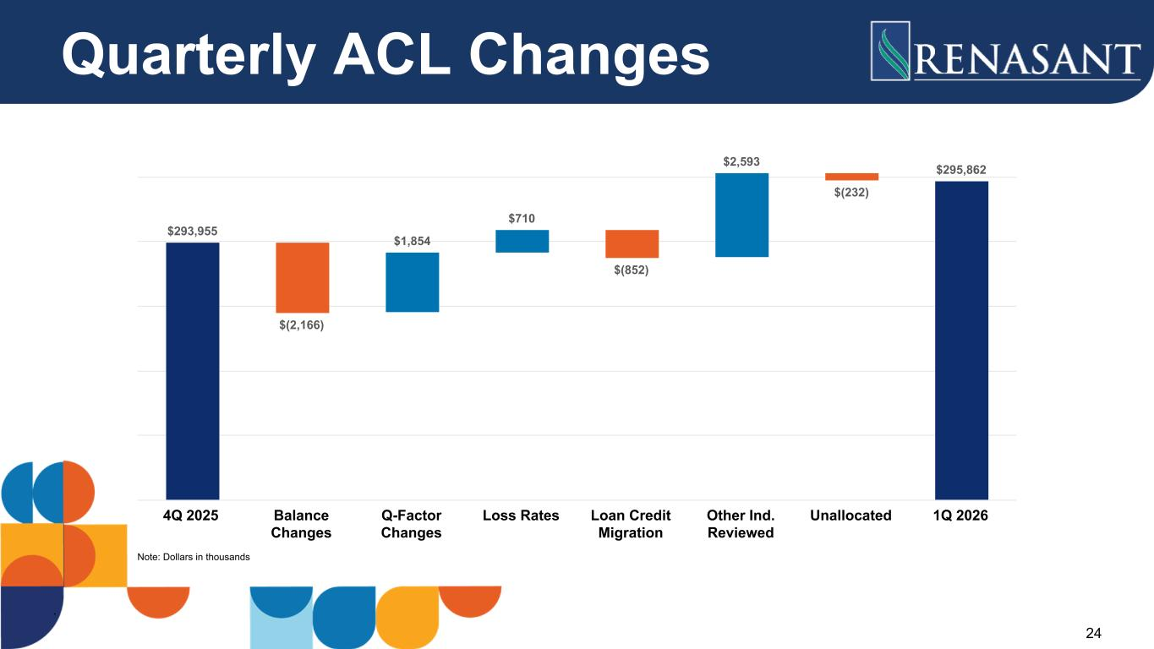
Quarterly ACL Changes $293,955 $(2,166) $1,854 $710 $(852) $2,593 $(232) $295,862 4Q 2025 Balance Changes Q-Factor Changes Loss Rates Loan Credit Migration Other Ind. Reviewed Unallocated 1Q 2026 24 Note: Dollars in thousands

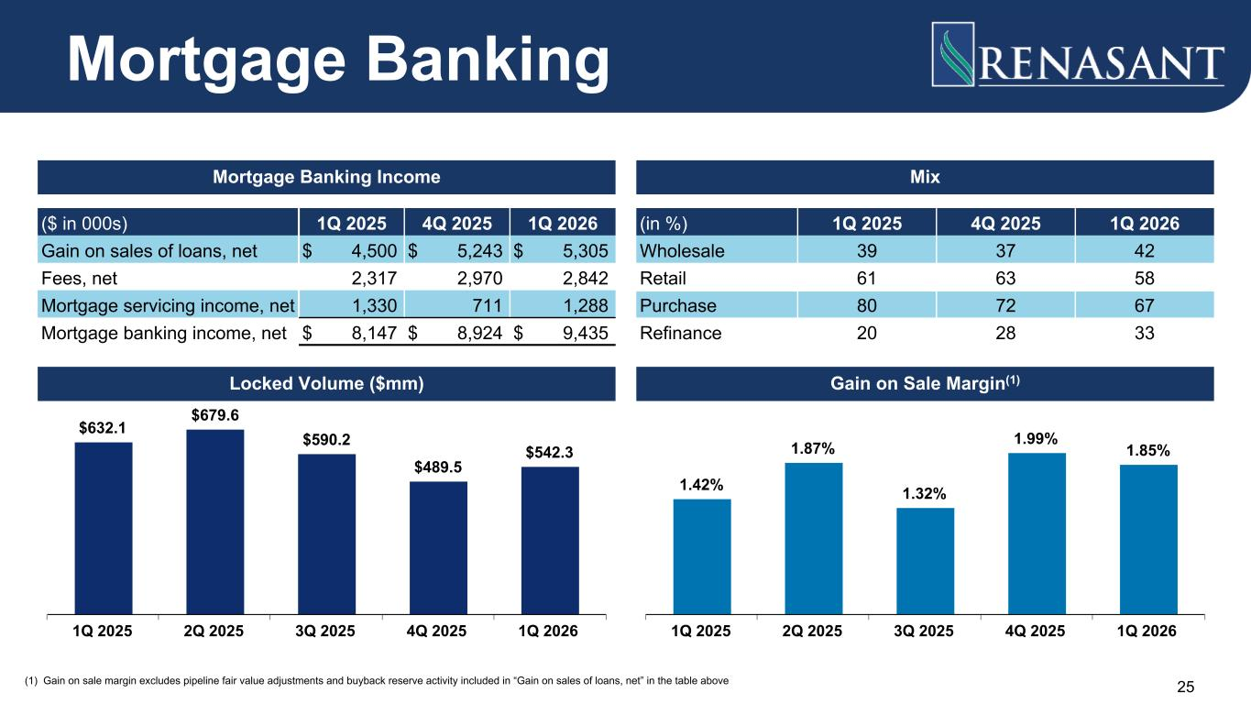
25 ($ in 000s) 1Q 2025 4Q 2025 1Q 2026 Gain on sales of loans, net $ 4,500 $ 5,243 $ 5,305 Fees, net 2,317 2,970 2,842 Mortgage servicing income, net 1,330 711 1,288 Mortgage banking income, net $ 8,147 $ 8,924 $ 9,435 (in %) 1Q 2025 4Q 2025 1Q 2026 Wholesale 39 37 42 Retail 61 63 58 Purchase 80 72 67 Refinance 20 28 33 $632.1 $679.6 $590.2 $489.5 $542.3 1Q 2025 2Q 2025 3Q 2025 4Q 2025 1Q 2026 (1) Gain on sale margin excludes pipeline fair value adjustments and buyback reserve activity included in “Gain on sales of loans, net” in the table above 1.42% 1.87% 1.32% 1.99% 1.85% 1Q 2025 2Q 2025 3Q 2025 4Q 2025 1Q 2026 Mortgage Banking Mortgage Banking Income Mix Locked Volume ($mm) Gain on Sale Margin(1)


Reconciliation of Non-GAAP Disclosures

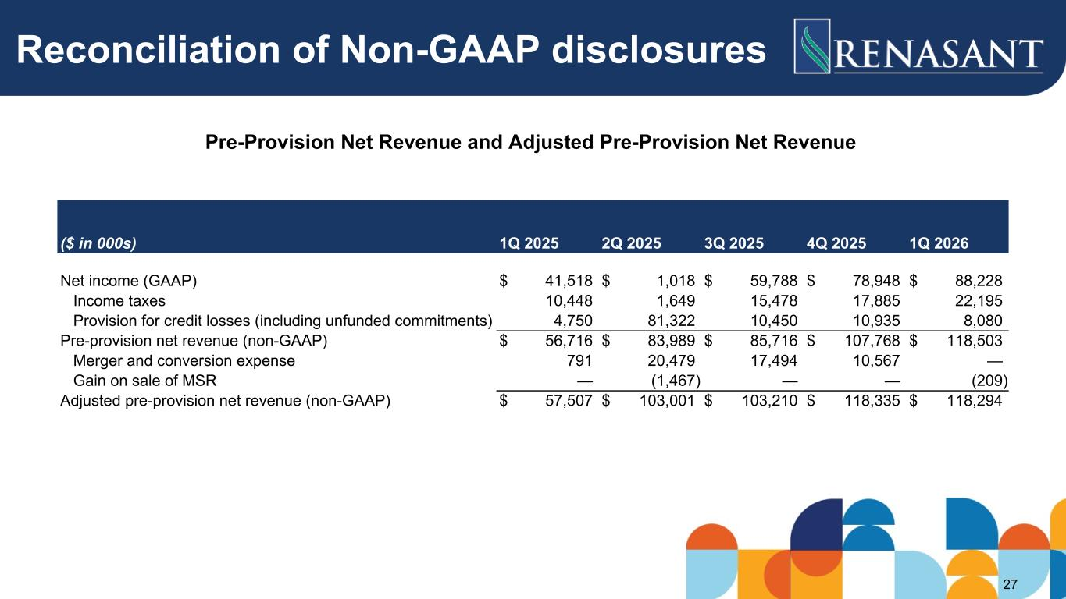
Reconciliation of Non-GAAP disclosures Pre-Provision Net Revenue and Adjusted Pre-Provision Net Revenue ($ in 000s) 1Q 2025 2Q 2025 3Q 2025 4Q 2025 1Q 2026 Net income (GAAP) $ 41,518 $ 1,018 $ 59,788 $ 78,948 $ 88,228 Income taxes 10,448 1,649 15,478 17,885 22,195 Provision for credit losses (including unfunded commitments) 4,750 81,322 10,450 10,935 8,080 Pre-provision net revenue (non-GAAP) $ 56,716 $ 83,989 $ 85,716 $ 107,768 $ 118,503 Merger and conversion expense 791 20,479 17,494 10,567 — Gain on sale of MSR — (1,467) — — (209) Adjusted pre-provision net revenue (non-GAAP) $ 57,507 $ 103,001 $ 103,210 $ 118,335 $ 118,294 27

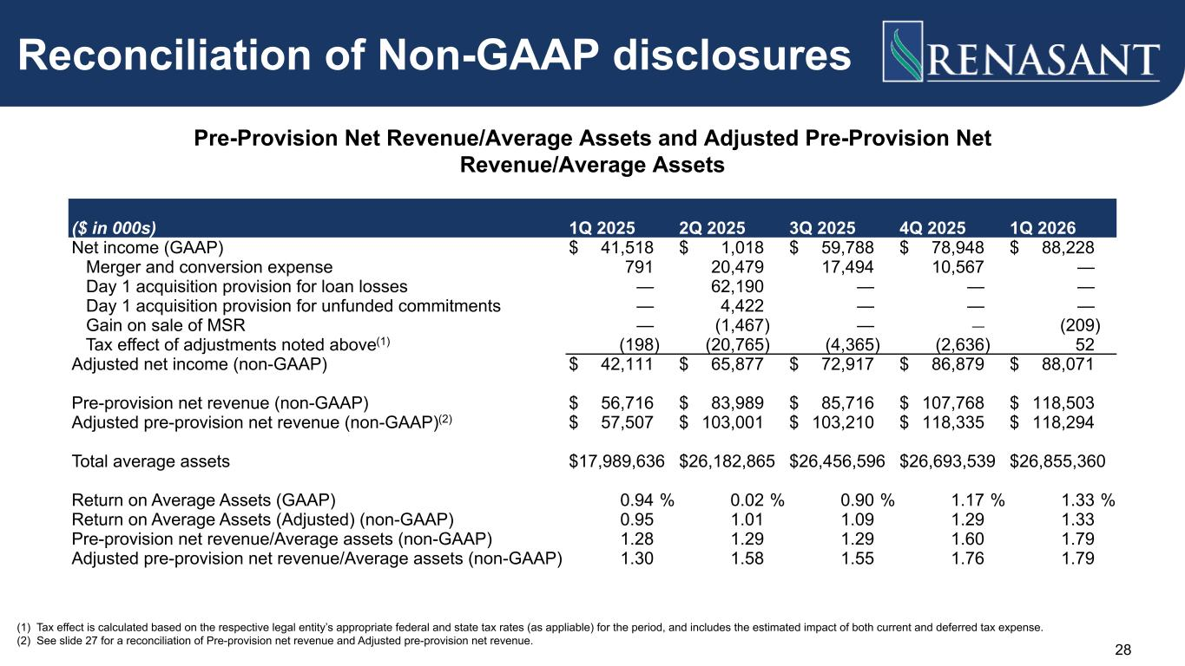
28 Reconciliation of Non-GAAP disclosures Pre-Provision Net Revenue/Average Assets and Adjusted Pre-Provision Net Revenue/Average Assets (1) Tax effect is calculated based on the respective legal entity’s appropriate federal and state tax rates (as appliable) for the period, and includes the estimated impact of both current and deferred tax expense. (2) See slide 27 for a reconciliation of Pre-provision net revenue and Adjusted pre-provision net revenue. ($ in 000s) 1Q 2025 2Q 2025 3Q 2025 4Q 2025 1Q 2026 Net income (GAAP) $ 41,518 $ 1,018 $ 59,788 $ 78,948 $ 88,228 Merger and conversion expense 791 20,479 17,494 10,567 — Day 1 acquisition provision for loan losses — 62,190 — — — Day 1 acquisition provision for unfunded commitments — 4,422 — — — Gain on sale of MSR — (1,467) — — (209) Tax effect of adjustments noted above(1) (198) (20,765) (4,365) (2,636) 52 Adjusted net income (non-GAAP) $ 42,111 $ 65,877 $ 72,917 $ 86,879 $ 88,071 Pre-provision net revenue (non-GAAP) $ 56,716 $ 83,989 $ 85,716 $ 107,768 $ 118,503 Adjusted pre-provision net revenue (non-GAAP)(2) $ 57,507 $ 103,001 $ 103,210 $ 118,335 $ 118,294 Total average assets $ 17,989,636 $ 26,182,865 $ 26,456,596 $ 26,693,539 $ 26,855,360 Return on Average Assets (GAAP) 0.94 % 0.02 % 0.90 % 1.17 % 1.33 % Return on Average Assets (Adjusted) (non-GAAP) 0.95 1.01 1.09 1.29 1.33 Pre-provision net revenue/Average assets (non-GAAP) 1.28 1.29 1.29 1.60 1.79 Adjusted pre-provision net revenue/Average assets (non-GAAP) 1.30 1.58 1.55 1.76 1.79

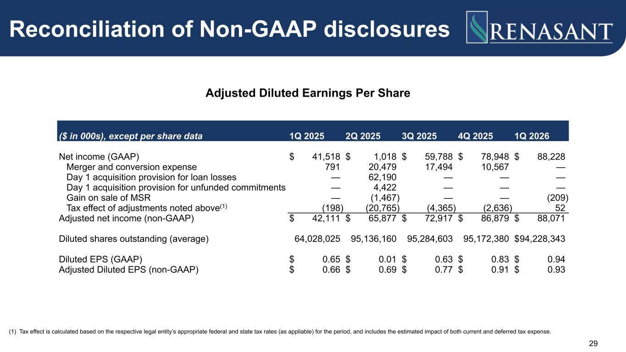
29 Reconciliation of Non-GAAP disclosures Adjusted Diluted Earnings Per Share ($ in 000s), except per share data 1Q 2025 2Q 2025 3Q 2025 4Q 2025 1Q 2026 Net income (GAAP) $ 41,518 $ 1,018 $ 59,788 $ 78,948 $ 88,228 Merger and conversion expense 791 20,479 17,494 10,567 — Day 1 acquisition provision for loan losses — 62,190 — — — Day 1 acquisition provision for unfunded commitments — 4,422 — — — Gain on sale of MSR — (1,467) — — (209) Tax effect of adjustments noted above(1) (198) (20,765) (4,365) (2,636) 52 Adjusted net income (non-GAAP) $ 42,111 $ 65,877 $ 72,917 $ 86,879 $ 88,071 Diluted shares outstanding (average) 64,028,025 95,136,160 95,284,603 95,172,380 $ 94,228,343 Diluted EPS (GAAP) $ 0.65 $ 0.01 $ 0.63 $ 0.83 $ 0.94 Adjusted Diluted EPS (non-GAAP) $ 0.66 $ 0.69 $ 0.77 $ 0.91 $ 0.93 (1) Tax effect is calculated based on the respective legal entity’s appropriate federal and state tax rates (as appliable) for the period, and includes the estimated impact of both current and deferred tax expense.

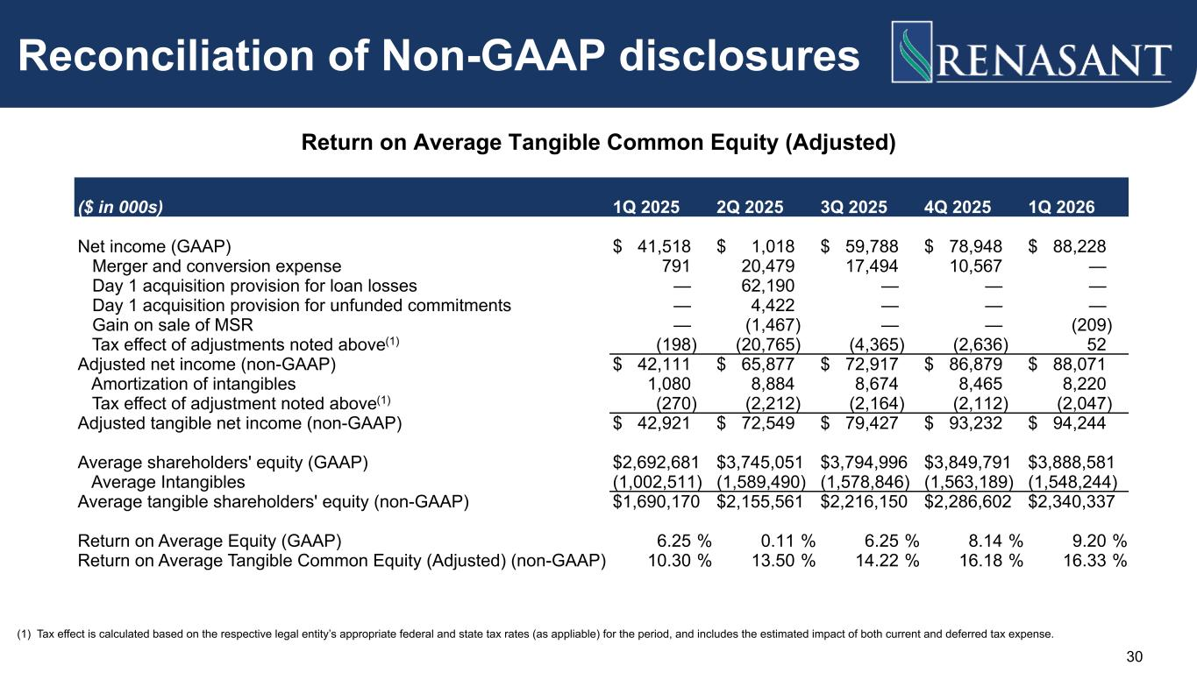
Reconciliation of Non-GAAP disclosures Return on Average Tangible Common Equity (Adjusted) ($ in 000s) 1Q 2025 2Q 2025 3Q 2025 4Q 2025 1Q 2026 Net income (GAAP) $ 41,518 $ 1,018 $ 59,788 $ 78,948 $ 88,228 Merger and conversion expense 791 20,479 17,494 10,567 — Day 1 acquisition provision for loan losses — 62,190 — — — Day 1 acquisition provision for unfunded commitments — 4,422 — — — Gain on sale of MSR — (1,467) — — (209) Tax effect of adjustments noted above(1) (198) (20,765) (4,365) (2,636) 52 Adjusted net income (non-GAAP) $ 42,111 $ 65,877 $ 72,917 $ 86,879 $ 88,071 Amortization of intangibles 1,080 8,884 8,674 8,465 8,220 Tax effect of adjustment noted above(1) (270) (2,212) (2,164) (2,112) (2,047) Adjusted tangible net income (non-GAAP) $ 42,921 $ 72,549 $ 79,427 $ 93,232 $ 94,244 Average shareholders' equity (GAAP) $ 2,692,681 $ 3,745,051 $ 3,794,996 $ 3,849,791 $ 3,888,581 Average Intangibles (1,002,511) (1,589,490) (1,578,846) (1,563,189) (1,548,244) Average tangible shareholders' equity (non-GAAP) $ 1,690,170 $ 2,155,561 $ 2,216,150 $ 2,286,602 $ 2,340,337 Return on Average Equity (GAAP) 6.25 % 0.11 % 6.25 % 8.14 % 9.20 % Return on Average Tangible Common Equity (Adjusted) (non-GAAP) 10.30 % 13.50 % 14.22 % 16.18 % 16.33 % 30 (1) Tax effect is calculated based on the respective legal entity’s appropriate federal and state tax rates (as appliable) for the period, and includes the estimated impact of both current and deferred tax expense.

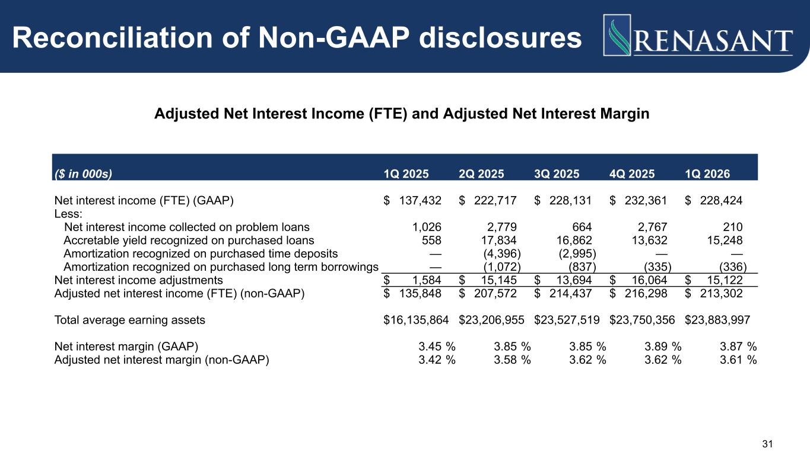
31 Adjusted Net Interest Income (FTE) and Adjusted Net Interest Margin Reconciliation of Non-GAAP disclosures ($ in 000s) 1Q 2025 2Q 2025 3Q 2025 4Q 2025 1Q 2026 Net interest income (FTE) (GAAP) $ 137,432 $ 222,717 $ 228,131 $ 232,361 $ 228,424 Less: Net interest income collected on problem loans 1,026 2,779 664 2,767 210 Accretable yield recognized on purchased loans 558 17,834 16,862 13,632 15,248 Amortization recognized on purchased time deposits — (4,396) (2,995) — — Amortization recognized on purchased long term borrowings — (1,072) (837) (335) (336) Net interest income adjustments $ 1,584 $ 15,145 $ 13,694 $ 16,064 $ 15,122 Adjusted net interest income (FTE) (non-GAAP) $ 135,848 $ 207,572 $ 214,437 $ 216,298 $ 213,302 Total average earning assets $ 16,135,864 $ 23,206,955 $ 23,527,519 $ 23,750,356 $ 23,883,997 Net interest margin (GAAP) 3.45 % 3.85 % 3.85 % 3.89 % 3.87 % Adjusted net interest margin (non-GAAP) 3.42 % 3.58 % 3.62 % 3.62 % 3.61 %

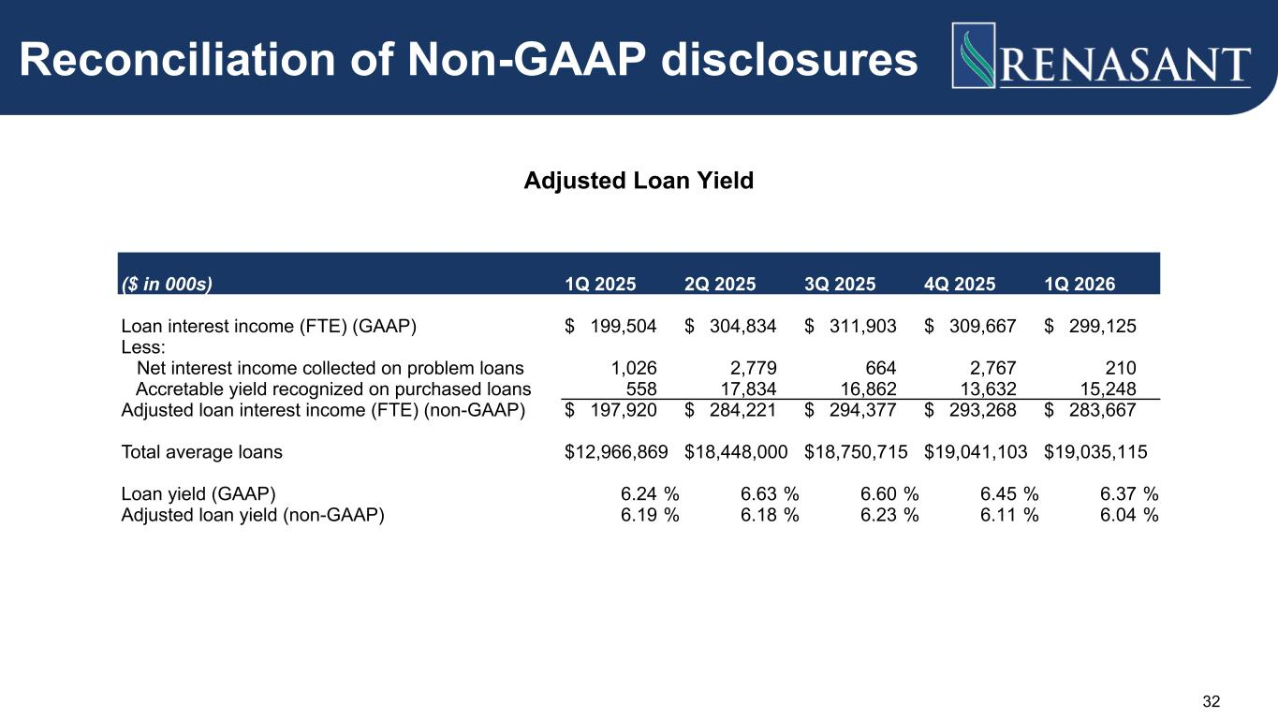
32 Adjusted Loan Yield Reconciliation of Non-GAAP disclosures ($ in 000s) 1Q 2025 2Q 2025 3Q 2025 4Q 2025 1Q 2026 Loan interest income (FTE) (GAAP) $ 199,504 $ 304,834 $ 311,903 $ 309,667 $ 299,125 Less: Net interest income collected on problem loans 1,026 2,779 664 2,767 210 Accretable yield recognized on purchased loans 558 17,834 16,862 13,632 15,248 Adjusted loan interest income (FTE) (non-GAAP) $ 197,920 $ 284,221 $ 294,377 $ 293,268 $ 283,667 Total average loans $ 12,966,869 $ 18,448,000 $ 18,750,715 $ 19,041,103 $ 19,035,115 Loan yield (GAAP) 6.24 % 6.63 % 6.60 % 6.45 % 6.37 % Adjusted loan yield (non-GAAP) 6.19 % 6.18 % 6.23 % 6.11 % 6.04 %

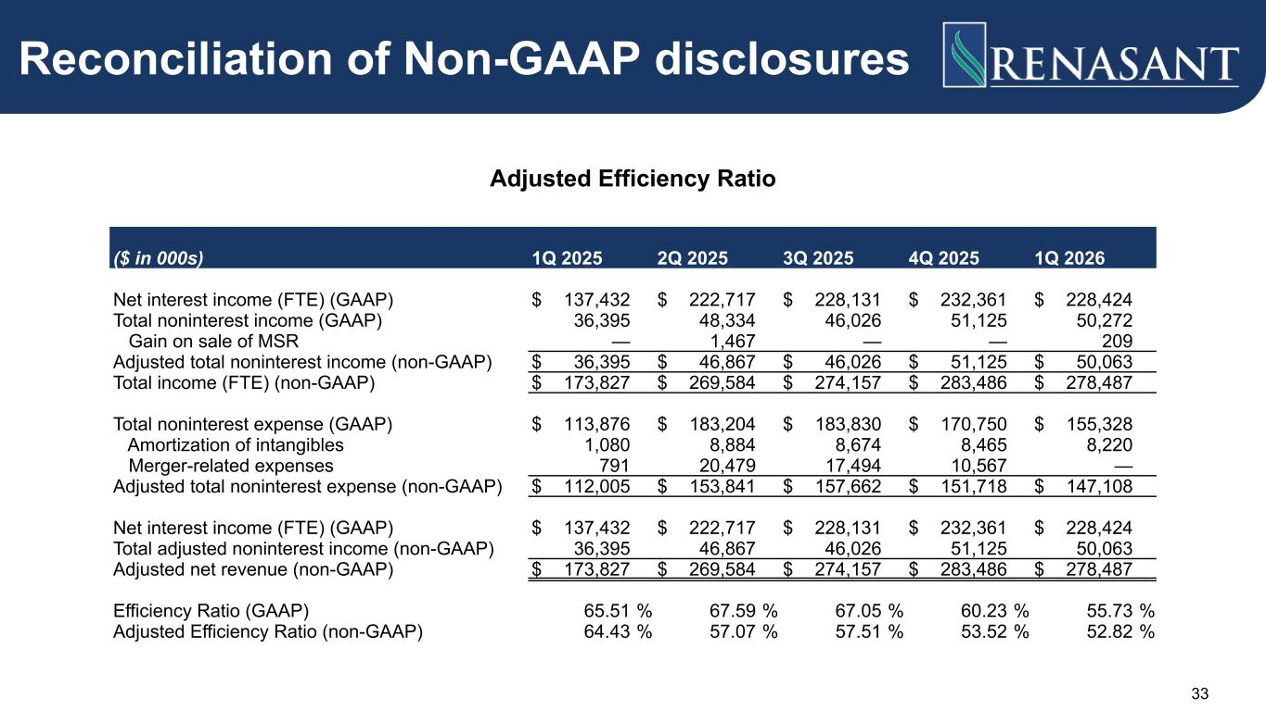
33 Reconciliation of Non-GAAP disclosures Adjusted Efficiency Ratio ($ in 000s) 1Q 2025 2Q 2025 3Q 2025 4Q 2025 1Q 2026 Net interest income (FTE) (GAAP) $ 137,432 $ 222,717 $ 228,131 $ 232,361 $ 228,424 Total noninterest income (GAAP) 36,395 48,334 46,026 51,125 50,272 Gain on sale of MSR — 1,467 — — 209 Adjusted total noninterest income (non-GAAP) $ 36,395 $ 46,867 $ 46,026 $ 51,125 $ 50,063 Total income (FTE) (non-GAAP) $ 173,827 $ 269,584 $ 274,157 $ 283,486 $ 278,487 Total noninterest expense (GAAP) $ 113,876 $ 183,204 $ 183,830 $ 170,750 $ 155,328 Amortization of intangibles 1,080 8,884 8,674 8,465 8,220 Merger-related expenses 791 20,479 17,494 10,567 — Adjusted total noninterest expense (non-GAAP) $ 112,005 $ 153,841 $ 157,662 $ 151,718 $ 147,108 Net interest income (FTE) (GAAP) $ 137,432 $ 222,717 $ 228,131 $ 232,361 $ 228,424 Total adjusted noninterest income (non-GAAP) 36,395 46,867 46,026 51,125 50,063 Adjusted net revenue (non-GAAP) $ 173,827 $ 269,584 $ 274,157 $ 283,486 $ 278,487 Efficiency Ratio (GAAP) 65.51 % 67.59 % 67.05 % 60.23 % 55.73 % Adjusted Efficiency Ratio (non-GAAP) 64.43 % 57.07 % 57.51 % 53.52 % 52.82 %

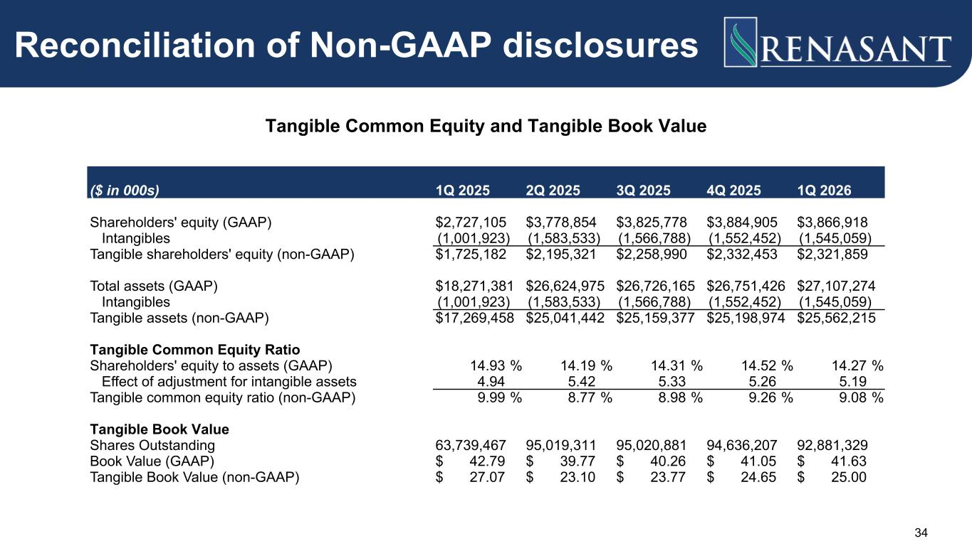
Reconciliation of Non-GAAP disclosures Tangible Common Equity and Tangible Book Value ($ in 000s) 1Q 2025 2Q 2025 3Q 2025 4Q 2025 1Q 2026 Shareholders' equity (GAAP) $ 2,727,105 $ 3,778,854 $ 3,825,778 $ 3,884,905 $ 3,866,918 Intangibles (1,001,923) (1,583,533) (1,566,788) (1,552,452) (1,545,059) Tangible shareholders' equity (non-GAAP) $ 1,725,182 $ 2,195,321 $ 2,258,990 $ 2,332,453 $ 2,321,859 Total assets (GAAP) $ 18,271,381 $ 26,624,975 $ 26,726,165 $ 26,751,426 $ 27,107,274 Intangibles (1,001,923) (1,583,533) (1,566,788) (1,552,452) (1,545,059) Tangible assets (non-GAAP) $ 17,269,458 $ 25,041,442 $ 25,159,377 $ 25,198,974 $ 25,562,215 Tangible Common Equity Ratio Shareholders' equity to assets (GAAP) 14.93 % 14.19 % 14.31 % 14.52 % 14.27 % Effect of adjustment for intangible assets 4.94 5.42 5.33 5.26 5.19 Tangible common equity ratio (non-GAAP) 9.99 % 8.77 % 8.98 % 9.26 % 9.08 % Tangible Book Value Shares Outstanding 63,739,467 95,019,311 95,020,881 94,636,207 92,881,329 Book Value (GAAP) $ 42.79 $ 39.77 $ 40.26 $ 41.05 $ 41.63 Tangible Book Value (non-GAAP) $ 27.07 $ 23.10 $ 23.77 $ 24.65 $ 25.00 34



